Creating an Isolated Droplet in Zero Gravity

I. Scientific Objectives
The height to which a fluid rises in a capillary tube is limited in the presence of gravity by the ever-increasing weight of the column of fluid. (Giancoli, 1998, p. 296) At some point the weight of the fluid counteracts the force of attraction between the tube and the fluid, and the fluid stops rising.
In a micro-gravity situation, we expect the fluid to rise up the height of the tube creating an oscillating balloon at the end. (Siegel, 1961) The energy of the moving fluid does not seem sufficient to cause droplet formation if the tube is not tapered at the end. The research question, then, is whether changing the end of the tube will cause the fluid to be ejected out into the air.
It is our hypothesis that if we change shape of the end of the tube the energy of the rising fluid will eject an isolated droplet in a micro-gravity environment. We have been able to produce water droplets during a ground test (see figure 1).
We will construct a Plexiglas container that will hold three partially immersed capillary tubes. We will use the provided video camera and a backlight inside the experiment apparatus to view the results of our experiment. We will have a ruler or other form of measuring device that will be used to calculate actual dimensions from the video. We will construct the experiment so the capillary tubes are removable, that way we can try several diameters and shapes to see which works best.
In order to insure that there will be enough time for the fluid to reach the top of the tube, we are using data from experiments conducted by Stange et al (2003) and Petrash et al. (1963). In their experiments they placed several open-ended tubes with diameters ranging from 4 mm to 70 mm into a container that already had 10 mm of liquid in it. When dropped, the liquid rose inside of the tube, and at the time of 2.2 seconds the liquid had risen from 170 mm to 50 mm for the larger tubes. We will analyze the data of the experiment to determine which combinations of tube height and diameter, coupled with the velocity, achieves the highest kinetic energy for times less than 2.2 seconds. The data from their experiment suggests we have ample time within 2.2 seconds to achieve a forceful collision with the top of the tube. In order to do ground testing for our experiment without a drop tower, we have simulated the rise of the fluid by immersing different lengths of tube into the fluid with the nozzles plugged. When the plug is removed, the fluid will rise up the tube rapidly and collide with the nozzle. We will test various tube tips to see which ones create drops at the lowest velocity. We will film this action and review the tape in order to determine which top gives our experiment the greatest chance for success.
The purpose of this experiment is to create isolated droplets. A benefit for this experiment would be to increase our knowledge of droplet formation in micro-gravity. Some practical applications might be to create jets for printing, to entrain the fluid droplets in moving air for transportation, or to create droplets for combustion. It might also be used to cool equipment by increasing evaporation. (NASA, 1995, CAPL-2)

II Technical Plan

The apparatus will consist of a rectangular Plexiglas container with a removable lid. The container will be filled with a fluid up to a designated level. (Figures 2, 3) The three open-ended capillary tubes will be immersed approximately 1 cm in the fluid from above. They will be placed in a row and be clipped to a holding plate that extends from one side of the container to the other. (Figure 4) We will have separate tube concepts with different dimensions in order to find the optimal design for creating an isolated droplet in microgravity. Different concepts include a tube with a simple taper, abrupt end, and tapered end. (Figure 5) Wetting barriers will also be connected on the sides of the tubes and container in order to prevent fluid from rising up the outside of the tubes. (Figures 2, 3) This will allow us to view the movement of the fluid inside the tube without any distractions. A professor at a local university has suggested to us that if we are able to find the correct correlation between liquid density, velocity, tube radius, and liquid-gas surface tension, we will be able to find the Weber number which we can maximize to achieve our expected results.
The experiment will be viewed using the provided camera and backlight in the education rig. A small amount of dye will be added to the fluid to enhance its visibility.
The following events will take place in the sequence of the experiment:
The capillary tubes will be placed into their respective holders inside the fluid-filled container. The height of immersion of the tubes inside the fluid will be fixed. At the top of the drop tower, final revisions will be made. The lid will be secured to prevent fluid from escaping upon impact with the air bags. The container will then be dropped and movement of the fluid will be observed by camera. As the container drops, the fluid will begin to accelerate, rising to the top of the tubes. When the fluid reaches the top, it will hopefully have enough energy to break a portion free from the end of the tube and create an isolated droplet. The specific design features of our apparatus contain no limitations that would prevent it from being able to survive the impact and be usable for another drop. The tubes will be securely held which will insure the safety of the tubes for multiple drops. All of the necessary data will be collected from the camera during the drop, and other tubes will be readily available if a replacement is necessary or to try different tube concepts.
Our analysis of the data from various sources (Petrash, Nelson, & Otto, 1963, & Stange, Dreyer, & Rath, 2003) including videos on the ZARM site (2004) indicate that there is a wide range of heights and tube diameters that will allow us to observe a collision of the moving fluid with the top of the tube within 2.2 seconds. The trial tubes we bring will be adjusted using their data.
There is no reason to question the safety of our drop. The liquid will be contained and will have no chance of interfering with the electrical equipment. Multiple security devices will properly hold all of the tubes and there will be no flammable liquids used.

III Team Organization
In order to accomplish the work that is necessary in a project of this magnitude, including researching the topic and writing the final report, we plan on dividing the work evenly, and utilizing the strengths of each team member. We plan on taking this project one step at a time, in order to insure that there are no miscalculations or overlooked factors. We will first obtain accurate background information before beginning to work. The team has set out to gather all the information they can get from various sources. A professor from a local university has offered to help us fund, and build the apparatus itself using his connections. We will perform tests on our own to find the probable result. The write up will include knowledge that was both learned through the experiment and known before, in order to come to an accurate conclusion that we will send to NASA.
On this team, there are a variety of skills that will enhance the probable positive outcome of our experiment. All members have a sound grasp of the physics involved in this experiment. One member would like to build his own drop tower, and this project would be a good stepping-stone into a career in physics, this member’s initiative will be of great value to the team. We also have strong leadership in more than one of our team members. They are willing to accept responsibility and take control of the situation. This team has worked together many times before, including on an IB area-4 project as well as getting together to study before a physics test. We have been successful in the past and will definitely be successful in the future.
The work will be divided up equally among the members, no one member will be burdened with a majority of the work. The work will not be done individually; it will be during a time that all the members can meet and work together. The workload and responsibilities will be assigned according to each member’s skill level and the consent of the group. Even on this proposal, each team member has contributed, with each member doing a different section. This team has the support of the entire school, the principal is fully behind us, our professor is willing to spend time after school assisting us, we have access to a local university library and we have talked to a professor from that local university.

IV Resource Credits

Bibliography
Stange, M., Dreyer, M. E., & Rath H. J. (2003). Capillary driven flow in circular cylindrical tubes. Physics of Fluids. 15(9) 2587-2601

Siegel, R. (1961). Transient Capillary Rise in Reduced and Zero Gravity Fields. Journal of Appl. Mech. 83 165-170

ZARM Center of Applied Space Technology and Microgravity. (2004). Capillary Rise in Tubes. Retrieved October 5, 2004, from
http://www.zarm.uni-bremen.de/2forschung/grenzph/isoterm/cap_rise/index.htm

NASA National Space and Aeronautics Administration. (1995). Capillary Pumped Loop-2 (CAPL-2). Retrieved October 7, 2004, from
http://ssppgse.gsfc.nasa.gov/hh/capl/capl.html

Physics – Principles with Applications. Giancoli, D. (1998). Physics – Principles with Applications. (5th ed.). New Jersey: Prentice Hall.

Petrash, D. A., Nelson, T. M., & Otto. (1963). Effect of surface energy on the liquid-vapor interface configuration during weightlessness. NASA TM D-1582

V Figures
Figures 2-4 follow.

Figure 1 – Ground Testing

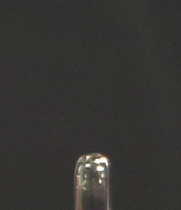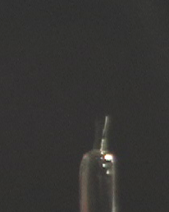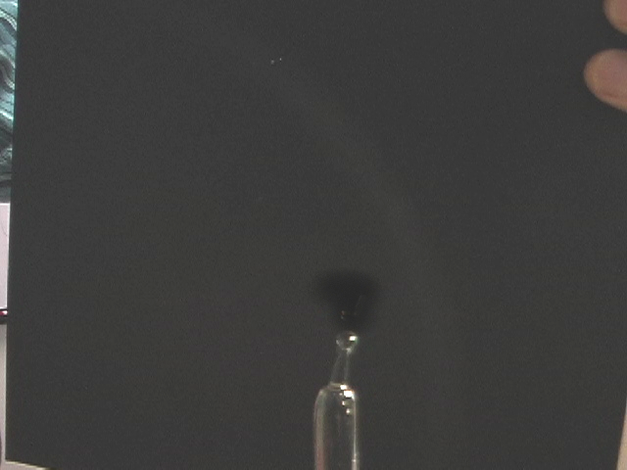

Time Sequence of droplet formed by water colliding with nozzle on a glass tube
