Soap Film Thickness Gradients in Microgravity

I. Scientific Objectives
A vertically oriented soap film will display a thickness gradient in the presence of gravity as the liquid is pulled down to the bottom. If white light is incident on the film, a rainbow pattern appears because of constructive interference between the light reflected off the front and the rear of the film as in Figure 1.
The aim of this study is to investigate the behavior of a film with a thickness gradient after gravity abruptly goes away. We hypothesize that the gravity-induced thickness gradient will decrease at some rate, and this rate is our dependent variable.
There are several independent variables that we could manipulate in this case – but (after some expert advice in the area) we would like to change the initial thickness of the film, with the hypothesis that an initially thicker film would respond more quickly, and to possibly (if we could get 4 drops) try the effect of two different types of surfactants – one that creates a moveable boundary layer on the surface (Dawn dish soap from the US) and one that holds the surface molecules fixed and allows motion only within the liquid (Fairy soap from the UK or similar) with the hypothesis that the fixed film will respond slower. We will be able to measure the response of the films to microgravity by using video analysis software and tracking the motion of the interference fringes. The controlled variables include, but are not limited to, the size and shape of the film, the concentration of the surfactant, and the manner of creating the films.
We have chosen the variable of thickness for a good reason. In 2006, students from this school sent a soap film up as a piggyback experiment on a C-9 Reduced Gravity Flight Program through the Johnson Space Center. In Figures 2 and 3 you will see two time sequences from the video of that experiment – one with (Figure 2) a thin initial film (an old film that has had more time to drain), and the other (Figure 3) with a thicker (newer) film. You can see that the changes in the thicker are more dramatic. We know that thinner films do not respond very quickly – and this agrees with what the experts have found as well (Verbist, Weaire and Kraynik, 1996, Leonard and Lemlich, 1965). So if we are dealing with short times (2.2 seconds in this case) the film needs to be fairly thick to see any effect at all, and we are curious how much the thickness affects the rate at which the film changes in microgravity. It is also interesting to note that even though we don’t have the 30 or so seconds that the aircraft people have, there is some effect within 2.2 seconds, for sure with the thicker film.
The difficulty that we had analyzing the data from the piggyback video is that the transitions from gravity to microgravity on the aircraft were gradual – typically they range from 1-3 seconds – plus exactly when they occurred was not always clear to us. What the drop tower can do is give us a more instantaneous and known transition from exactly one gravity to microgravity. Then we can see what happens at precise time intervals by examining the shift of the interference patterns that takes place. We have made preliminary drops for short distances (≈ 1.0 m) using the apparatus that went up in the C-9 program and a digital camera to see what shapes we might want to try in the big 2.2 tower. Even in the 0.5 seconds we have to work with, we can see the patterns even out. (See Figures 4-6)
There is an interesting story about the variable of the surfactants. Apparently, scientists in the US (Using Dawn as a surfactant) were getting markedly different results in the area of foam drainage from investigators in the UK. The debate got fairly heated, until a third party wrote a letter (Stein and Laven, 2001) pointing out the two different behaviors of the surfactants. Dawn - a leading US soap – has a mobile surface – molecules are free to move along the air-liquid boundary, and Fairy – the UK brand leader fixes the molecules at the surface. Films like this are thin enough that this makes a significant difference in their motion. So we would like to include this variable for the sake of history and good relations with the UK.
As for the benefits and practical applications of the research – we hope to contribute to the body of knowledge regarding soap bubbles and films. There is a large scientific community that does research in this area – in fact we actually contacted Dr. Weaire from Trinity College in Dublin and he gave us some ideas for research. His work inspired the Beijing Bubble Building that housed the swimming events in the 2008 Olympics. Applications of foam research are found in many areas ranging from the manufacturing of plastics and insulation (Isenberg 1992) to quantum theories about the origin of the universe.

II Technical Plan
The apparatus we have designed is quite simple. It will be a box 7“ wide, 9.5” tall, and 6.25” deep constructed of ½ “ clear polycarbonate (Lexan) plastic. (Refer to figures 7-8) It will have a removable watertight lid that is held tight with screws, and a base that extends 2” beyond the dimensions of the box so that we can bolt it to the NASA-provided adaptor plate. Attached to the lid, and shining downward will be a white flat backlight that will be powered by the 12 VDC provided by the Education Rig. Somewhere visible to the video camera will be a zero gravity indicator light that will turn on when the apparatus is dropped so that we know when it goes into microgravity. Inside the box to a height of 2” at the bottom of the box there will be a pinning edge – a 1/8” piece of plastic glued around the perimeter of the box at the base so that the liquid does not climb the inside of the box and get in the way of the camera shot in zero gravity. Before the drop, we will fill the box to a depth of 1” with a soap-water mixture. To make the soap films right before the drop, there will be a wire loop inside the box that can be dipped into the liquid by rotating a knob outside the box.
Operating the experiment will take teamwork. A drop tower operator will create the soap film, we will verify that we can see the rainbow interference pattern on the rig camera, and then they will disconnect the safety cable, and at a specific time (when the film is the right thickness for the experiment), drop the experiment. The built in camera will capture the changes in the soap film as it falls as evidenced by the changes in the interference patterns. We can then measure the shift of the interference pattern by using video analysis software to measure the position each frame of the interference patterns on the film.

III Team Organization
In order to realize our goals for this project, we will not only equally distribute the work of our team but also utilize each person’s unique strengths, visions, and abilities to accomplish our tasks. The unique strengths in our team include a solidified mathematician, a member with access to a shop full of tools and apparatuses as well as strong points in engineering, a member with past experiences of competing in science fairs at the state level, and another member with extreme attention to detail and subtleties. As with any project done in a group, we will use each other’s calculations as a form of peer review to ensure accuracy upon the completion of our tasks. We will also be looking into the background information of our topic in order to take past errors or what we view as potential detrimental factors into mind as well as past successes in tests similar to ours. This way, our final conclusion of our report will be more educational and will incorporate known information along with our own findings.
As a team, we have all worked together at some time in the past. Not only have we worked together on labs in physics, but also in math classes, carrying figurative and literal large objects through challenges, and sporting events. Teamwork is a concept we are all familiar with and used to with each other. As team members, we are all very well rounded with some room for specialization in certain concepts and ideas. Each of us has certain talents and attributes that can be contributed into project. We have a combination of leaders and followers in our team.

IV Resource Credits

Bibliography

Isenberg, C. (1992). The Science of Soap Films and Soap Bubbles. Mineola NY: Dover Publishing Co.

Leonard, R. A. , and Lemlich, R. A I.Ch.E.J. 8, 3715 (1996)

Stein, H. N. and Laven, J. Journal of Colloid and Interface Science 244, 436-438 (2001)

Verbist, G., Weaire, D., and Kraynik, A. M., J. Phys. Condens. Matter 8, 3715 (1996)

V Figures
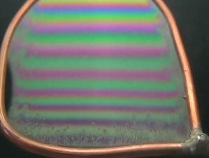
Figure 1 – Interference pattern revealing thickness gradient in soap film – presumably thicker on the bottom, thinner at the top

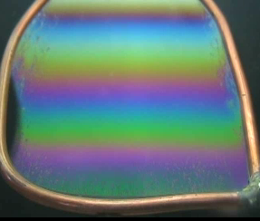  t = 0.0 s | 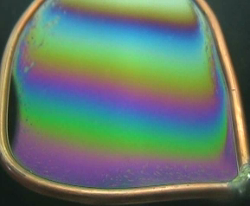  t = 2.0 s | 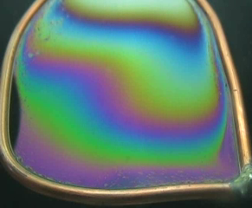  t = 4.0 s

Figures 2 – A thin film responding to microgravity (from piggyback video)

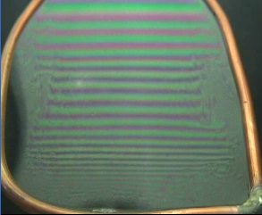  t = 0.0 s | 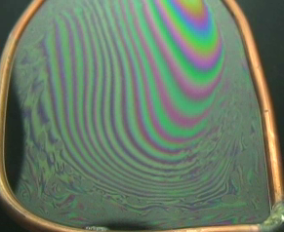  t = 2.0 s | 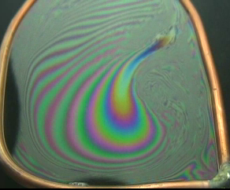  t = 4.0 s

Figures 3 – A thicker film responding to microgravity (from piggyback video)

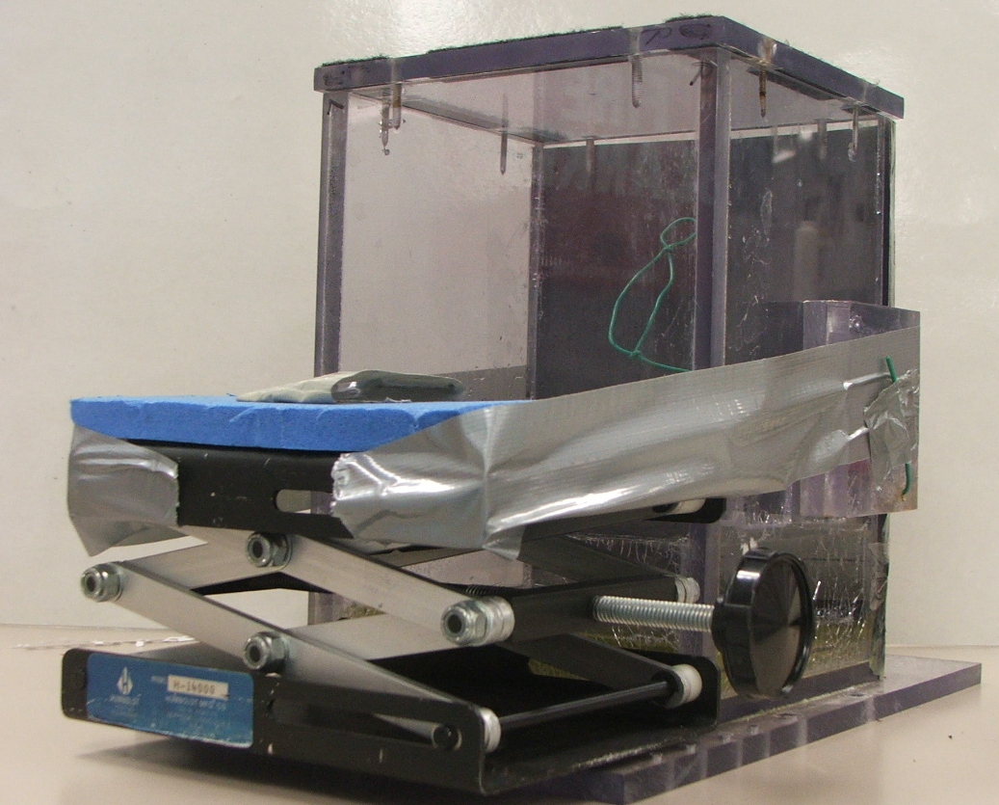
Figure 4 – Our prototype apparatus. Note use of duct tape.

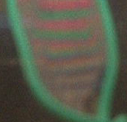  t = 0.0 s | 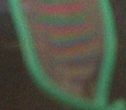  t = 1/6 s | 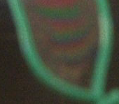  t = 2/6 s

Figures 5 – A time sequence of a dropping film – note the spread of the pattern

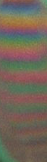  t = 0.00 s | 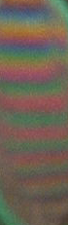  t = 0.10 s | 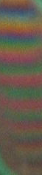  t = 0.20 s | 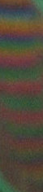  t = 0.30 s

Figures 6 – Another time sequence of a dropping film

White backlight
Watertight lid
Zero Gravity Light

Container – ½ “ Lexan
Soap Film
Knob

Pinning edge

Bolting Base
Soap Solution

Figure 7 – View of the experiment as seen by the camera

Path of light

Camera on Educational Rig

Figure 8 – Side view (from the right of the front view)

