Soap Film Thickness Gradients in Microgravity
Grant Gholston, Joshua Jordan, Alex Lockwood, and Evan Pinckard
Advisor – Chris Murray
Tualatin High School

Introduction
A vertically oriented soap film will display a thickness gradient in the presence of gravity as the liquid is pulled down to the bottom. If white light is incident on the film, a rainbow pattern appears because of interference between the light reflected off the front and the rear of the film. The horizontal bands indicate a thickness gradient – where the film is presumably thicker at the bottom, and thinner at the top due to gravity induced drainage.

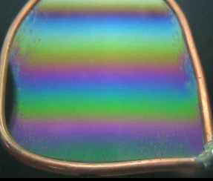
Interference Pattern showing thickness gradient

The aim of this study was to investigate the behavior of a film with a thickness gradient after gravity abruptly goes away. We hypothesized that the gravity-induced thickness gradient would decrease at some rate as the surface tension acted to straighten the fluid surface. This rate was our dependent variable.

The independent variable was to try, with two different soaps, different drainage times prior to dropping. The hypothesis here was that the longer the film drained, the thinner it would be, and the slower it would react to the microgravity – because we thought that the fluids would have a harder time moving around in a thin film. The two soaps were Dawn soap from the U.S. that creates a moveable boundary layer on the surface and Fairy from the U.K. that holds the surface molecules fixed and allows motion only within the liquid. We hypothesized that the fixed film (Fairy) would respond slower because of viscosity related forces acting between the fixed surface, and the mobile interior of the film.

The Apparatus
The apparatus was double chambered box constructed of Lexan plastic with wire loops in the chamber that we could operate from outside. There was a zero gravity LED indicator attached to the release indicator relay and mounted between the cells so we would know when the package went into zero gravity, and a rig-powered fluorescent top light that would shine down on the films so the light would reflect into the camera:
Fluorescent top light

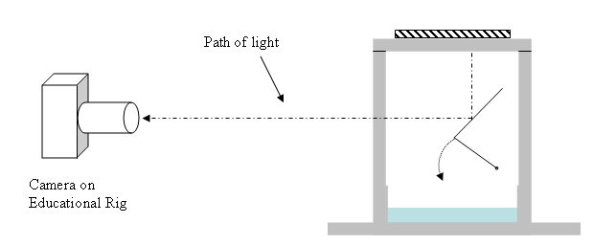
The box concept – showing one chamber only

The two chambers were for Dawn and Fairy soap solutions, which we mixed water with 100 ml of soap to make a volume of 400 ml total. The wire loops were made of 14 gauge copper wire soldered to make a rectangular loop 4.4 cm wide, and 8.9 cm tall, bent so that they could dip down into the solution, and then flip up and make a 45º angle inside the box with the vertical.

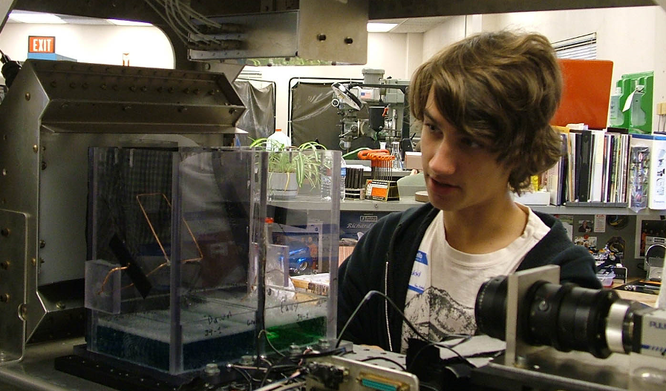
The box mounted in the ed. rig with the lid and top light removed

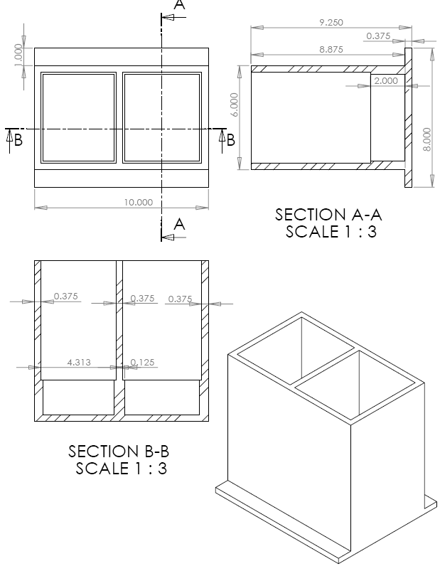
Dimensions of box

The Procedure
With each cell filled with 400 ml of a 1:3 soap-water solution, (The left side was Dawn, and the right, Fairy) we secured the lid tightly with screws, and waited some time for the humidity inside to reach 100%. (We discovered that the bubbles last far longer with the lid closed.) With the experiment package at the top of the drop tower we had NASA personnel create a film simultaneously on both loops while a team member timed. The drag shield doors were closed, and the safety cable was released, and when the proper amount of drainage time was reached, the timer told the operator to drop. The video was captured on a Macintosh computer.

The Analysis
For video analysis, we chose the boundary between the bright yellow and the magenta lines on the soap film. The first time this color occurs, it indicates a path difference of half the wavelength of blue light (about 400 nm), and the magenta color is the result of destructive interference subtracting blue from the white light of the top light. We chose this transition because it happens near the top, and is easy to pick out visually for video analysis. So the first magenta line is a path length difference of 0.5λ blue light, the second is 1.5λ, the third, 2.5λ and so on.

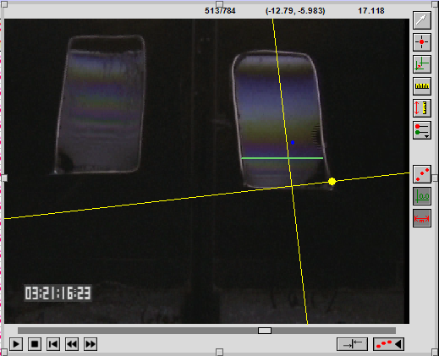
Frame detail from video analysis – analyzing the 2nd magenta line for Fairy Soap from the first drop

We tried to analyze the first three magenta bands for all the drops, but in some cases the third band was not visible. In all cases, we analyzed the interference pattern at the center of the frame, and compensated for camera angle by aligning the y-axis in the Vernier LoggerPro software with the frame itself.
We also had difficulty with the 2nd and 7th drop videos. In the 2nd the video skipped nearly all the frames of the drop, so we discarded the data, and in the 7th drop, only the first 40 frames out of 60 some odd usual frames were available. Presumably the computer found something more important to do during these times?
Results
First, we plotted graphs of the height of the magenta bands from the bottom of the loop during free fall, and fitted straight lines to the data:

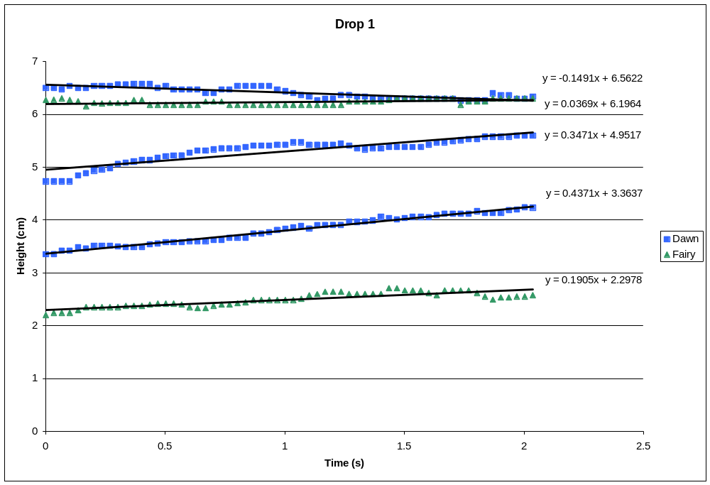
Drop 1 – Drainage Time 30 seconds

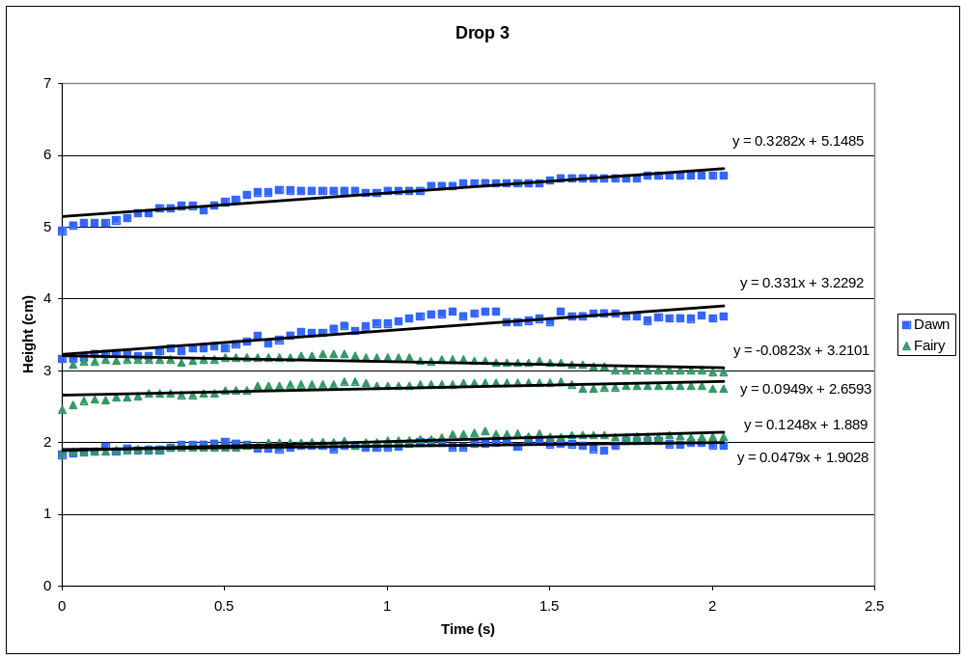
Drop 3 – Drainage time 60 s

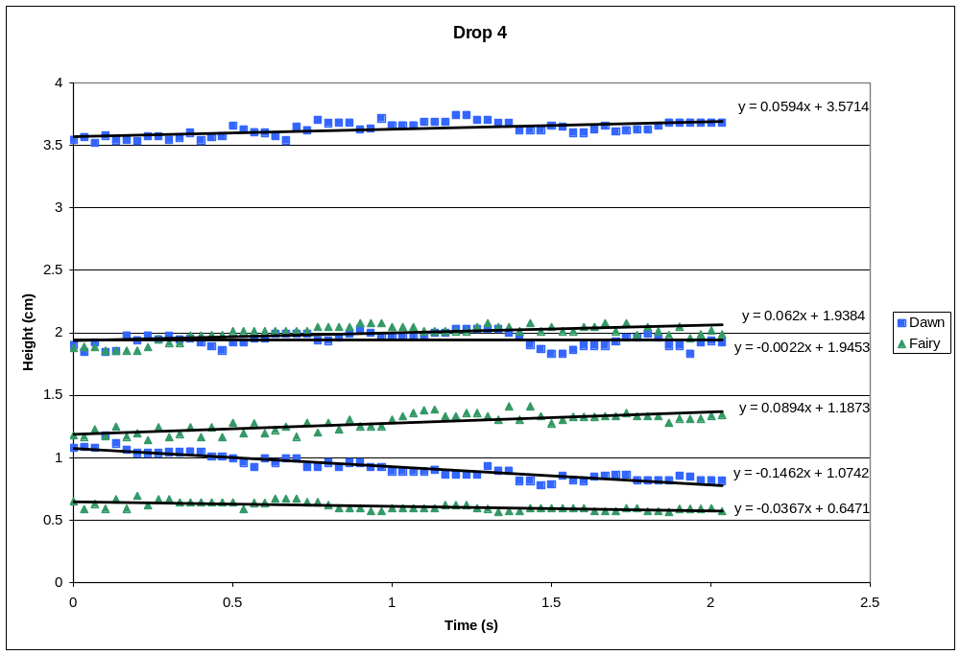
Drop 4 – Drainage time 120 s

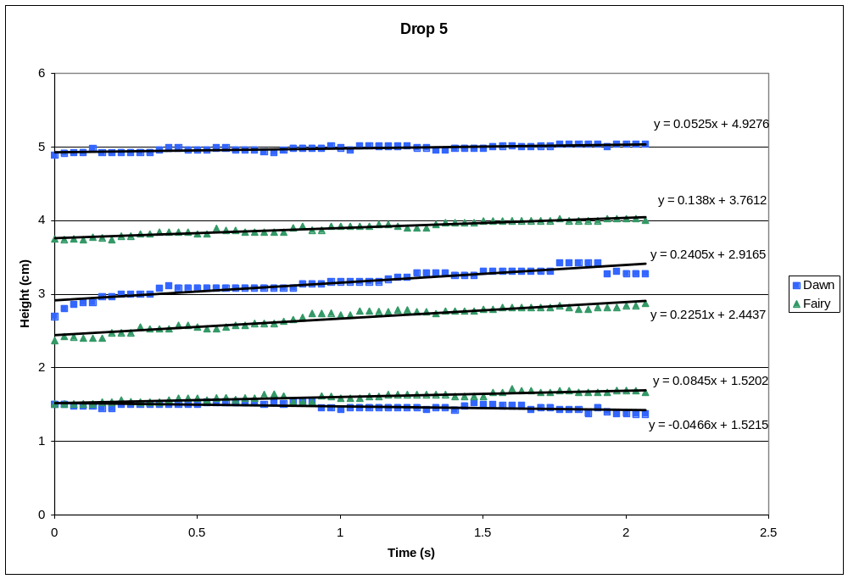

Drop 5 – Drainage time 180 s

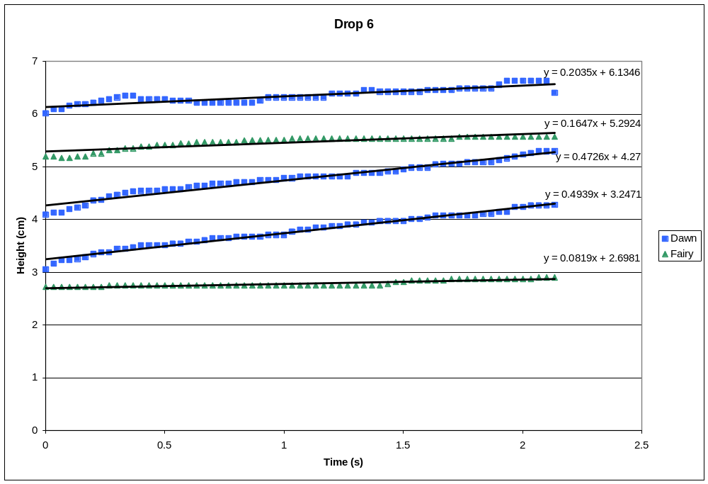
Drop 6 – Drainage time 300 s

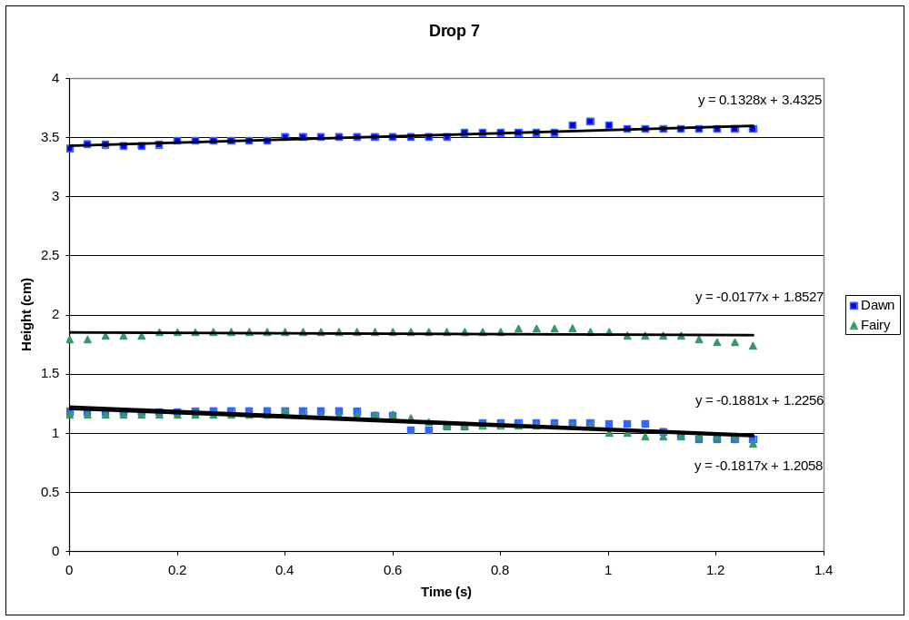
Drop 7 – Drainage time 420 s
Summary of Results

 | Drainage time | Dawn 1 | Fairy 1 | Dawn 2 | Fairy 2
Drop 1 | 30 | -0.1491 | 0.0369 | 0.3471 | 0.1905
Drop 3 | 60 | 0.3282 | -0.0823 | 0.331 | 0.0949
Drop 4 | 120 | 0.0594 | 0.062 | -0.0022 | 0.0894
Drop 5 | 180 | 0.0525 | 0.138 | 0.2405 | 0.2251
Drop 6 | 300 | 0.2035 | 0.1647 | 0.4726 | 0.0819
Drop 7 | 420 | 0.1328 | -0.0177 | -0.1881 | -0.1817
 | Average: | 0.10455 | 0.050267 | 0.20015 | 0.08335

Summary of line slopes for the first two magenta bands

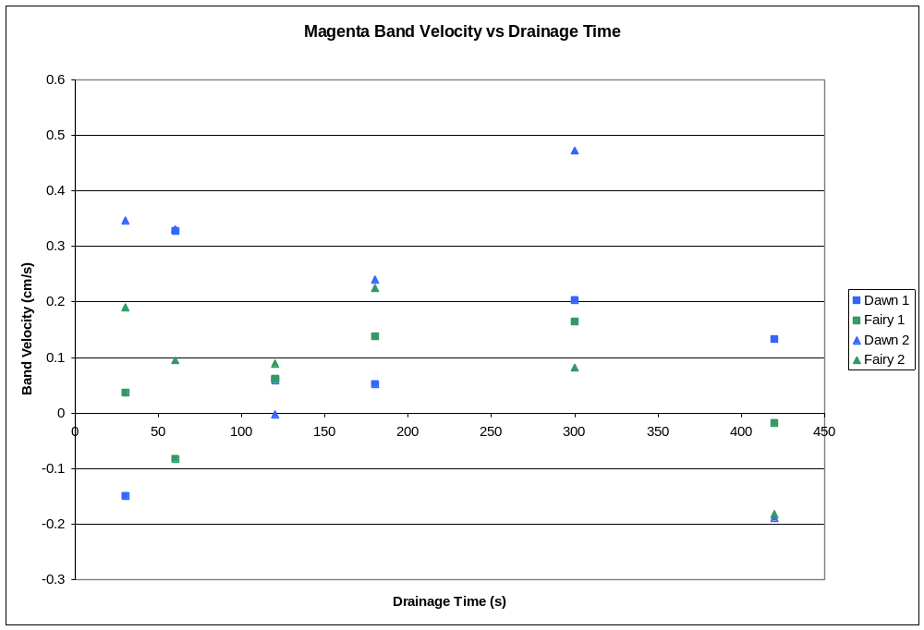
Summary graph of band velocity vs. drainage time

Most of the magenta band velocities were positive – which means the middle of the interference pattern moved up inside the frame making the film more uniform, but drops 1, 3 and 4 had one band where the center actually moved down. Drop 7, with a very long drainage time had 3 of the 4 band velocities negative.
On the average, the Dawn did move faster than the Fairy soap for both bands, but there were many instances where the Fairy moved faster.
As far as a trend for band velocities depending on the drainage time it is hard to see a real pattern in the data. There is no drop to drop increase in drainage time that does not yield both increases and decreases of band velocity due to increasing the drainage time.

Conclusion
Our first hypothesis was that the bands would move up, gradually eliminating the thickness gradient that gravity produced. In general this was true, of the 24 band velocities we recorded, 18 were positive. We were very surprised, however, to see that there were some negative band velocities. This would mean that the thickness gradient actually increased in the middle of the frame during zero gravity.
One possibility is that since we were looking at only the center, perhaps capillarity was drawing the fluid up on the sides, bringing the middle down.

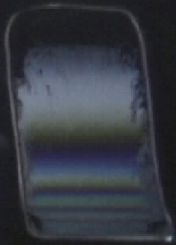 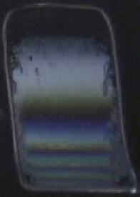 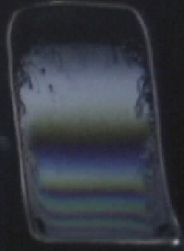 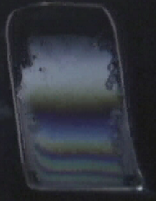
Time sequence of Fairy Soap with the second magenta line moving down on drop 7

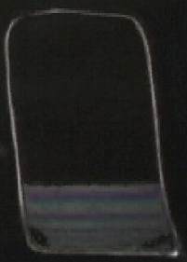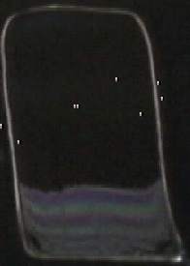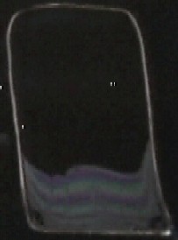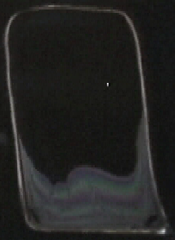
Time sequence of capillarity drawing the film up the sides for Fairy soap on drop 4

The second hypothesis was that Dawn would move faster than Fairy soap because the molecules would be freer to move on the surface and inside. In comparisons of band speed, 9 of the 12 speeds for Dawn are greater than Fairy, but in some of those cases, the Dawn had a negative velocity, but was moving faster downward than the Fairy moved up. So again, this was mostly true, but in general there was no conclusive trend here, and why, for particular instances Fairy was faster, we really don’t know.

Our final hypothesis, that longer drainage times would result in slower fluid motion within the film, was inconclusive. In fact there seemed to be evidence that this was at times exactly wrong. The fastest band movement was the second line of Dawn in the 6th drop we did, with a drainage time of 5 minutes. We thought we saw a trend when we went from 2 minutes to 3 minutes and the velocity of the bands increased, so perhaps future research could gather more data points in this region.
One possible explanation for an increase in band speed with greater drainage times, is that as the fluid drains, the film surface becomes curved in cross section and the strain against the surface tension acts like a spring. Springs move faster if they are distorted more and then released, so maybe the fluid surface acts like this.

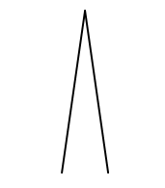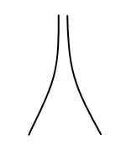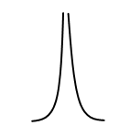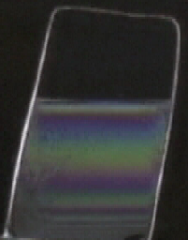

A B C D

Here is what we imagine is happening – A B and C are a proposed time sequence of the cross-sectional shape of the film, and that as time goes on, the film gradient becomes more and more non-uniform with most of the thickness change occurring near the bottom. In C, there is the most tension on the fluid surface, and it is gravity that is causing the extreme curved shape. Presumably, there is fluid on the wire frame that is hanging on droplets, or is otherwise available to rush back into the film in zero gravity. Picture D above is from Dawn in drop 5 (3 minutes drainage time) just before release. You can see the interference bands are not evenly distributed. There is very little thickness change near the top, and quite a bit near the bottom, so the cross section is very much as in C.

Here is a plot of the cross section of the film pictured in D made by assuming that the magenta lines correspond to 400 nm interference:

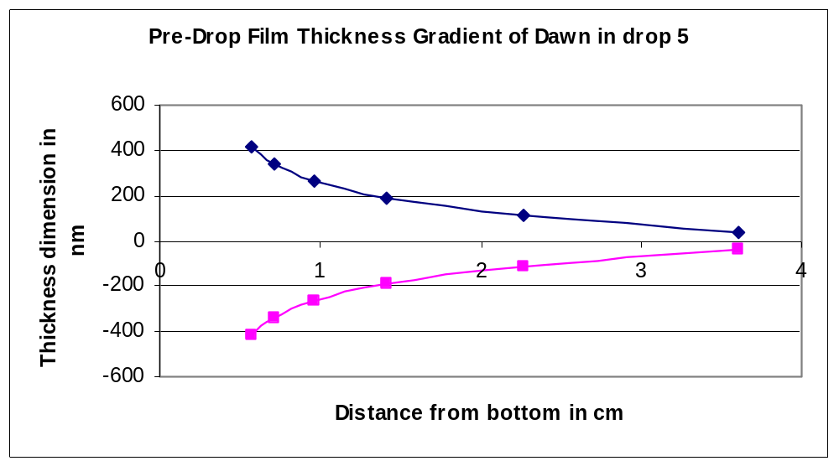
Cross section of the film pictured in D above

So it was a touch unexpected that longer drainage times sometimes resulted in greater band velocity, but we think we know why this was happening.
For future work, we would recommend more data points in the 1 to 4 minute range, where this spring release behavior was occurring, as well as perhaps different concentrations. Our solution had a lot of soap in it, so we wondered what a film would do if the fluid were not quite as viscous.
Finally, it would be nice to have more saturated color for the analysis – the camera on the ed rig was pretty color flat which made the video hard to analyze. The video frame skip problem was not discovered until we were back in Portland, so the moral of the story here is to go frame by frame through the drop video as soon as you have it, and make sure you have all the frames. We could have pulled the missing video off of tape had we caught it in Ohio.

Acknowledgements
We would like to thank Daniel Dietrich, for his sage advice in being our advisor, Richard De Lombard for helping bring back DIME, and also not dying while driving an antique bicycle down a steep hill, and Nancy Rabel Hall for heading up the whole project assisted by Arela Leidy from the Ohio Space Grant Consortium. Thank you to Jordan Howe of TAP Plastics in Tigard for fabricating our experiment and giving us a deal. We also thank Mark Weislogel of Portland State University for his advice, and Denis Weaire of Trinity College, Dublin for tolerating random questions from a high school teacher.

Bibliography
Isenberg, C. (1992). The Science of Soap Films and Soap Bubbles. Mineola NY: Dover Publishing Co.
Leonard, R. A. , and Lemlich, R. A I.Ch.E.J. 8, 3715 (1996)
Stein, H. N. and Laven, J. Journal of Colloid and Interface Science 244, 436-438 (2001)
Verbist, G., Weaire, D., and Kraynik, A. M., J. Phys. Condens. Matter 8, 3715 (1996)

