Tualatin DIME Team

Design Description

Soap Film Thickness Gradients in Microgravity

Josh Jordan
Alex Lockwood

Evan Pinckard

Anu Rajendran

Chris Murray – Advisor

February 25th, 2010

Science

The purpose of this investigation is to measure the rate of response of a soap-water film that has developed a thickness gradient to a step reduction in gravity that a drop tower provides. We intend to test two different soaps – Fairy soap which is the brand leader in the UK, and Dawn – a popular soap in the US, against different drainage times prior to the drop.
We hypothesize that the Fairy soap trials will respond in general slower than the Dawn because Fairy holds the surface molecules fixed, and also, that films that have drained a longer amount of time will also respond more slowly because they are thinner, and thin films respond more slowly because there is less room for the liquid to move around in.

Drawing and Materials
The apparatus consists of a two chambered rectangular box made of 3/8“solvent-welded polycarbonate plastic. The box will measure 10” wide, 6” (as seen from the front), and about 10” tall. The cells themselves will measure about 4 ¼ “ by 5 ¼ “ and have a 1/8 inch pinning edge about 2” from the bottom to prevent the soap water mixture from climbing up the wall during the drop. The bottom plate will extend a little to the front and back creating a flange that can be drilled to allow the passage of the bolts that mount it to the mounting plate. The box will be bolted as far back as it can, and since it is only 10” wide, this will still leave the corner holes clear for mounting to the educational rig. The lid will be held on with screws, and there will be a gasket between the lid and the cells to seal the liquid inside. Attached by Velcro to the top of the lid will be an LED backlight made of LEDs and translucent plastic, and powered by the 12 V from the Ed Rig, and there will be another LED affixed to the front of the cells that will use the drop indicator relay to turn on when the package is released. Inside the cells will be a soldered loop made of 14 gauge copper wire that exits through a reinforced hole in the cell wall. The hole will be drilled so that there is a very snug fit for the wire, and this will help hold the loop in position, and seal the hole for leaks, and the wall will be fully ¾” thick at this point. Somewhere in the Field of view will be a ruler for calibrating the video analysis.
The liquid in the cells will be a mixture of dish detergent (Fairy in one cell, and Dawn in the other) and water.

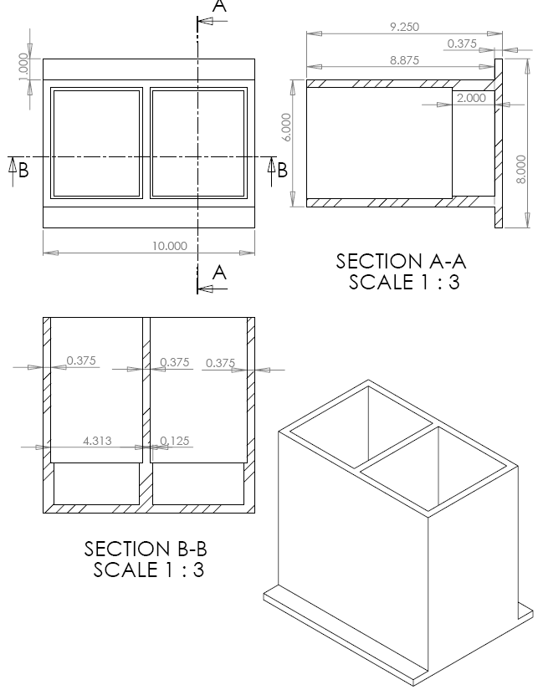

Here is a side view showing the loop and approximate fluid level expected in the cell for the experiment. You can also see the lid in place, and the backlight shining down on the experiment.

Hazardous Materials
Dish soap is fairly benign. I will get an MSDS for it anyway.

Fasteners
The plastic cells will have a drilled mounting flange that extends to the front and rear of the cells. We will use 8 bolts to attach the cells to the mounting plate. The bolts will be 7/8” long so that they penetrate the mounting flange and engage the aluminum mounting plate by at least 3/8”. We will use washers between the bolt and the mounting flange for two reasons – the clearance holes in the mounting flange will be slightly larger than the ¼” diameter of the bolt, and the washers will spread out the force of the bolt.
The lid will be held on using 11 small diameter screws around the perimeter and center that penetrate, but do not interrupt the gasket that seals the liquids inside the cells. These lid sealing screws will be tapped into holes in the walls, and will engage these threads by ½”. (This has worked well in the past – polycarbonate plastic can be threaded and screwed into without cracking – it is the plastic used in bullet proof windows) We will attach the Zero g light between the cells using a wee screw eye.

Fluids
The solvent welded cells will be water proof – so the only way for liquid to escape the experiment is through at the lid, and we will seal that with a gasket made of 1/8 “ closed cell foam, and through the holes in each cell where the wire loops exit. These latter holes will be so tightly fitting, and above the normal fluid level in the cell that they will not leak. We can seal them with stiff vacuum silicon grease if they leak in our tests. The fluid containment is the same as was used in the PSU Piggyback experiment in the C-9 Reduced Gravity Flight Program through the Johnson Space Center. The apparatus did not leak in that experiment, so we are confident it will be fine here.

Survival
The fluid cells will be constructed using plastic that could halt a high velocity round from a rifle without shattering. We are confident that the polycarbonate box design will survive, as we have used the same basic design for two previous DIME experiments without incident. We are going to construct our own backlight using LEDs epoxied to translucent plastic, and soldered to a grid because we suspect that commercially available ones are not designed with high impact in mind.

Mass
The mass we calculate is not close to the limit of 11.3 kg. We have 145 cubic inches of polycarbonate which should have a mass of 2.9 kg, and 93 cubic inches of water with a mass of about 1.5 kg. Adding the 3.1 kg Aluminum mounting plate and fasteners, we are at a total of about 7.6 kg. I don’t think the LEDs and wires will add much mass.

 | Material | Density (kg/m3) | Volume (m3) | Mass (kg)
Plastic | Polycarbonate | 1200 | 2.377E-03 | 2.853 | kg
water | water | 1000 | 1.527E-03 | 1.527 | kg
 |  |  | Total | 4.380 | kg
Fasteners: |  | qty | mass (kg) | mass (kg)
Bolts .25", 5/8" | steel | 8 | 1.000E-02 | 0.080 | kg
Lid Screws | steel | 16 | 5.000E-03 | 0.080 | kg
Mounting Plate | Aluminum |  |  | 3.084 | kg
Our Mass | 7.6 | kg | 16.8 | lbs
Limit of Mass | 11.3 | kg | 25.0 | lbs

 | width" | depth" | height" | Volume (in3) | Volume in cubic meters
Cells | 10 | 6 | 9.5
Bottom | 10 | 8 | 0.375 | 30.000
Lid | 10 | 6 | 0.375 | 22.500
Sides (3) | 0.375 | 5.25 | 8.75 | 17.227
Front/Back | 10 | 0.375 | 8.75 | 32.813
 | Total Plastic volume in cubic inches |  |  | 145.078 | 2.377E-03 | m3
Liquid | 8.875 | 5.25 | 2 | 93.188 | 1.527E-03 | m3

Procedure
Here is the basic procedure that we imagine we will use:
In the workshop area:
- Attach the experiment to the educational rig.
- Connect the Educational rig to the auxiliary power to charge the onboard batteries
- Connect the connectors to the 12 V power J2.
- Connect the release light to the Release Indicator J4 (we will use J4-1 and J4-2 so the light turns on when released
- Confirm operation of the backlight and release light
- Fill the cells to 1 “ with the proper solution. (Fairy soap solution in one, and Dawn solution in the other)
- Test the loops and get a film on each loop.
- Clean liquid off the front surface of the chamber with a squeegee if needed.
- Place but do not screw the lid and backlight on, and turn on the backlight.
- Adjust the focus, zoom and aperture of the camera so that it gets both films, the ruler, and the zero g light.
- Confirm that the loop moves into the correct position.
- Attach the lid and gasket with screws and check that the gasket is in place.
We will then cart the rig carefully to the crane, being careful not to splash the liquid around too much. They will lift it up to the top.
At the top of the drop tower
- Confirm that the video recording works and is recording
- Put a film onto each loop, and close the drag shield doors
- Confirm the light exposure level at this point and adjust if necessary.
- Confirm the proper operation of the release light.
- Put a new film on the loops.
- Close the drag shield doors again.
- Release the safety cable
- Wait the time prescribed in the experiment (this will vary drop to drop)
- Drop the package
- Recover
- Get the video and store it.
To analyze the video, we will pick the transition between red and violet. Every set of rainbow colors indicates a remainder of that wavelength of light. (i.e. the path length of the light in the film divided the index of refraction is an integer number of wavelengths) So every set of rainbows represents increasing this path length by a full wavelength of violet light – for example – about 400 nm. If we let the film sit long enough in the same conditions while filming it, we will eventually see a portion at the top that has no rainbow colors. This portion has a path length for the light smaller than the wavelength of visible light. We can then correlate the time that the film has drained to the number of wavelengths if we watch and count the rainbows as they pass a certain point. That way we will know that at 2:30 the film has a path length of say 78 wavelengths. Since the light will be coming in with an incident angle of 45º, we will have to solve a bit of a geometry and trigonometry problem to correlate path length and index of refraction to actual film thickness, but that is what Excel is for.

Electrical Diagram
We will use power from the 12 V connection at J2-A to J2-B to power our “Backlight”. (The backlight is on top, so it is really a toplight – but Bill Gates does not think toplight is a word.) Our release indicator light will be powered by the same voltage source, but will in addition use the connectors J4-1 to J4-2 of the Release Indicator Relay so that it turns on when the package is dropped to aid in our video analysis.
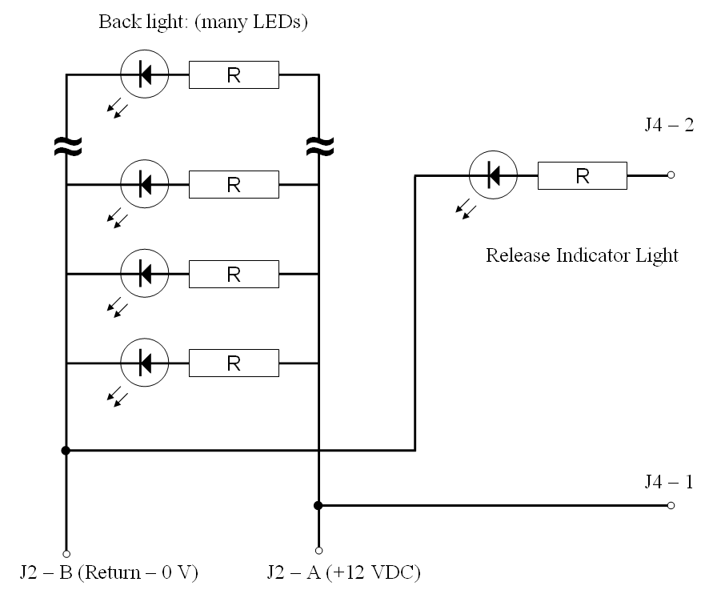

So I guess we will get the connectors when we arrive at NASA GRC, and attach them there. We plan to solder all connections so that this is as shock resistant as possible

Time Delay
We will not use the time delay feature. There is a small, but non-zero chance that we may use a solenoid or motor and the Power Switch Relay so that we can operate the loops to make a film when the doors of the drag shield are closed, and the safety cable has been disengaged. (i.e. right before the package is dropped) If we can figure out a robust way to do this we will, but right now it sounds like the thing that won’t work right at the very end. The solar array that won’t unfurl. The engine that fails to fire…

Data Logger
We will not use the electronic data logger. We will be using the built in camera that comes with the educational rig.

Additional Information
Chris Murray was born in the year of the Tiger, and it is again the year of the Tiger.

