Noteguide for Beats (Videos 12I) Name
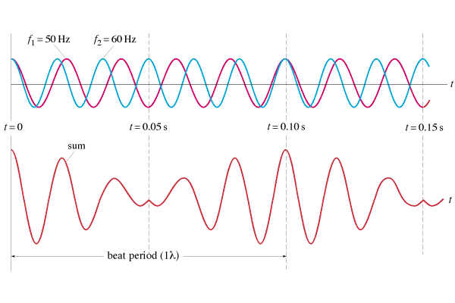

f_{beat} = |f₁ - f₂|

Examples:
1. I play a pitch of 256 Hz (C) on my Pennywhistle, and you play a pitch of 384 Hz (G) on your whistle. What is the beat frequency?

2. If I am playing a pitch of 384 Hz, and I hear a beat frequency of 10.0 Hz, what are the possible other frequencies that are playing?

Whiteboards:
1. What beats do you hear if you play an e 640 Hz with a c 1024 Hz?  (384 Hz, G in octave below the E ) | 2. If you are playing an A 440 Hz, and you hear a beat frequency of 20 Hz, what are the other possible frequencies that could be playing?  (460 Hz or 420 Hz )
3. The concertmaster is playing an A 440.0 Hz. Another violin hears a beat every 0.20 seconds. What frequency are they playing?
(445.0 Hz or 435.0 Hz )

