Noteguide for Superposition and Interference (Videos 12E) Name
Superposition: (Overlapping waves add)
Examples:

Interference:
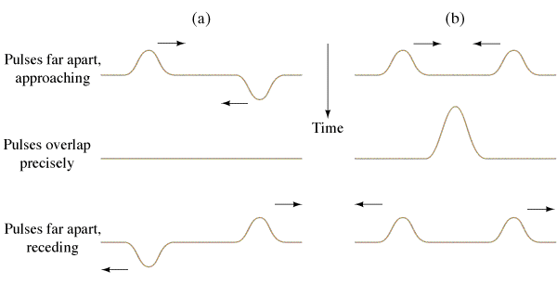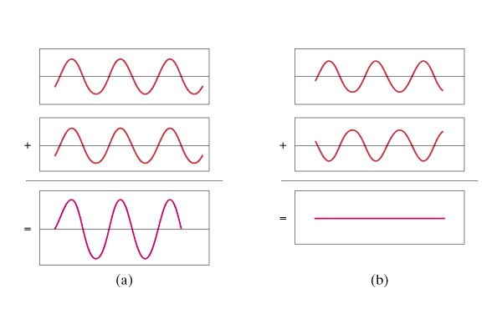

Wavelength rule for constructive interference: | Wavelength rule for destructive interference:

Other Examples:

