Orbit and Gravity Questions from SA7.3
Use the value of G = 6.67x10⁻¹¹ Nm²/kg²
38,600 N  44.5 kg  2.53x10²⁴ kg  2.43x10⁶ s | 1. a. What is the force of gravity between a 6.50x10¹⁶ kg asteroid and a 18,700 kg spaceship if their centers are 1,450 m distant?  b. The centers of two lead spheres are separated by 6.70 m. If one sphere has a mass of 56.0 kg, and there is an attractive force of 3.70x10⁻⁹ N, what is the mass of the other sphere?  c. You are orbiting the planet Qwrmczl at a radius of 1.45x10⁷ m, at a velocity of 3410 m/s. What is its mass?  d. What is the period of an orbit that is 3.90x10⁸ m from earth's center? (m = 5.97x10²⁴ kg)
7.68 N  175 m  5.31x10²³ kg  5.38x10¹¹ m | 2. a. What is the force of gravity between a 2.60x10¹³ kg asteroid and a 56,100 kg spaceship if their centers are 3,560 m distant?  b. What distance separates the centers of two lead spheres if one has a mass of 123 kg, the other a mass of 12.0 kg and there is an attractive force of 3.20x10⁻¹² N?  c. You are orbiting the planet Wnnydrydrl at a radius of 7.80x10⁶ m, and a period of 2.30x10⁴ seconds. What is the planet’s mass?  d. What is the radius of an orbit around earth (m = 5.97x10²⁴ kg) that has an orbital velocity of 27.2 m/s?
3,980 N  2.84 kg  2.51x10⁸ m  4.89x10⁵ s | 3. a. What is the force of gravity between a 2.10x10¹⁵ kg asteroid and a 23,800 kg spaceship if their centers are 915 m distant?  b. The centers of two lead spheres are separated by 1.35 m. If one sphere has a mass of 125 kg, and there is an attractive force of 1.30x10⁻⁸ N, what is the mass of the other sphere?  c. What is the radius of the orbit that has an orbital velocity of 1260 m/s around the earth? (m = 5.97x10²⁴ kg)  d. What is the period of an orbit with a radius of 3.10x10⁷ m around the moon? (Moon’s mass is 7.36x10²² kg)
72.4 N  1.67 m  2.92x10⁵ s  7.54x10²⁵ kg | 4. a. What is the force of gravity between a 2.30x10¹⁴ kg asteroid and a 12,700 kg spaceship if their centers are 1,640 m distant?  b. What distance separates the centers of two lead spheres if one has a mass of 215 kg, the other a mass of 125 kg and there is an attractive force of 6.40x10⁻⁷ N?  c. What is the period of the orbit that has a radius of 9.50x10⁷ m around the earth? (m = 5.97x10²⁴ kg)  d. You orbit the planet Kssnndnnwrr at a radius of 8.20x10⁷ m with a velocity of 7830 m/s. What is its mass?
40.0 N  9.60 kg  986 m/s  2.15x10²³ kg | 5. a. What is the force of gravity between a 23.6x10¹² kg asteroid and a 14,600 kg spaceship if their centers are 758 m distant?  b. The centers of two lead spheres are separated by 4.90 m. If one sphere has a mass of 45.0 kg, and there is an attractive force of 1.20x10⁻⁹ N, what is the mass of the other sphere?  c. What is the velocity of the orbit that has a radius of 4.10x10⁸ m around the earth? (m = 5.97x10²⁴ kg)  d. You are in an orbit with a radius of 8.50x10⁷ m and a period of 1.30x10⁶ s around the planet Rjxnstdnnr. What is its mass?
e.
Questions: Answers:
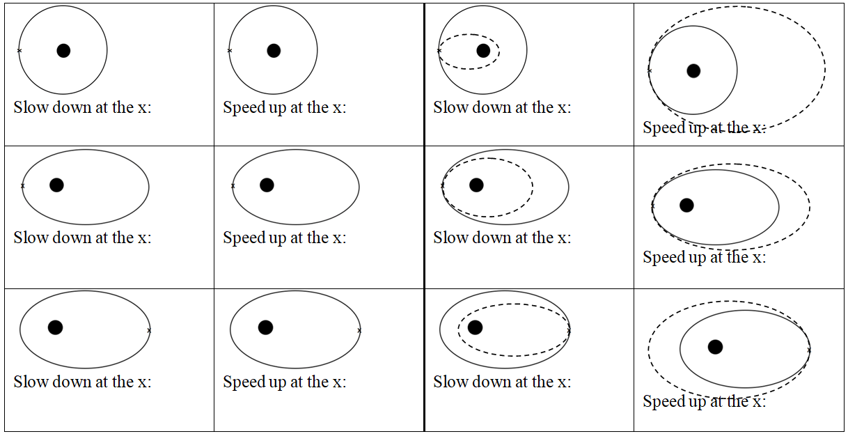
In general, speeding up brings the far side out, slowing down brings the far side in. Speeding up brings the entire trajectory outside the old one, and slowing down brings entire trajectory inside the old one.

