**7.2 Quizlette - Vertical Circle Name**

1. An airplane goes in a 232 m radius vertical circle (inside loop). What is the minimum velocity the plane can have for the pilot to stay in her seat without requiring a seatbelt?

(47.7 m/s)

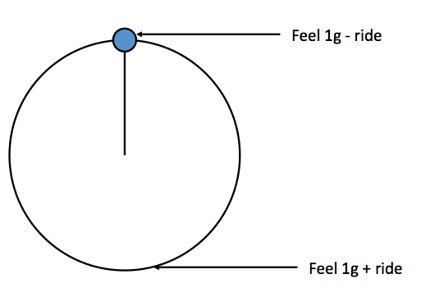 **"g" Forces in a vertical circle:**

**Top: Measure = 1-ride Bottom: Measure = 1+ ride**

2. A Ferris wheel is pulling 0.130 "g"s of centripetal acceleration. What "g"s do the riders feel and measure at the top and bottom of the ride? (top: 0.870 "g"s, bottom: 1.130 "g"s)

3. Riders on a Ferris wheel measure 0.880 "g"s at the top of the ride. What "g"s do the riders feel and measure at the bottom, and how many "g"s is the ride really pulling? What is the acceleration of the ride in m/s/s? (bottom: 1.120 "g"s, ride: 0.120 "g"s, 1.176 m/s/s)

4. Riders on the "Zero g" at Oaks park feel 0.820 inverted "g"s at the top (feel -0.820 "g"s). What "g" force does the ride pull? What "g"s do they feel at the bottom? What is the acceleration of the ride in m/s/s? ( ride: 1.820 "g"s, bottom: 2.820 "g"s, 17.8 m/s/s)

5. Riders on the "Hurl-O-Matic" register a "g" force of 2.780 "g"s at the bottom of the ride. What "g" force is the ride pulling, and what "g"s do they feel at the top? What is the acceleration of the ride in m/s/s?

(ride: 1.780 "g"s, top: -0.780 "g"s (inverted), 17.4 m/s/s)



1. Find ac

2. Convert to "g"s (divide m/s/s by 9.8 m/s/s)

3. Top: 1-ride, Bottom: 1+ride



6. A Ferris wheel has a radius of 8.10 m, and a tangential velocity of 4.30 m/s. What "g" force do they read at the top and bottom of the ride? (top: 0.767 "g"s, bottom: 1.233 "g"s)

7. A vertical circle ride has a radius of 9.20 m, and a period of 10.5 s. What "g" force to the riders feel and measure at the top and at the bottom of the ride? (top: 0.664 "g"s, bottom: 1.336 "g"s)

8. A vertical circle ride has a radius of 4.70 m, and a velocity of 9.50 m/s. What "g" force to the riders feel and measure at the top and at the bottom of the ride? (top: -0.959 "g"s inverted, bottom: 2.959 "g"s)

9. A vertical circle ride has a radius of 5.20 m, and a period of 4.20 s. What "g" force to the riders feel and measure at the top and at the bottom of the ride? (top: -0.188 "g"s inverted, bottom: 2.188 "g"s)

1. Find the "g"s of the ride: Top: 1-ride, Bottom: 1+ride

2. Convert to m/s/s (multiply "g"s by 9.8 m/s/s)

3. Use formulas to find v or T





10. Riders at the bottom of a Ferris wheel measure a "g" force of 1.305 "g"s. What is the tangential velocity of the ride if the radius is 8.10 m? (4.92 m/s)

11. Riders at the top of a Ferris wheel measure a "g" force of 0.860 "g"s. What is the period of the ride if the radius is 8.30 m? (15.45 s)

12. A 3.10 m radius vertical circle ride makes riders feel 2.600 "g"s at the bottom of the ride. What is the tangential velocity of the ride? (6.97 m/s)

13. A vertical circle ride has a radius of 5.40 m and generates an inverted "g" force of -0.310 "g"s at the top. What is the period of the ride? (4.08 s)