P7.3 - Orbit  Orbit: | Or , G = 6.67x10⁻¹¹ Nm²/kg²
331.4 m/s | 1. What is the orbital velocity 3400. m from the center of a 5.60 x 10¹⁸ kg asteroid?
4.85x10¹⁹ kg | 2. You find that you can orbit at 516 m/s 12,150 m from the center of a small moon. What is its mass?
3.4 x 10⁸ m | 3. What distance from the center of the moon is your orbital velocity 120 m/s?
3.2 x 10²⁴ kg | 4. A satellite orbits a planet at a distance of 7.5 x 10⁶ m from the center every 8900 seconds. What is the mass of the planet?
7727 s | 5. What is the period of orbit of a satellite that orbits 1.950 x 10⁶ m from the center of the moon?
1.50 x 10¹¹ m | 6. What is the radius of an orbit with a period of 3.16 x 10⁷ s around the sun?
1470 m/s  9620 s | 7. What velocity do you need to orbit 5.20 x 105 m from the surface of the moon? What would be your period of orbit?
537 m/s  1.01x10²³ kg | 8. Fred the alien orbits the planet Zirkon, completing an orbit with a radius of 23.4 x 10⁶ m every 3.17 earth days. What is his velocity, and what is the mass of the planet he is orbiting?
4.22 x 107 m  6.61 Re | 9. What is the radius of a geosynchronous orbit? (Around earth, T = 23 hrs, 56 min, 4 sec - but convert it to seconds) How many earth radii is this?
365 days  (31556425.51 s) | 10. What is the period of an orbit 149.6x10⁹ m from the center of the sun (in earth days)?
9.58x10⁶ m | 11. At what distance from the surface of the earth is the orbital velocity 5000. m/s?

Useful things to know:

Mass of the Earth | 5.97x10²⁴ kg | Radius of the Moon | 1.738x10⁶ m
Mass of the Moon | 7.35x10²² kg | Radius of the Earth | 6.38x10⁶ m
Mass of the Sun | 1.99x10³⁰ kg | Earth-Moon Distance | 3.84x10⁸ m
 |  | Earth-Sun Distance | 1.496x10¹¹ m
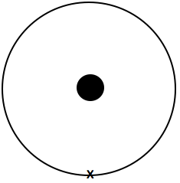  Slow down at the x: | Speed up at the x: | Slow down at the x: | Speed up at the x:
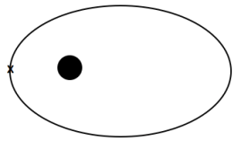  Slow down at the x: | Speed up at the x: | Slow down at the x: | Speed up at the x:
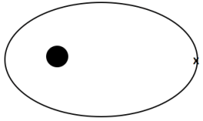  Slow down at the x: | Speed up at the x: | Slow down at the x: | Speed up at the x:
In general, speeding up brings the far side out, slowing down brings the far side in. Speeding up brings the entire trajectory outside the old one, and slowing down brings entire trajectory inside the old one.

