**Noteguide for Centripetal Acceleration and Force:**

Directions - go to the chapter 7 site, and using this noteguide, follow the examples, and try to complete the whiteboards. Show your work here. If you get stuck on a whiteboard problem, you can hit play, and watch me solve it. Try not to just sit there and copy what I write, rather play only enough to see where I am going with the calculation, and solve the rest by yourself.

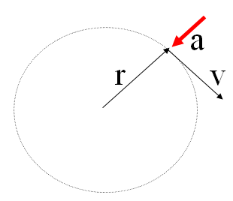

Velocity = Speed + Direction

|  |  |
| --- | --- |
| a = Centripetal acceleration (m/s/s)  v = tangential velocity (m/s)  r = radius of circle (m) | a = Centripetal acceleration (m/s/s)  T = Period (s)  r = radius of circle (m) |
| a = Centripetal Force (N)  m = mass (kg)  v = tangential velocity (m/s)  r = radius of circle (m) | F = Centripetal Force (N)  m = mass (kg)  T = Period (s)  r = radius of circle (m) |

**Example** - What is the centripetal acceleration of a 1200 kg car going 24 m/s around an 80. m radius corner?

What centripetal force is needed?

What is the minimum coefficient of friction needed?

**Whiteboards:**

1. What is the centripetal acceleration if a tuna is going 6.2 m/s around a 2.3 m radius corner? (17 m/s/s)

2. A Volkswagen can do 0.650 “g”s of lateral acceleration. What is the minimum radius turn at 27.0 m/s? (114 m)

3. A carnival ride pulls an acceleration of 12 m/s/s. What speed in a 5.2 m radius circle? (7.9 m/s)

**Centripetal acceleration with Period (T):**

**Derivation:**

**Example** - A merry-go-round completes a revolution every 7.15 seconds. What is your centripetal acceleration if you are 3.52 m from the center of rotation?

**Whiteboard**: What should be the period of motion if you want 3.5 “g”s of centripetal acceleration 5.25 m from the center of rotation? (2.5 s)

**Dealing with RPMs:**

What is the acceleration of a point 32 cm out on a grinding wheel spinning at 1200 RPM?

**Centripetal Force:**

**F = ma**

**Example**: What force is required to swing a 5.0 kg object at 6.0 m/s in a 75 cm radius circle?

**Whiteboards:**

1. Ice skates can give 420 N of turning force. What is rmin for a 50. kg skater @10.m/s? (11.9 m)

2. A ride makes a 60 kg small redheaded child go in a 4.1 m radius circle with a force of 470 N. What period? (4.5 s)

3. It takes 35 N of force to make a glob of Jello go in a 2.0 m radius circle with a period of 1.85 seconds What’s the mass? What’s its flavor? (1.5 kg)