Physics
GQ 7.3 – Orbit and Gravity
Name
Show your work, circle your answers, and label them with units.
1. What is the force of gravity between a 3.4 kg sphere, and a 8.1 kg sphere if their centers are separated by 4.7 m?

2. What distance from the center of the earth (m = 5.97x10²⁴ kg) is the force of gravity on a 5.00 kg mass
equal to 10.0 N?

3. Your spaceship is orbiting 2.26x10⁷ m from the center of a planet with a velocity of 100. m/s. What is the mass of the planet?

4. At what distance from the center of our 7.35x10²² kg moon is the orbital period equal to 86,164 seconds?

5. Draw the new orbit: (Circle or oval indicates your current orbit)
Speed up at x: Slow down at x: Slow down at x:
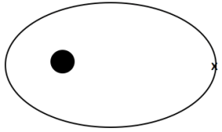
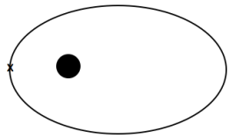
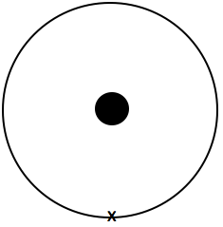
(elliptical, inside, tangent at x) (more elliptical, outside orbit, tangent at x) (less elliptical, outside orbit, tangent at x)

