Name:______________________________________________ Date:_____________ Period:________

**Plate Lab**

**Goal:** to analyze the forces needed for circular motion and   
understand what happens when those forces are removed.

On the table, without the plate, the marble would go in a straight line if pushed.

A marble on a plate can be made to go in a circle. Push a marble along the edge of a whole (uncut) plate and think about and answer the questions below. For this activity, the drawings and images will be from the viewpoint directly above the plate looking down.

After your push, what is the force causing this circular motion?

In the diagram below, imagine the ball is going anti-clockwise. Draw an arrow representing the instantaneous velocity at this point. Label it "V". Draw another arrow showing the direction of the force acting on the marble to make it go in a circle. Label it "F". Also label which way you think the acceleration is with an arrow labeled "a"

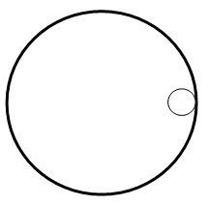  
A second plate has a section cut out of it. If you give the marble a push near the top so that it travels along the plate counter-clockwise, predict what path you think the marble take when it exits the plate. Draw the predicted path on the picture below. Write a short sentence why you think this will happen.

Predicted: Actual:

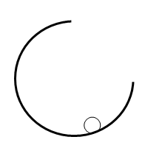 

Test out your guess with the plate and marble. Do the experiment several times to make sure you know what actually happens. Draw the path it actually takes.

**7.1 Quizlette - Centripetal Force and Acceleration Name**

 Velocity - radius equation

1. What is the centripetal acceleration of a skier going 23.0 m/s around a corner with a radius of 56.0 m? (9.45 m/s/s)

2. A car going around a corner with a radius of 340. m is accelerating laterally at 6.40 m/s/s. What is its speed? (46.6 m/s)

3. A car goes 23.0 m/s around a corner with a lateral acceleration of 4.50 m/s/s. What is the radius of the corner? (118 m)

 Period - radius equation

4. A centrifuge has a radius of 0.0870 m, and a period of 0.0230 s. What is its centripetal acceleration? (6493 m/s/s)

5. A centrifuge generates a centripetal acceleration of 3760 m/s/s with a period of 0.0310 s. What is the radius of the centrifuge? (0.0915 m)

6. A centrifuge generates an acceleration of 9250 m/s/s with a radius of 0.0680 m. What is its period of motion? (0.0170 s)

, so  and  Centripetal force

7. What centripetal force do you need to make a 78.0 kg skier go 39.0 m/s around a 98.0 m radius corner? (1211 N)

8. What is the maximum velocity you can twirl a 3.90 kg hammer in a 1.80 m radius circle if the string it is attached to has a tensile strength of 190. N? (9.36 m/s)

9. A centrifuge makes 0.0140 kg test tubes go in a 0.0860 m radius circle with a period of 0.0455 s. What force does it exert on the test tubes? (23.0 N)

10. A centrifuge exerts 213 N on a 0.0120 kg test tube spinning in a 0.0750 m radius circle. What is its period of motion?

(0.0129 s)

**Friction provides centripetal force:**

 

11. A 1450 kg car with a coefficient of friction of 0.870 goes around a level corner at 27.0 m/s. What is the minimum radius the corner can have? (85.5 m)

12. There is a coefficient of friction of 0.930 between a 1230 kg car and the level road. What is its maximum possible

velocity around a 330. m radius corner? (54.8 m/s)

13. A 0.120 kg mass is on a level turntable. If there is a coefficient of friction of 0.340 between the turntable and the mass, and the turntable has a period of 1.33 s, what is the maximum distance the mass can be from the center and not fly off?

(0.149 m)

14. A 0.0110 kg eraser is on a level turntable 0.180 m from the center. If there is a coefficient of friction of 0.880 between the turntable and the eraser, what is the minimum period of motion the turntable can have for the eraser to remain without flying off?

(0.908 s)

**Physics**

**FA7.1 - Circular Motion**

Name

Favorite TV Show

When you have finished this, go to the website and check your answers. If you got a problem wrong, cross it off on the front, and do it correctly on the back.

**Show your work, and circle your answers and use sig figs to receive full credit.**

1. With what maximum velocity can a car go around a 312 m radius curve if it cannot exceed 3.136 m/s/s of lateral acceleration?

2. A Centrifuge has a radius of 5.75 cm, and spins with a period of 0.0171s. What is the centripetal acceleration?

3. What centripetal force would make a 120. kg bike and rider go 17.0 m/s around a 178 m radius corner?

4. A spinning carnival ride has a radius of 4.20 m. What is the period of the ride if it is exerting a centripetal force of 895 N on a 64.0 kg person?

5. What is the minimum coefficient of friction needed for a 1205 kg car to go 27.0 m/s around a level corner with a radius of 280. m? What about a 3450 kg SUV?

Practice 7.1 (Optional)

|  |
| --- |
| 1. a. What velocity must a car go around a 250. m radius corner to have a centripetal acceleration of 3.30 m/s/s? (28.7 m/s)  b. A centrifuge generates a centripetal acceleration of 3450 m/s/s with a period of 0.0258 s. What is the radius of the centrifuge? (0.0582 m)  c. What centripetal force do you need to make a 85.0 kg skier go 25.0 m/s around a 15.0 m radius corner? (3542 N)  d. A centrifuge exerts a force of 182 N on a 0.130 kg test tube spinning with a period of 0.0312 s. What is the radius of the centrifuge? (0.0345 m)  e. A 1120 kg car with a coefficient of friction of 0.730 goes around a level corner at 25.0 m/s. What is the minimum radius the corner can have? (87.4 m) |
| 2. a. What is the centripetal acceleration of a skater going 6.40 m/s around a corner with a radius of 2.00 m? (20.48 m/s/s)  b. A centrifuge generates an acceleration of 9520 m/s/s with a radius of 0.0780 m. What is its period of motion? (0.0180 s)  c. A centrifuge has a radius of 0.0350 m, and a period of 0.0256 s. What force does it exert on a 0.0670 kg test tube? (141 N)  d. A 81.0 kg ice skater goes around a corner at 16.0 m/s. If the ice skates can generate a maximum lateral force of 480. N, what is the minimum radius of corner they can go around? (43.2 m)  e. A 0.0180 kg eraser is on a level turntable 0.170 m from the center. If there is a coefficient of friction of 0.850 between the turntable and the eraser, what is the minimum period of motion the turntable can have for the eraser to remain without flying off? (0.898 s) |
| 3. a. A car goes 23.0 m/s around a corner with a lateral acceleration of 4.50 m/s/s. What is the radius of the corner? (118 m)  b. A centrifuge has a radius of 0.0920 m, and a period of 0.0450 s. What is its centripetal acceleration? (1794 m/s/s)  c. What force do you need to twirl a 4.30 kg hammer in a 1.28 m radius circle at 7.20 m/s? (174 N)  d. A centrifuge exerts 298 N on a 0.0370 kg test tube spinning in a 0.0650 m radius circle. What is its period of motion?  (0.0178 s)  e. There is a coefficient of friction of 0.870 between a 1670 kg car and the level road. What is its maximum possible velocity around a 130. m radius corner? (33.3 m/s) |
| 4. a. A car going around a corner with a radius of 180. m is accelerating laterally at 3.40 m/s/s. What is its speed? (24.7 m/s)  b. A centrifuge generates an acceleration of 6590 m/s/s spinning test tubes in a circle with a period of 0.0370 s. What is the radius of the centrifuge? (0.229 m)  c. A centrifuge makes 0.0790 kg test tubes go in a 0.0750 m radius circle with a period of 0.0545 s. What force does it exert on the test tubes? (78.8 N)  d. What is the maximum velocity you can twirl a 3.76 kg hammer in a 1.40 m radius circle if the string it is attached to has a tensile strength of 158 N? (i.e. that is the centripetal force) (7.67 m/s)  e. A 0.100 kg mass is on a level turntable 0.120 m from the center. If there is a coefficient of friction of 0.210 between the turntable and the mass, what is the minimum period of motion the turntable can have for the mass to remain without flying off? (1.52 s) |
| 5. a. What is the centripetal acceleration of a skier going 13.0 m/s around a corner with a radius of 26.0 m? (6.5 m/s/s)  b. A centrifuge generates an acceleration of 2560 m/s/s with a radius of 0.0870 m. What is its period of motion? (0.0366 s)  c. What force do you need to twirl a 7.40 kg hammer in a 1.50 m radius circle at 12.0 m/s?? (710.4 N)  d. A 0.0650 m radius centrifuge exerts a force of 190. N on a test tube. What is the mass of the test tube if its period of motion is 0.0380 s? (0.107 kg)  e. There is a coefficient of friction of 0.740 between a 1780 kg car and the level road. What is its maximum possible velocity around a 180. m radius corner? (36.1 m/s) |

**7.2 Quizlette - Vertical Circle Name**

1. An airplane goes in a 232 m radius vertical circle (inside loop). What is the minimum velocity the plane can have for the pilot to stay in her seat without requiring a seatbelt?

(47.7 m/s)

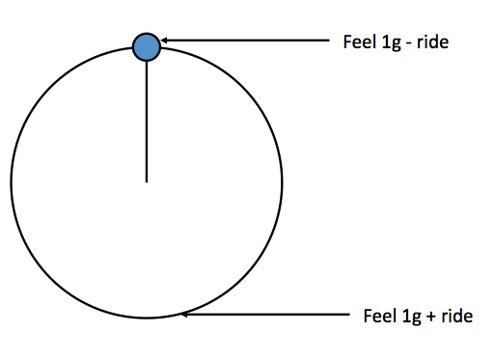 **"g" Forces in a vertical circle:**

**Top: Measure = 1-ride Bottom: Measure = 1+ ride**

2. A Ferris wheel is pulling 0.130 "g"s of centripetal acceleration. What "g"s do the riders feel and measure at the top and bottom of the ride? (top: 0.870 "g"s, bottom: 1.130 "g"s)

3. Riders on a Ferris wheel measure 0.880 "g"s at the top of the ride. What "g"s do the riders feel and measure at the bottom, and how many "g"s is the ride really pulling? What is the acceleration of the ride in m/s/s? (bottom: 1.120 "g"s, ride: 0.120 "g"s, 1.176 m/s/s)

4. Riders on the "Zero g" at Oaks park feel 0.820 inverted "g"s at the top (feel -0.820 "g"s). What "g" force does the ride pull? What "g"s do they feel at the bottom? What is the acceleration of the ride in m/s/s? ( ride: 1.820 "g"s, bottom: 2.820 "g"s, 17.8 m/s/s)

5. Riders on the "Hurl-O-Matic" register a "g" force of 2.780 "g"s at the bottom of the ride. What "g" force is the ride pulling, and what "g"s do they feel at the top? What is the acceleration of the ride in m/s/s?

(ride: 1.780 "g"s, top: -0.780 "g"s (inverted), 17.4 m/s/s)



1. Find ac

2. Convert to "g"s (divide m/s/s by 9.8 m/s/s)

3. Top: 1-ride, Bottom: 1+ride



6. A Ferris wheel has a radius of 8.10 m, and a tangential velocity of 4.30 m/s. What "g" force do they read at the top and bottom of the ride? (top: 0.767 "g"s, bottom: 1.233 "g"s)

7. A vertical circle ride has a radius of 9.20 m, and a period of 10.5 s. What "g" force to the riders feel and measure at the top and at the bottom of the ride? (top: 0.664 "g"s, bottom: 1.336 "g"s)

8. A vertical circle ride has a radius of 4.70 m, and a velocity of 9.50 m/s. What "g" force to the riders feel and measure at the top and at the bottom of the ride? (top: -0.959 "g"s inverted, bottom: 2.959 "g"s)

9. A vertical circle ride has a radius of 5.20 m, and a period of 4.20 s. What "g" force to the riders feel and measure at the top and at the bottom of the ride? (top: -0.188 "g"s inverted, bottom: 2.188 "g"s)

1. Find the "g"s of the ride: Top: 1-ride, Bottom: 1+ride

2. Convert to m/s/s (multiply "g"s by 9.8 m/s/s)

3. Use formulas to find v or T





10. Riders at the bottom of a Ferris wheel measure a "g" force of 1.305 "g"s. What is the tangential velocity of the ride if the radius is 8.10 m? (4.92 m/s)

11. Riders at the top of a Ferris wheel measure a "g" force of 0.860 "g"s. What is the period of the ride if the radius is 8.30 m? (15.45 s)

12. A 3.10 m radius vertical circle ride makes riders feel 2.600 "g"s at the bottom of the ride. What is the tangential velocity of the ride? (6.97 m/s)

14. A vertical circle ride has a radius of 5.40 m and generates an inverted "g" force of -0.310 "g"s at the top. What is the period of the ride? (4.08 s)

**Physics**

**FA7.2 - Vertical Circle**

Name

Favorite Movie

When you have finished this, go to the website and check your answers. If you got a problem wrong, cross it off on the front, and do it correctly on the back.

**Show your work, and circle your answers and use sig figs to receive full credit.**

1. A clever Physics teacher swings a bucket in a 1.12 m radius vertical circle at a constant speed. What is the maximum period the motion can have for the water to stay in the bucket?

2. The Zero-G at Oaks Park pulls 1.80 "g"s of centripetal acceleration in a vertical circle. What "g" force do the riders feel at the top and at the bottom?

3. Riders on a Ferris wheel read 0.72 "g"s at the top. What "g"s is the ride doing, and what "g"s would they measure at the bottom? What is the acceleration of the ride in m/s/s?

4. A Rock-O-Plane has a radius of 5.64 m and a period of 6.25 s. What "g" force do they read at the top and the bottom of the ride?

5. A vertical circle ride generates a "g" force of -0.850 "g" (inverted "g"s) at the top. If the ride has a radius of 4.20 m, what is the tangential velocity at the top?

**Practice 7.2 (Optional)**

|  |
| --- |
| 1. a. A very clever Physics teacher twirls a bucket in a 1.50 m radius vertical circle at a constant speed. What is the maximum period the motion can have for the water to stay in the bucket? (2.46 s)  b. A Ferris wheel has an acceleration of 0.210 "g"s. What do the riders feel at the top and at the bottom?  (0.790 "g"s top, 1.210 "g"s bottom)  c. Riders on a Ferris wheel measure 1.200 "g"s at the bottom of the ride. What "g"s do the riders feel and measure at the top, and how many "g"s is the ride really pulling? What is the acceleration of the ride in m/s/s? (0.800 "g"s, 0.200 "g"s, 1.96 m/s/s)  d. A Ferris wheel has a radius of 7.80 m, and a period of 9.00 s. What "g" force do they read at the top and bottom of the ride? (0.612 "g"s, 1.388 "g"s)  e. A 3.10 m radius vertical circle ride that holds its riders upside down at the top makes riders feel 2.60 "g"s at the bottom of the ride. What is the tangential velocity of the ride? (6.97 m/s) |
| 2. a. The Chuck wagon makes riders go in a 4.60 m radius vertical circle. What is the maximum period the motion can have for the riders to not fall off the ride when they turn upside down at the top? (4.30 s)  b. b. A Zero-G has an acceleration of 1.650 "g"s. What to the riders feel at the top and at the bottom?  (-0.650 "g"s inverted top, 2.650 "g"s bottom)  c. A Ferris wheel is pulling 0.170 "g"s of centripetal acceleration. What "g"s do the riders feel and measure at the top and bottom of the ride? What is the acceleration of the ride in m/s/s? (0.830 "g"s, 1.170 "g"s, 1.67 m/s/s)  d. A vertical circle ride that holds its riders upside down at the top has a radius of 9.20 m, and a period of 4.60 s. What "g" force to the riders feel and measure at the top and at the bottom of the ride? (-0.751 "g"s (inverted), 2.751 "g"s)  e. Riders at the bottom of the Ferris wheel measure a "g" force of 1.320 "g"s. What is the tangential velocity of the ride if the radius is 7.50 m? (4.85 m/s) |
| 3. a. The old Looping Thunder had 3.80 m radius inverting loop. What was the minimum tangential velocity at the top for the riders to stay on the ride without falling off? (6.10 m/s)  b. A Ferris wheel has an acceleration of 0.140 "g"s. What do the riders feel at the top and at the bottom?  (0.860 "g"s top, 1.140 "g"s bottom)  c. Riders on a Ferris wheel measure 0.910 "g"s at the top of the ride. What "g"s do the riders feel and measure at the bottom, and how many "g"s is the ride really pulling? What is the acceleration of the ride in m/s/s? (1.090 "g"s. 0.090 "g"s, 0.882 m/s/s)  d. A Ferris wheel has a radius of 8.20 m, and a tangential velocity of 4.50 m/s. What "g" force do they read at the top and bottom of the ride? (0.748 "g"s, 1.252 "g"s)  e. A vertical circle ride that holds its riders upside down at the top has a radius of 5.30 m and generates an inverted "g" force of -0.420 "g"s at the top. What is the period of the ride? (3.88 s) |
| 4. a. An airplane goes in a 112 m radius vertical circle (inside loop). What is the minimum velocity the plane can have for the pilot to stay in her seat without requiring a seatbelt? (33.1 m/s)  b. A Zero-G has an acceleration of 1.420 "g"s. What to the riders feel at the top and at the bottom?  (-0.420 "g"s inverted top, 2.420 "g"s bottom)  c. Riders on a Ferris wheel measure 1.350 "g"s at the bottom of the ride. What "g"s do the riders feel and measure at the top, and how many "g"s is the ride really pulling? What is the acceleration of the ride in m/s/s? (0.650 "g"s, 0.350 "g"s, 3.43 m/s/s)  d. A vertical circle ride that holds its riders upside down at the top has a radius of 4.50 m, and a velocity of 9.70 m/s. What "g" force to the riders feel and measure at the top and at the bottom of the ride? (-1.134 "g"s (inverted), 3.134 "g"s)  e. Riders at the bottom of the Ferris wheel measure a "g" force of 1.120 "g"s. What is the period of the ride if the radius is 9.50 m? (17.9 s) |
| 5. a. The Zero G has a radius of 4.30 m. What is the maximum period the ride can have to keep the riders from falling off the ride at the top when it is vertical? (4.16 s)  b. A Ferris wheel has an acceleration of 0.350 "g"s. What do the riders feel at the top and at the bottom?  (0.650 "g"s top, 1.350 "g"s bottom)  c. A Ferris wheel is pulling 0.210 "g"s of centripetal acceleration. What "g"s do the riders feel and measure at the top and bottom of the ride? What is the acceleration of the ride in m/s/s? (0.790 "g"s, 1.210 "g"s, 2.06 m/s/s)  d. A Ferris wheel has a radius of 7.60 m, and a period of 11.50 s. What "g" force do they read at the top and bottom of the ride? (0.768 "g"s, 1.232 "g"s)  e. A vertical circle ride that holds its riders upside down at the top has a radius of 5.80 m and generates an inverted "g" force of -0.720 "g"s at the top. What is the tangential velocity of the ride? (9.89 m/s) |

**7.3 Quizlette - Gravity and Orbit Name**

**Gravity** - Use G = 6.67x10-11 Nm2/kg2.

1. What is the force of gravity between a 3.50x1013 kg asteroid and a 29,300 kg spaceship if their centers are 1,720 m distant? (23.1 N)

2. What is the force of gravity between a 2.50x1014 kg asteroid and a 48,420 kg spaceship if their centers are 5,580 m distant? (25.9 N)

3. The centers of two lead spheres are separated by 2.70 m. If one sphere has a mass of 32.0 kg, and there is an attractive force of 1.70x10-9 N, what is the mass of the other sphere? (5.81 kg)

4. The centers of two lead spheres are separated by 1.55 m. If one sphere has a mass of 223 kg, and there is an attractive force of 1.90x10-8 N, what is the mass of the other sphere? (3.07 kg)

5. What distance separates the centers of two lead spheres if one has a mass of 502 kg, the other a mass of 56.0 kg and there is an attractive force of 2.60x10-12 N? (849 m)

6. What distance separates the centers of two lead spheres if one has a mass of 215 kg, the other a mass of 197 kg and there is an attractive force of 2.40x10-8 N? (10.8 m)

Orbital Trajectories:

Questions: Answers:

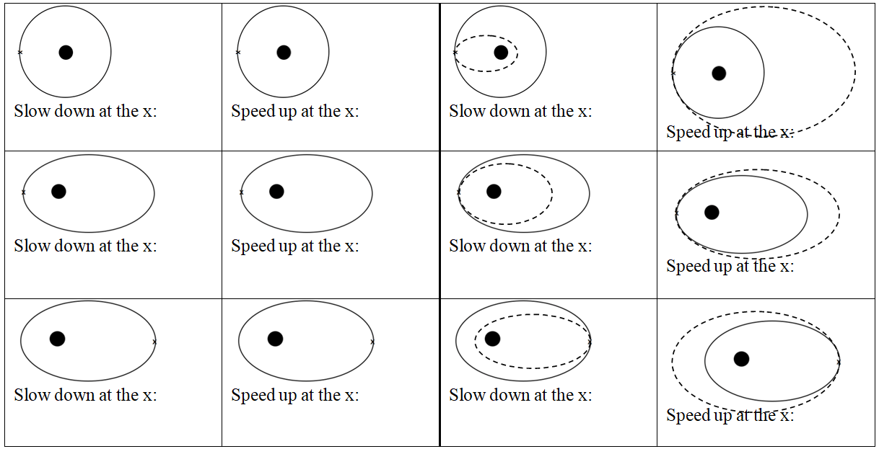

In general, speeding up brings the far side out, slowing down brings the far side in. Speeding up brings the entire trajectory outside the old one, and slowing down brings entire trajectory inside the old one.

**Orbit:**

Useful things to know:

|  |  |  |  |
| --- | --- | --- | --- |
| Mass of the Earth | 5.97x1024 kg | Radius of the Moon | 1.738x106 m |
| Mass of the Moon | 7.35x1022 kg | Radius of the Earth | 6.38x106 m |
| Mass of the Sun | 1.99x1030 kg | Earth-Moon Distance | 3.84x108 m |
| G = 6.67 x 10-11 Nm2/kg2 |  | Earth-Sun Distance | 1.496x1011 m |

1. What is the orbital velocity 3400 m from the center of a 5.6 x 1018 kg asteroid? (331.4 ≈ 330 m/s)

2. You find that you can orbit at 516 m/s 12,150 m from the center of a small moon. What is its mass? (4.85 x 1019 kg)

3. A satellite orbits a planet at a distance of 7.5 x 106 m from the center every 8900 seconds. What is the mass of the planet? (3.2 x 1024 kg)

4. What distance from the center of Earth’s moon is your orbital velocity 120 m/s? (3.4 x 108 m)

5. What is the period of orbit of a satellite that orbits 1.95 x 106 m from the center of Earth’s moon? (7730 s)

6. What is the radius of an orbit with a period of 3.16 x 107 s around the sun? (1.50 x 1011 m – yep – it’s the earth)

**Physics**

**FA 7.3 – Orbit and Gravity**

Name

Show your work, round to the correct significant figures, circle your answers, and label them with units.

When you have finished this, go to the website and check your answers. If you got a problem wrong, cross it off on the front, and do it correctly on the back.

1. What is the force of gravity between the Philae probe with a mass of 100. kg and comet 67P with a mass of 1.05x1013 kg if the probe is resting on the surface of the 2.05 km (2.05x103 m) radius comet. (That we will pretend is spherical - it's highly not)

2. What distance needs to separate the centers of two 5.20 kg spheres so that the force of gravity between them is 1.20x10-9 N

3. Your 12,500 kg spaceship is orbiting 1.16x107 m from the center of a planet every 17,500 s. What is the mass of the planet?

4. At what distance from the center of our 7.35x1022 kg moon is the orbital velocity 340. m/s?

5. Draw the new orbit: (Circle or oval indicates your current orbit)

Slow at x: Speed up at x: Speed up at x:

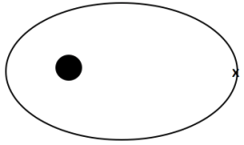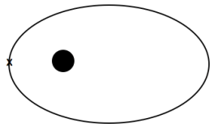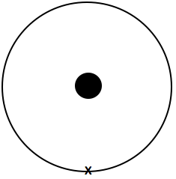 (elliptical, inside, tangent at x) (more elliptical, outside orbit, tangent at x) (less elliptical, outside orbit, tangent at x)

**Orbit and Gravity Questions from SA7.3 (Optional)**

Use the value of G = 6.67x10-11 Nm2/kg2

|  |  |
| --- | --- |
| 38,600 N  44.5 kg  2.53x1024 kg  2.43x106 s | 1. a. What is the force of gravity between a 6.50x1016 kg asteroid and a 18,700 kg spaceship if their centers are 1,450 m distant?  b. The centers of two lead spheres are separated by 6.70 m. If one sphere has a mass of 56.0 kg, and there is an attractive force of 3.70x10-9 N, what is the mass of the other sphere?  c. You are orbiting the planet Qwrmczl at a radius of 1.45x107 m, at a velocity of 3410 m/s. What is its mass?  d. What is the period of an orbit that is 3.90x108 m from earth's center? (m = 5.97x1024 kg) |
| 7.68 N  175 m  5.31x1023 kg  5.38x1011 m | 2. a. What is the force of gravity between a 2.60x1013 kg asteroid and a 56,100 kg spaceship if their centers are 3,560 m distant?  b. What distance separates the centers of two lead spheres if one has a mass of 123 kg, the other a mass of 12.0 kg and there is an attractive force of 3.20x10-12 N?  c. You are orbiting the planet Wnnydrydrl at a radius of 7.80x106 m, and a period of 2.30x104  seconds. What is the planet’s mass?  d. What is the radius of an orbit around earth (m = 5.97x1024 kg) that has an orbital velocity of 27.2 m/s? |
| 3,980 N  2.84 kg  2.51x108 m  4.89x105 s | 3. a. What is the force of gravity between a 2.10x1015 kg asteroid and a 23,800 kg spaceship if their centers are 915 m distant?  b. The centers of two lead spheres are separated by 1.35 m. If one sphere has a mass of 125 kg, and there is an attractive force of 1.30x10-8 N, what is the mass of the other sphere?  c. What is the radius of the orbit that has an orbital velocity of 1260 m/s around the earth? (m = 5.97x1024 kg)  d. What is the period of an orbit with a radius of 3.10x107 m around the moon? (Moon’s mass is 7.36x1022 kg) |
| 72.4 N  1.67 m  2.92x105 s  7.54x1025 kg | 4. a. What is the force of gravity between a 2.30x1014 kg asteroid and a 12,700 kg spaceship if their centers are 1,640 m distant?  b. What distance separates the centers of two lead spheres if one has a mass of 215 kg, the other a mass of 125 kg and there is an attractive force of 6.40x10-7 N?  c. What is the period of the orbit that has a radius of 9.50x107 m around the earth? (m = 5.97x1024 kg)  d. You orbit the planet Kssnndnnwrr at a radius of 8.20x107 m with a velocity of 7830 m/s. What is its mass? |
| 40.0 N  9.60 kg  986 m/s  2.15x1023 kg | 5. a. What is the force of gravity between a 23.6x1012 kg asteroid and a 14,600 kg spaceship if their centers are 758 m distant?  b. The centers of two lead spheres are separated by 4.90 m. If one sphere has a mass of 45.0 kg, and there is an attractive force of 1.20x10-9 N, what is the mass of the other sphere?  c. What is the velocity of the orbit that has a radius of 4.10x108 m around the earth? (m = 5.97x1024 kg)  d. You are in an orbit with a radius of 8.50x107 m and a period of 1.30x106 s around the planet Rjxnstdnnr. What is its mass? |

e.

Questions: Answers:



In general, speeding up brings the far side out, slowing down brings the far side in. Speeding up brings the entire trajectory outside the old one, and slowing down brings entire trajectory inside the old one.