Noteguide Momentum - Videos 6A Name
Videos 6A - Momentum
What does Momentum mean:

Write down the formula for momentum: (Be sure to write down what all the symbols mean, and their units)

p =

Example: What is the momentum of a 145 g baseball going 40. m/s:

Example: 60 kg Fran is running at 4 m/s when she collides with 80 kg Joe head on. They hit and stop dead, so how fast was Joe going?

Video B - Impulse
Write down the formula for impulse: (Be sure to write down what all the symbols mean, and their units)

Impulse =

Example: What impulse is imparted by exerting a 12 N force for 4.0 s?

Example: Impulse is the area under a F vs. t graph
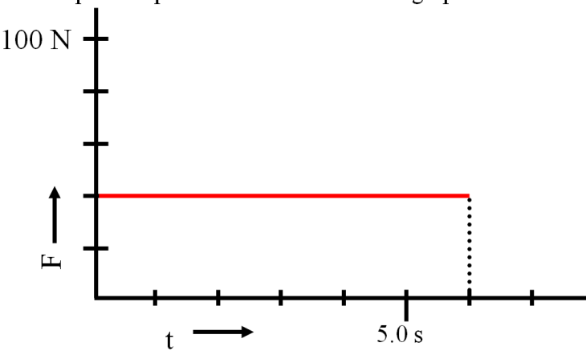
Show your calculation here:

Video C - Impulse and Momentum
Write down what these symbols are below:

Impulse = F Δt = m Δv

F =
Δt =
m =
Δv =

Example: A pitcher pitches a 0.145 kg baseball at +40. m/s, and the batter hits it directly back at -50. m/s to the outfield. What is the average force exerted by the bat if the collision lasted 0.013 s? (-1.0E3N)

Why Δv is tricky:

Do at least one of the examples from the three that are below the first video:
What force for 10. seconds makes a 2.0 kg rocket speed up to 75 m/s from rest?

A baseball bat exerts a force of 200. N on a .50 kg ball for .10 seconds. What is the ball’s change in velocity?

Jolene exerts a 50. N force for 3.0 seconds on a stage set. It speeds up from rest to .25 m/s. What is the mass of the set?

Deriving Newton's Second law: (Write down the math steps from the last video)

