Noteguide for Types of Rockets - Videos 6E part 3 Name
Solid Fuel:
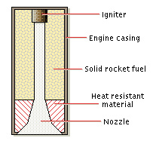

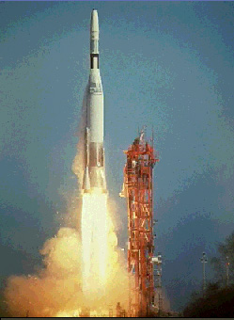
Liquid Fuel:
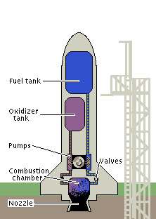
How do you keep from tipping?

Why is there "Steam" coming off the rocket

Saturn V rocket:
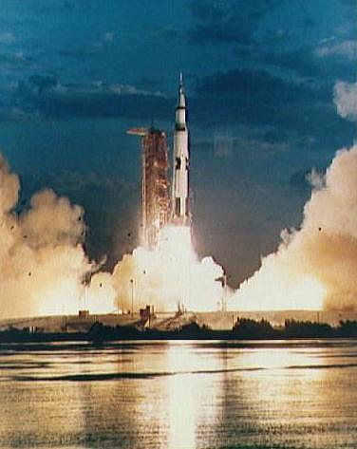
Label the diagram on the right

What is the main advantage of having multiple stages?

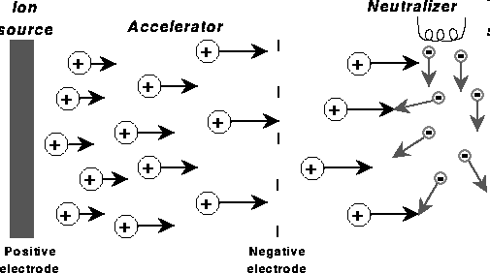
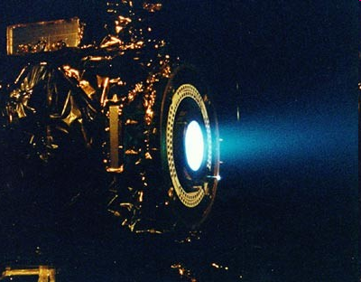
Ion Propulsion

Where does an ion drive get its energy?

