Noteguide for Rocket Science - Videos 6D Name
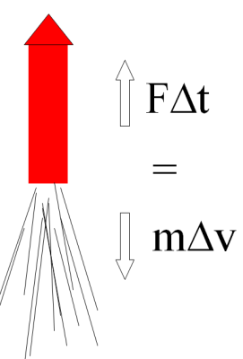
Write down what these are in terms of Rockets:

F Δt = m Δv

F =
Δt =
m =
Δv =

Example 1: A rocket burns fuel at a rate of 1.2 kg/s, with an exhaust velocity of 1250 m/s. What thrust does it develop?

Example 2: A model rocket engine develops 12.0 N of thrust with an exhaust velocity of 718 m/s. What is its fuel burn rate?

What is the rocket’s initial acceleration if it has a mass of 238 g?

Whiteboards:
A certain rocket engine burns 0.0352 kg of fuel per second with an exhaust velocity of 725 m/s. What thrust does it generate?  (25.5 N) | The Saturn V’s first stage engines generated 33.82 MN of thrust (33.82 x 10⁶ N) with an exhaust velocity of 2254.7 m/s. What was its fuel burn rate?  (15,000 kg/s)
A D12 engine generates 11.80 N of thrust burning fuel at a rate of 0.0143 kg/s. What is the exhaust velocity?
If the rocket has a mass of 139 grams, what is the initial upward acceleration?
(825 m/s, 75.1 m/s/s)

Draw a picture of a pretty pony here:

Vertical Acceleration of a Rocket

What are the 4 steps for solving these:

1.

2.

3.

4.

Example 1: A rocket has a total mass of 12.0 kg, 10.0 kg of which is fuel. It consumes all of its fuel in 8.50 seconds with an exhaust velocity of 420. m/s What are its initial and final accelerations?

Example 2: A 21.0 kg rocket, 16.0 kg of which is fuel, burns its fuel at a rate of 0.820 kg/s with an exhaust velocity of 730. m/s. What are its initial and final acceleration as it takes off from earth?

