Quizlette 5.2.1 - Conservation of Energy with Pictures Name

Fd + mgh + ¹/₂mv² = Fd + mgh + ¹/₂mv²
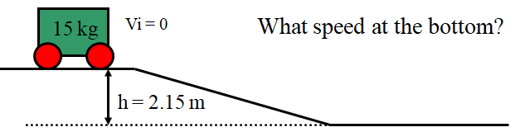(6.5 m/s)

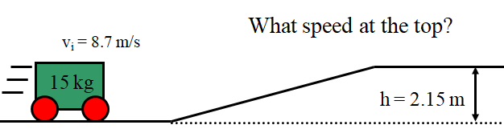 (5.8 m/s)

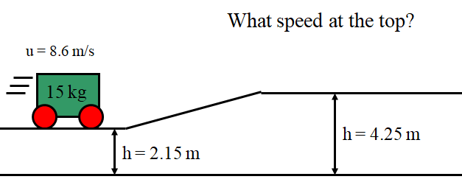 (5.7m/s)

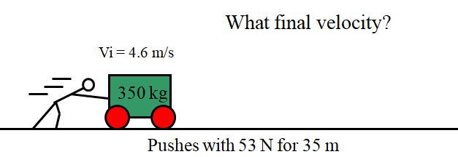 (5.6 m/s)

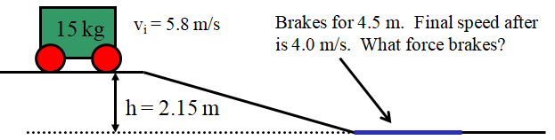(99.6 N)

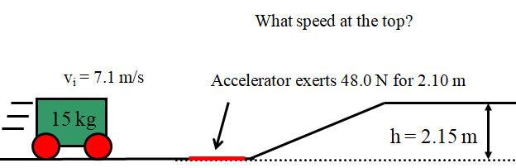 (4.66 m/s)

