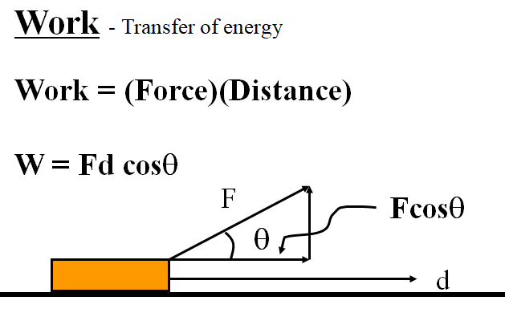
Noteguide for Work - Videos 5A Name

Example - Fred O’Dadark exerts 13.2 N on a rope that makes a 32º angle with the ground, sliding a sled 12.5 m along the ground. What work did he do?

Work and Weight Example – Joe Dadi lifts a 5.0 kg mass 2.5 m. What work does he do?

W
F
d
m
μ
F = mg (lifting)
F = μmg (dragging)
W = Fd

Work and Friction Example – Herman Leftur drags a 150 kg sled 45 m across a lake where the coefficient of kinetic friction is 0.12. How much work does he do?

W
F
d
m
μ
F = mg (lifting)
F = μmg (dragging)
W = Fd

(Do the whiteboards on the back)

Whiteboards (simple work)
1. Jane Linkfence does 132 J of work lifting a box 1.56 m. What is the weight of the box? (What force did she exert?) (84.6 N) | 2. Bob White does 2,345 J of work pushing a car with a force of 186 N of force. What distance did he push the car? (12.6 m)
3. Helena Handbasket brings a 5.2 kg box down from a 1.45 m tall shelf. What work does she do?
(-74 J)

Work and Weight:
4. Paul E. Wannacracker does 2375 J of work lifting what mass a height of 1.18 m? (205.4 kg) | 5. Tubi O’ Notubi does 137 J of work lifting a 5.25 kg mass to what height? (2.66 m)

Work and Friction:
6. Hugh Jazz drags a 125 kg sled with a coefficient of kinetic friction of .15 a distance of 34 m. What work does he do? | 7. Seymour Butz does 1200 J of work dragging a 32 kg box with a coefficient of kinetic friction of .21 how far?

Noteguide for Power - Videos 5B Name

A person does 48 J of work in 6.0 s. What is their power output?

My 30. HP van could go 25 m/s top speed. What was the force resisting its motion?
1 horsepower = 745.7 Watts, 1 kW = 1000 Watts

Whiteboards:
1. Joe Mama does 613 J of work in 2.13 seconds. What is his power output?  (288 W) | 2. Ima Wonder can put out 127 W of power. What time will it take her to do 671 J of work?  (5.28 s)
3. What work does a 1.5 HP motor do in 1 minute? (P = 1.5x745.7 W)  (67,113 J) | 4. Bob N. Frappels slides a box with 43 N of force at a constant speed of 5.3 m/s. What is his power output?  (230 W)
5. Frieda People can put out 430. W of power. With what speed can she push a car if it takes 152 N to make it move at a constant velocity?
(2.83 m/s)

Noteguide for Work and Power JAMBALAYA - Videos 5C Name

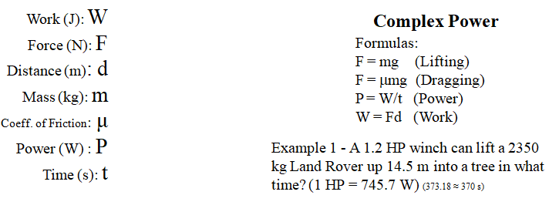

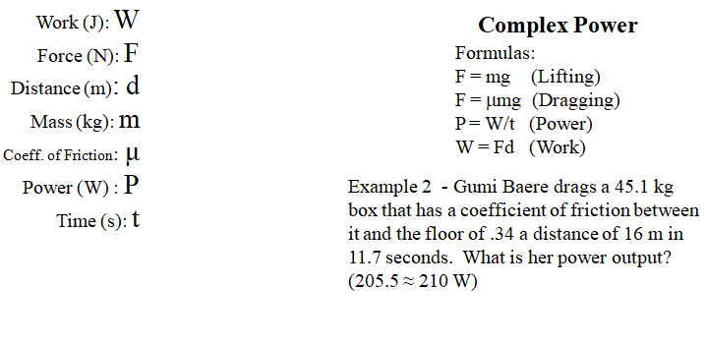

(do the whiteboards on the back)

Whiteboards:
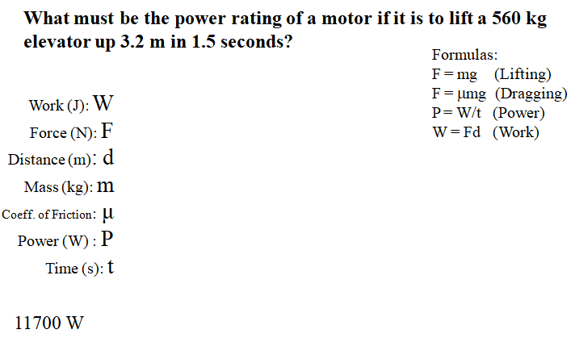
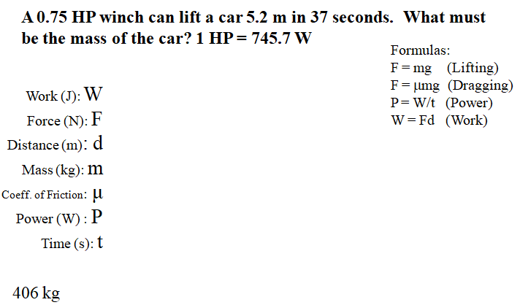
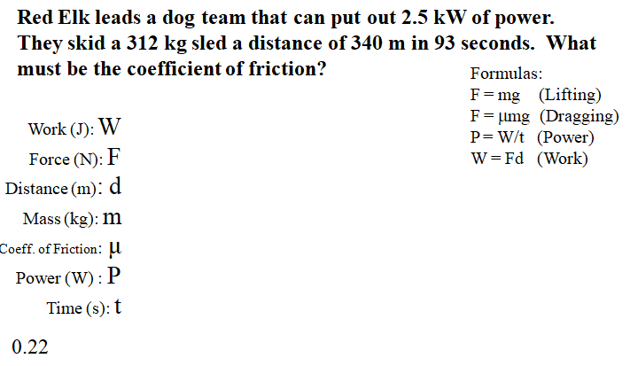
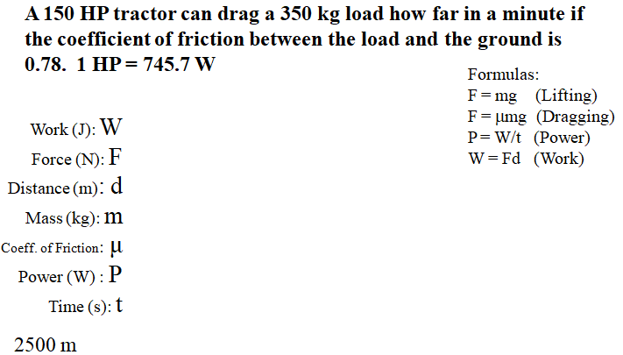

Noteguide for Efficiency - Videos 5D Name

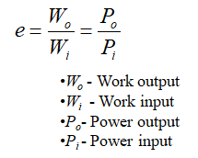
Example - 1 HP motor consumes 815 W of power

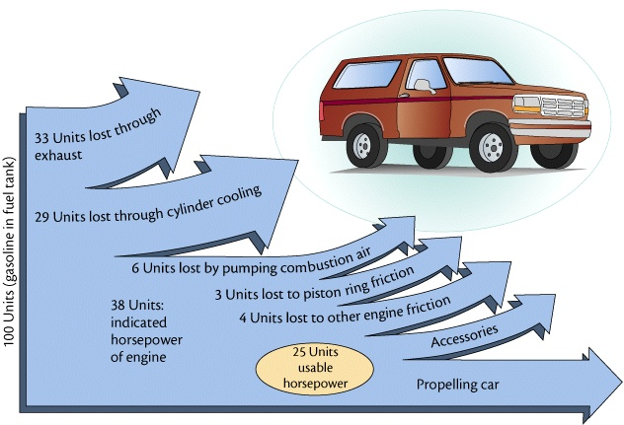

Whiteboards:
1. A motor consumes 425 J of energy and does 300 J of work. e = ? (0.71, or 71%) | 2. A person is 13% efficient. How much food energy to do 600. J of work? (4615 J)
3. A 60.% efficient heater uses 800. J of energy. What is its heat output? (480 J) | 4. A car is 25% efficient. What energy input does it need to climb a 320 m tall hill if its mass is 1200 kg? (15,052,800 J) (Hint - Wo = (F)d = (mg)h )

