Noteguide for Gravitational Potential Energy - Videos 5F Name

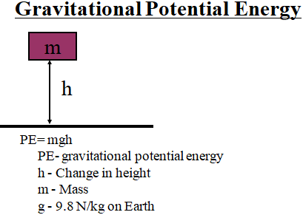

Example: What is the Potential Energy of a 5.0 kg mass 2.1 m from the ground?

Whiteboards:
1. What is the potential energy of a 4.5 kg bowling ball, 13.5 cm above the ground? (5.953 J) | 2. Toby Continued lifts a 75.0 kg box doing 1573 J of work. What is the change in height of the box?  (2.14 m)
3. Colin Host lifts himself up 15 m doing 9555 J of work. What is his mass? (65 kg)

