Noteguide for Net Force - Videos 4D (keep) Name

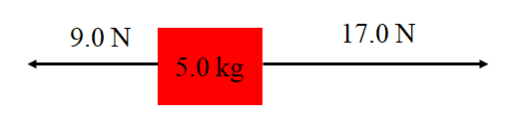
Steps:

1.

2.

3.

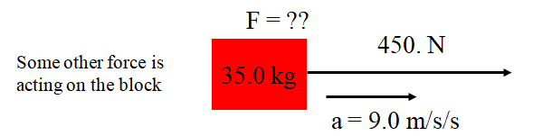

Try these example problems. If you don't get the answer, watch the video to see how.
1. 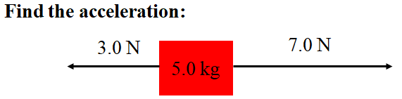(0.80 m/s/s) | 2. 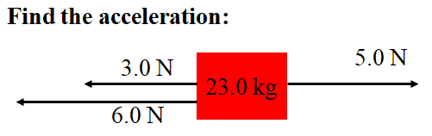(-0.17 m/s/s)
3. 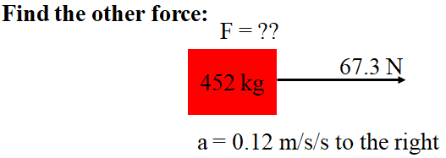(-13 N) | 4. 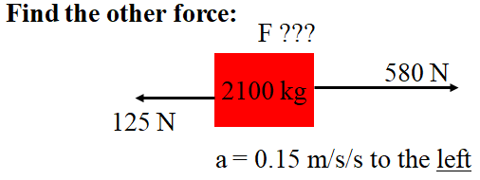(-770 N)

