3.1 Vector Quizlette (turn this in) Name

B. Find these Vector Components and write each vector as a proper component vector:
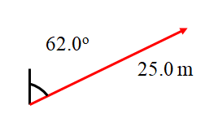
#1: 22.1 m x + 11.7 m y #2: -72.4 m, x + -38.5 m y #3: -44.0 m x + 9.36 m y
#1

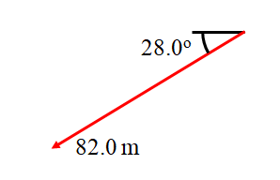
#2

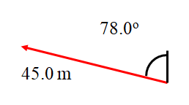
3.1 Vector Quizlette
#3
#4
3.1 Vector Quizlette
#4: 289 m x + -234 m y #5: -16.3 m x + 14.7 m y #6: -179 m x + -167 m y
#4
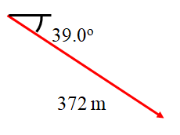

#5

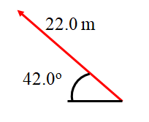

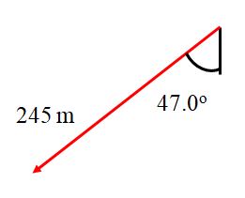
#6

3.1 Vector Quizlette
C. Add these component vectors:
A: 12 m x + 34 m y  B: 16 m x + 9.0 m y  A+ B:  #a  28 m x + 43 m y | A: 1.20 m x + 3.10 m y  B: -5.30 m x + 1.30 m y  A+ B:  #b  -4.1 m x + 4.4 m y
A: 3.60 m x + -5.60 m y  B: 12.5 m x + 8.10 m y  A+ B:  #c  16.1 m x + 2.50 m y | A: 12.6 m x + 58.1 m y  B: 16.5 m x + -96.0 m y  A+ B:  #d  29.1 m x + -37.9 m y

D. Draw these vectors as Angle Magnitude vectors. The vector should be an arrow, and calculate and label its magnitude (hypotenuse) and the angle:
1) 10.0 m right and up 53.1º above the x axis, 2) 7.82 m left and up at 54.9º above the x axis
3) 6.44 m left and down 37.3º below the x axis, 4) 67.4 m right and down 33.3º below the x axis

1) 6.00 m x + 8.00 m y

2) -4.50 m x + 6.40 m y

3) -5.12 m x + -3.90 m y

4) 56.3 m x + -37.0 m y
3.1 Vector Quizlette
E1: Adding two Angle Magnitude Vectors (Just like the test…)

Find the Components of these two vectors:
Carry three decimal places in your calculations.

Mag. = 12.0 m, θ = 21.0º

1 = x + y

2 = x + y

Mag. = 8.00 m, θ = 17.0º

Add the Two Vectors: 1+2 = x + y

Draw a picture of the resultant vector with its tail on the origin, find its magnitude, and label an angle indicating its direction:

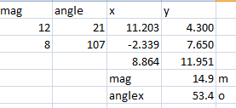 14.9 m, up and right, above 53.4º the x-axis
3.1 Vector Quizlette
E2: Adding two Angle Magnitude Vectors

Find the Components of these two vectors:
Carry three decimal places in your calculations.

1 = x + y
Mag. = 18.0 m, θ = 43.0º

2 = x + y

Mag. = 42.0 m, θ = 12º

Add the Two Vectors: 1+2 = x + y

Draw a picture of the resultant vector with its tail on the origin, find its magnitude, and label an angle indicating its direction:

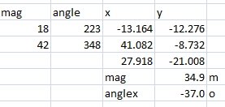 34.9 m, right and down at 37º below the x axis

