Noteguide for Vector Component to Angle Magnitude - Videos 3D Name

Write down step by step directions:

Given this VC Vector: 5.10 m x + -1.70 m y, Draw the AM vector

Try these example problems. Don't freak out if you can't immediately get the answer. We will work on these as a group in class. They are solved in the linked videos that follow the main one. Answers to these are on the back of this sheet. Be sure you can make the drawings correctly with the arrows in the right direction.
1. Draw this vector, and find its magnitude and the angle it forms with the x-axis:  3.4 m x + 2.0 m y | 2. Draw this vector, and find its magnitude and the angle it forms with the x-axis:  -22 m/s x + 15 m/s y
3. Draw this vector, and find its magnitude and the angle it forms with the x-axis:  9.00 N x + -15.0 N y | 4. Draw this vector, and find its magnitude and the angle it forms with the x-axis:  15.00 m/s/s x + -9.80 m/s/s y

Answers to whiteboards – be sure you have drawn the arrows the right way. Don’t worry if the videos do something with a trig angle – that is not a thing anymore

1. 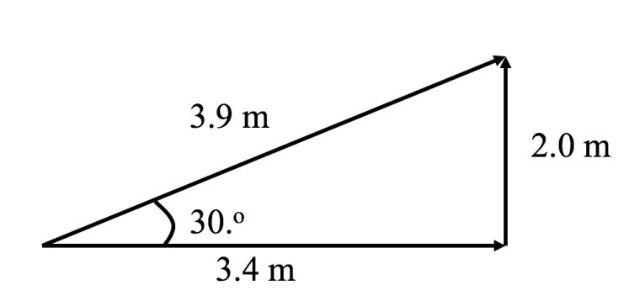 | 2. 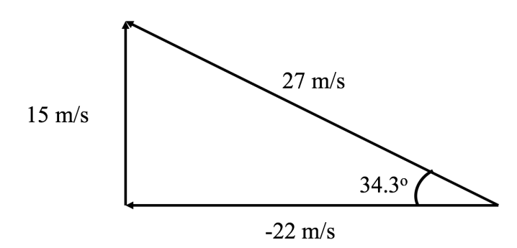
3. 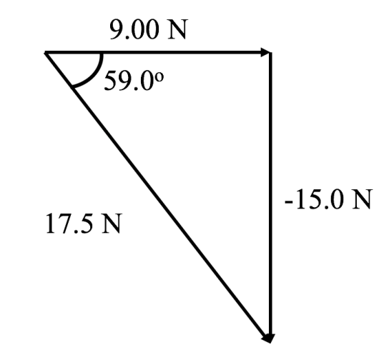 | 4. 