Noteguide for Types of vectors - Videos 3A Name

Make a guess, then watch the video:

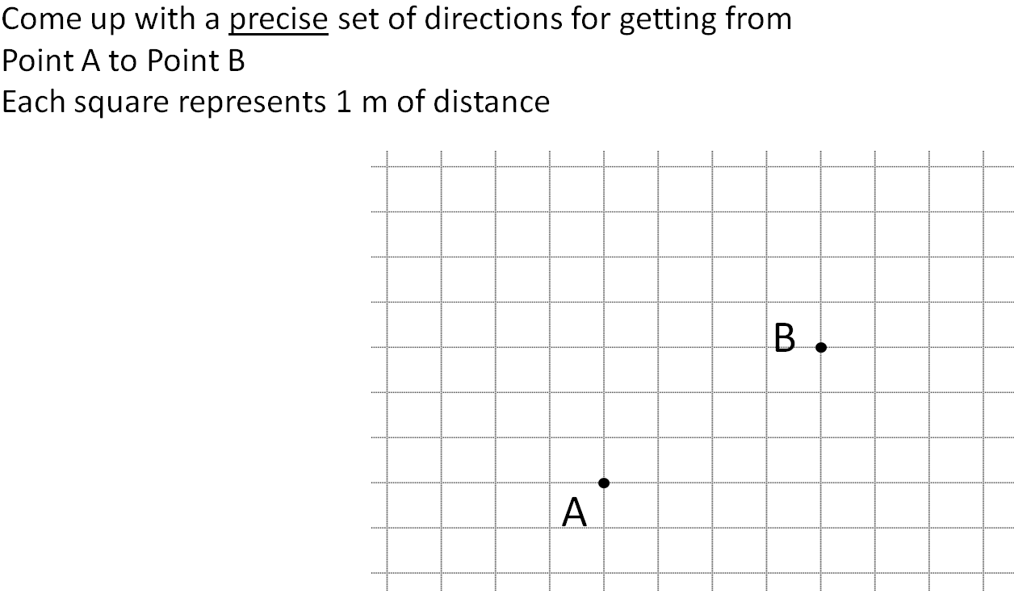

Write these directions:
Vector Component:

Angle Magnitude:

