Noteguide for Boat Crossing River - Videos 3J Name

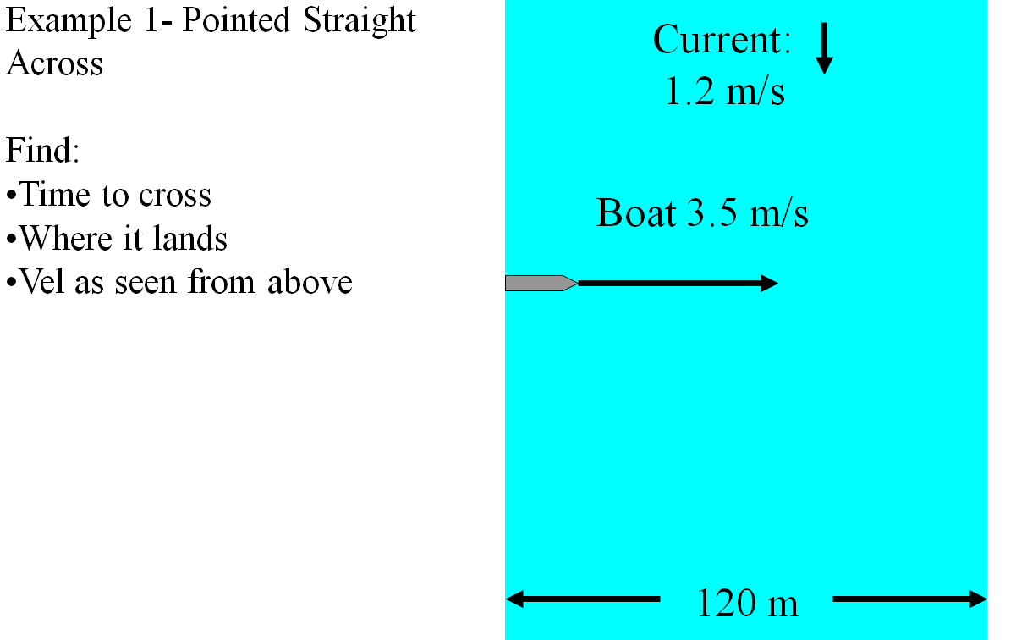

Example 2:
A boat with a velocity (in still water) of 1.49 m/s points straight across river with a current of 0.750 m/s In doing this it is carried downstream 25.2 m.
1. What time does it take to cross?
2. How wide is the river?
3. What is the velocity (in angle magnitude notation) of the boat as it moves across the river? Draw a picture of the velocity.

(Do the example on the back side too)

Example 3:
A boat crosses a 62.0 m wide river in 45.2 s by pointing straight across. In so doing, it is carried downstream a distance of 17.5 m
1. What is the velocity of the boat with respect to the water?
2. What is the speed of the current?
3. What is the velocity (in angle magnitude notation) of the boat as it moves across the river? Draw a picture of the velocity.

