Noteguide for Speed - Videos 2A1 Name

2A1 – Calculating Speed

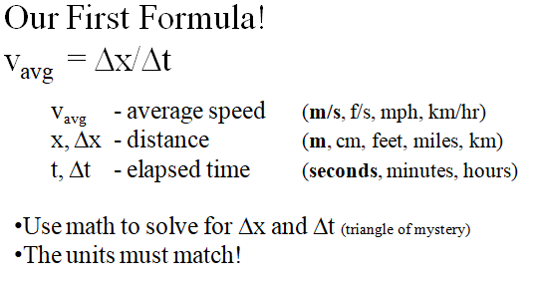
A car is going 25 m/s. How far does the car go during the 1.3 seconds it takes you to change songs?

A winch moves a cable 12.5 cm per second. What time will it take to reel in 15 m of cable?

Try these example problems. Don't freak out if you can't immediately get the answer. They are solved in the linked videos that follow the main one, so if you get stuck, just watch the video.
1. How fast are you going if you run 27.0 m in 3.2 seconds? (8.4 m/s) | 2. In what time will a car that is traveling 95.3 f/s go 13.45 feet? (0.141 s)
3. How far will a bullet traveling 350 m/s go in 6.34 seconds? (2200 m) | 4. A car traveling 80. km/hr will go how far (in meters) in 2.7 seconds? (60 m)
5. What time (in days) will it take a glacier that moves 15.6 feet/day to travel 100 yards? (19.2 days)

Noteguide for Speed - Videos 2A1 Name

2A2 – Unit Conversions
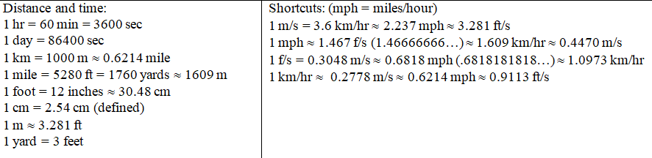

Unit cancellation:
30. mph to ft/s:

Try these example problems. Don't freak out if you can't immediately get the answer. They are solved in the linked videos that follow the main one, so if you get stuck, just watch the video.
1. Convert 32 mile/hour to feet/second (47 f/s) | 2. Convert 88.0 feet/second to mph (60.0 mph)
3. Convert 26.82 m/s to mph (60 mph) | 4. Convert 110. km/hr to m/s (30.6 m/s)
5. Convert 132 f/s to km/hr (144.8km/hr) | 6. Convert 130. km/hr to mph (80.8 mph)
7. Convert 90. mph to m/s (40.2 m/s) | 8. Convert 1400 f/s to m/s (426.7 m/s)

Noteguide for Acceleration - Videos 2B Name

2B – Vector Velocity

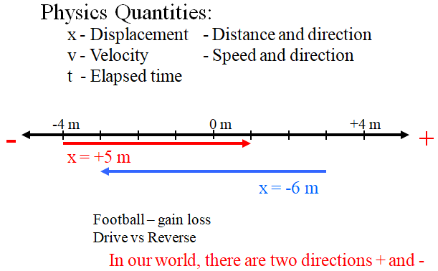

1. A car has a velocity of -2.4 m/s for 36 seconds. What is its displacement in this time, and if it started at a position of +127.0 m, where will it end up?

2. A train starts at a position of -35.1 m and ends at a position of 12.5 m in a time of 13.8 seconds. What was its velocity during this time?

3. A train has a velocity of -25.2 m/s and ends up at a position of -57 m after a time interval of 15 seconds. What was its displacement during this time, and where did it start?

Noteguide for Acceleration - Videos 2C Name

2C - Simple Acceleration

Write down what these quantities are:

Quantity Formula Units What it is called
v
a

Example: A car goes from 0 to 27 m/s in 9.0 seconds, what is its acceleration?

Super Confusing Example: A rocket accelerates at 4.5 “g” s. What time will it take to reach the speed of sound (Mach I = 343 m/s) from rest?

Try these example problems. Don't freak out if you can't immediately get the answer. They are solved in the linked videos that follow the main one, so if you get stuck, just watch the video.
1. A car speeds up from 0 to 21 m/s in 5.3 seconds. What is their acceleration? (4.0 m/s/s) | 2. A train can accelerate at 0.15 m/s/s. What time will it take to reach its top speed of 24 m/s from rest? (160 s)
3. What is the final speed if a person accelerates from rest at 32 f/s/s for 2.7 seconds? (86 f/s) | 4. What is your acceleration if your velocity goes from 35 m/s to 20. m/s in 4.7 seconds? (-3.2 m/s/s - hint - what is the change in velocity?)
5. What is your final velocity if you are going 12 m/s and you accelerate at 0.48 m/s/s for the next 16 seconds? (19.68 m/s ≈ 20. m/s - hint - you are already going 12 m/s - figure out the change in velocity with the formula, and add it to 12 m/s)

Noteguide for Displacement Graphs - Videos 2G Name

Slope on a position time graph:

Whiteboards:
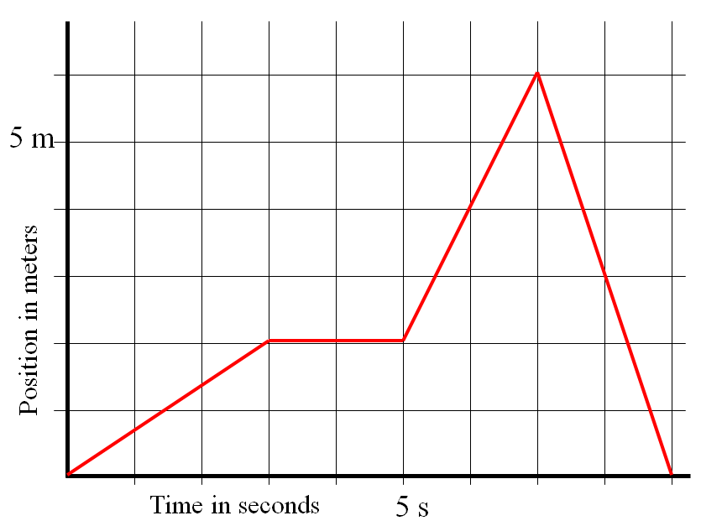
Keep in mind that when you find the slope, you should use the entire line segment. (i.e. 2.0 seconds, use the entire line from t = 0 to t = 3.0 s, and find the rise/run for that entire segment.)
1. What is the velocity at 2.0 s? (0.67 m/s) | 2. What is the velocity at 4.0 s? (0 m/s)
3. What is the velocity at 6.2 s? (2.0 m/s) | 4. What is the velocity at 8.15 s? (-3.0 m/s)

Noteguide for Velocity Graphs - Videos 2H Name

Slope of velocity graphs:
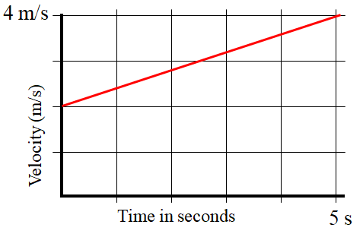
What does the slope on a velocity graph mean?

Whiteboards:
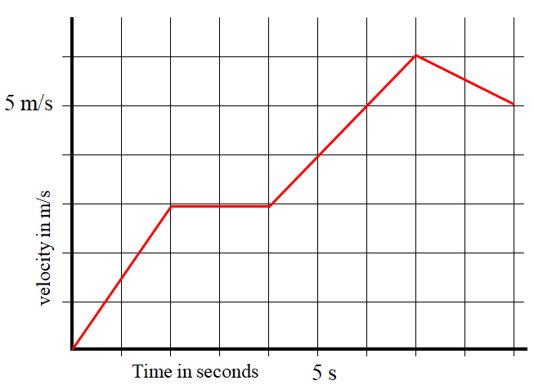
Keep in mind that when you find the slope, you should use the entire line segment.
1. What is the Acceleration at 1.15887 seconds? (1.5 m/s/s) | 2. What is the Acceleration at 8.1 s? (-0.50 m/s/s)
(In calculus the slope is the derivative)

Area under velocity graphs:

What does the area under a velocity graph mean?

Whiteboards:

"Area under" means the area between the graph and the x-axis. The units of this "area" are meters in this case, so it's not area in a strict sense. Graph areas can have all kinds of different units.
1. What displacement between 2 and 4 seconds? (6.0 m) | 2. What displacement between 4 and 7 seconds? (13.5 m)
(In calculus the area under is the integral)

Noteguide for Qualitative Position Graphs - Videos 2I Name
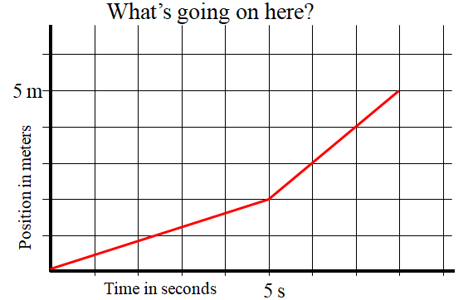 | 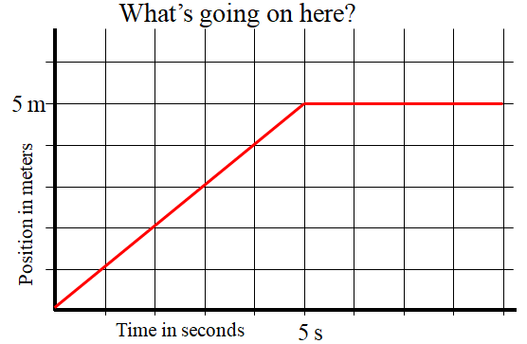
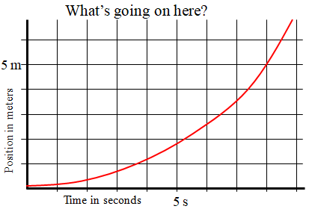 | 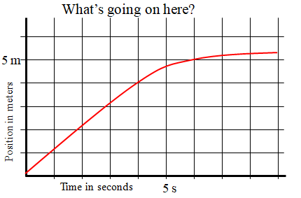
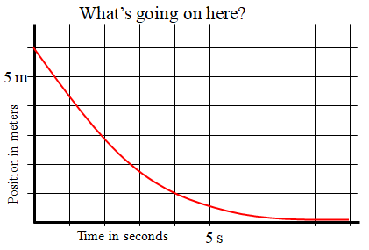 | 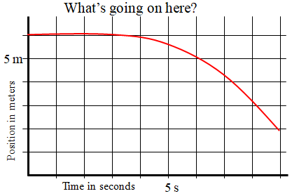
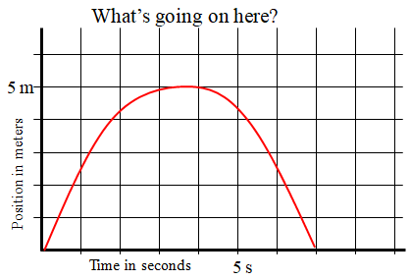 | 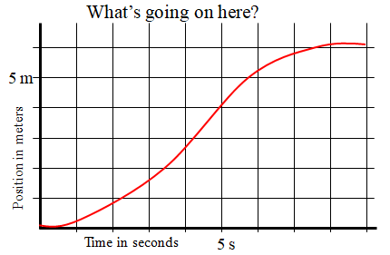

For all of these, state what happens to the velocity, and whether this is + or - acceleration
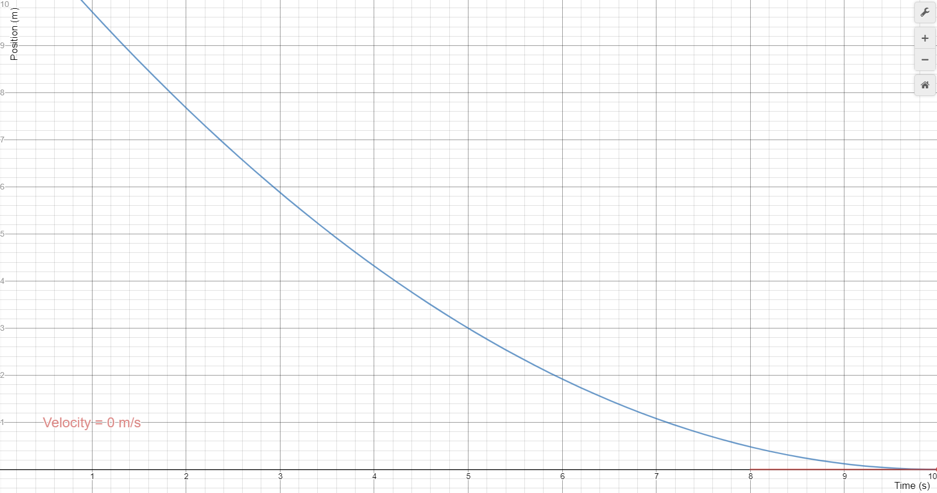 | 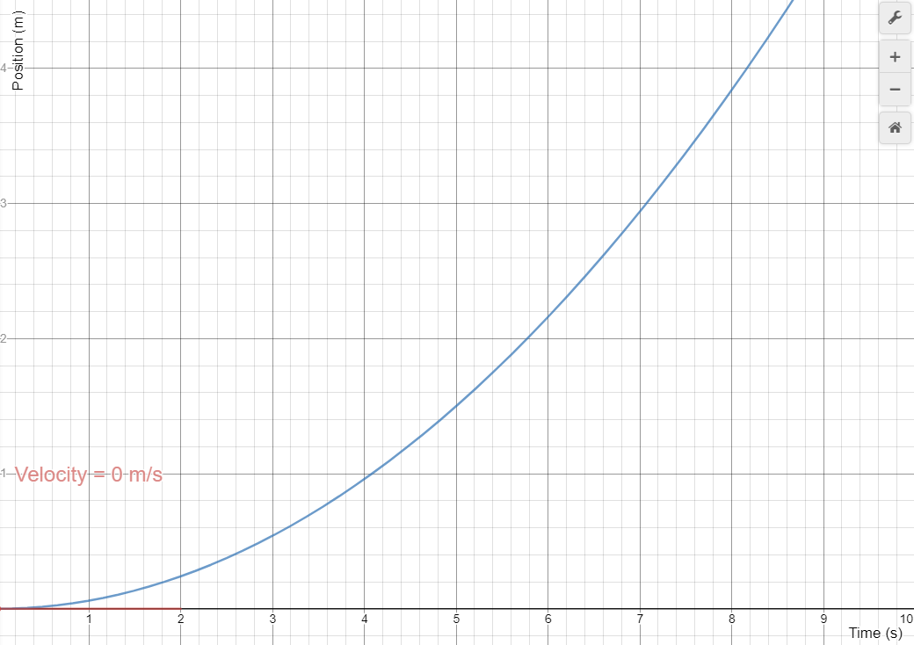
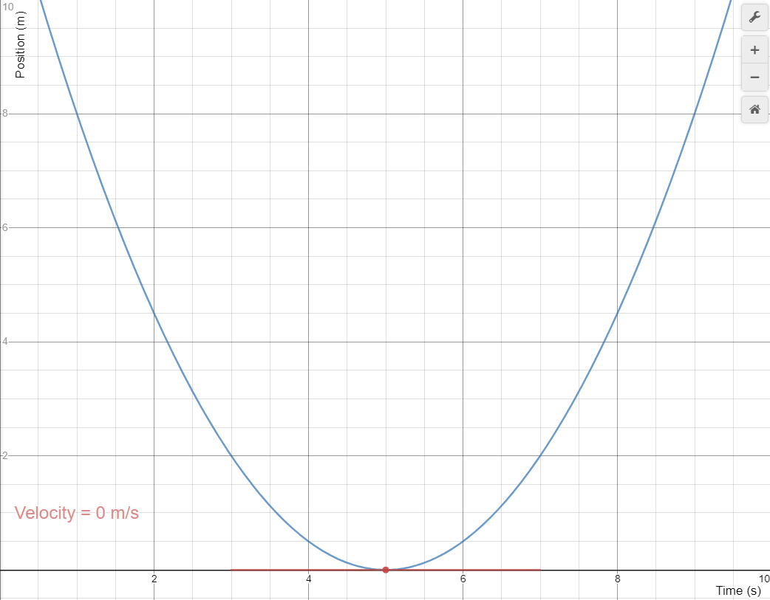 | 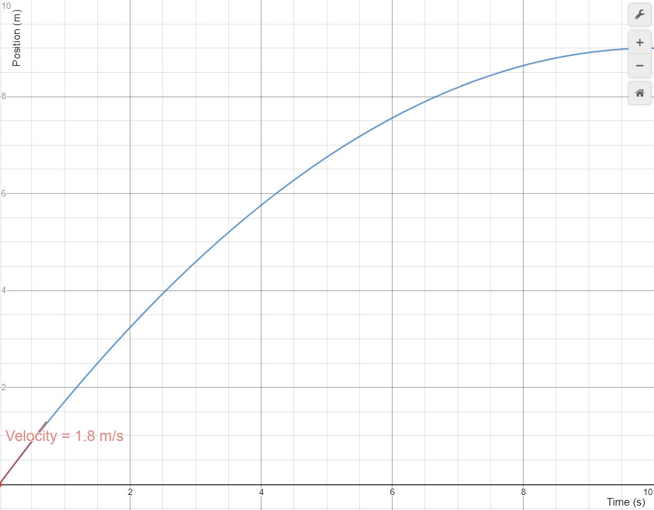
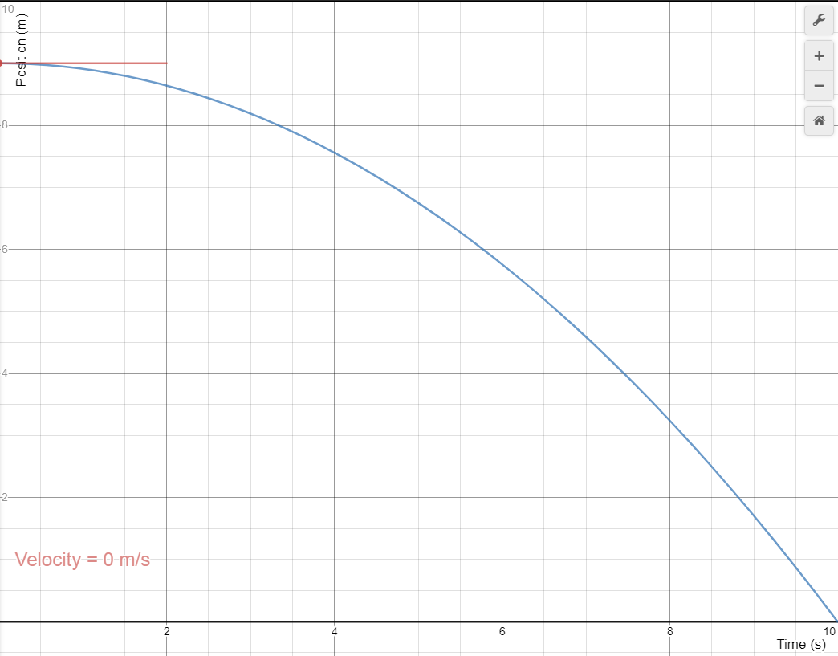 | 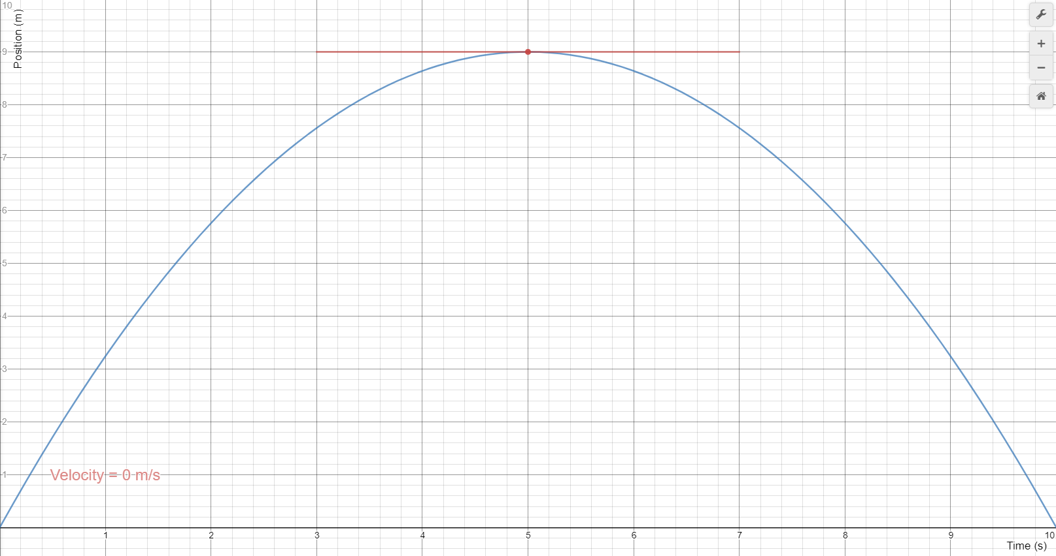

Noteguide for Qualitative Velocity Graphs - Videos 2J Name
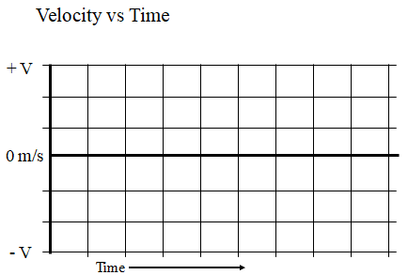 | 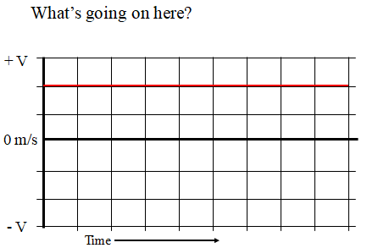
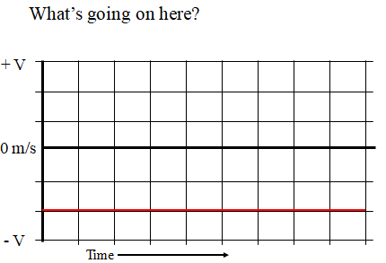 | 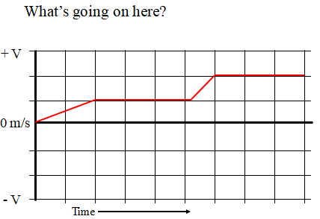
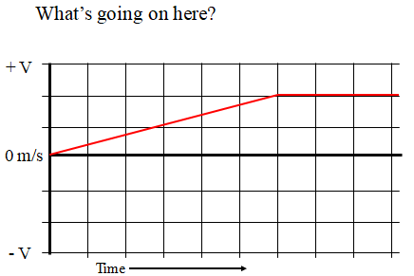 | 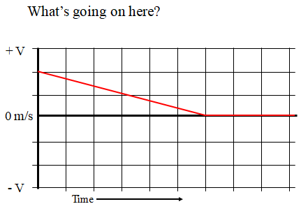
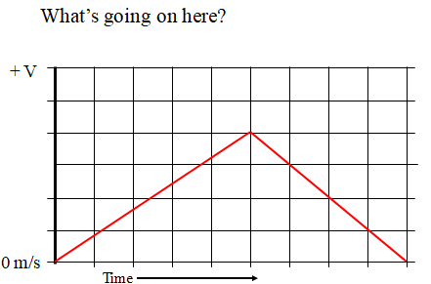 | (This is the position graph of the one to the left)  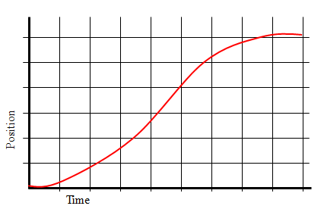

For each of these, what direction is it going? Is it speeding up, or slowing down? State whether the acceleration is + or –
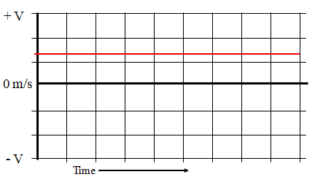 | 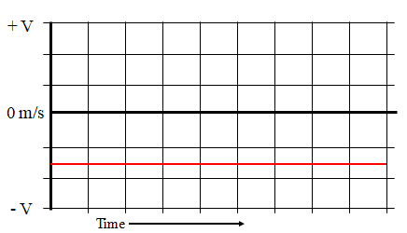
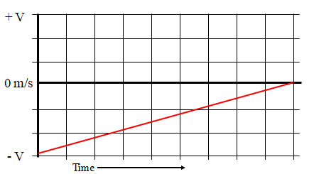 | 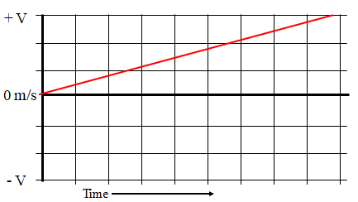
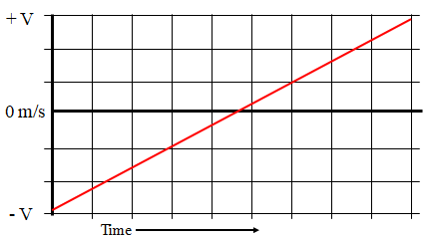 | 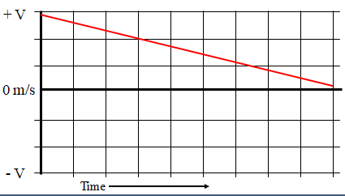
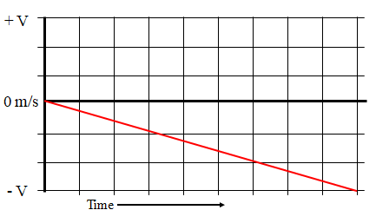 | 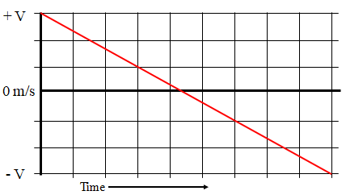

Noteguide for Kinematics - Videos 2E Name

2E - Kinematics

v_{f} = v_{i} + at  x = ½(v_{i} + v_{f})t  v_{f}² = v_{i}² + 2ax  x = v_{i}t + ¹/₂at² | x - displacement (m)  v_{i} - initial velocity (m/s)  v_{f} - final velocity (m/s)  a - acceleration (m/s/s)  t - time (s)
(write down the names I give them, like "No X", "No a" etc.)

Example 1: A car goes from 14 m/s to 26 m/s in 300. m.
- What is the acceleration, and
- What time does it take?

Example 2: A rocket going 3130 m/s accelerates at 0.00135 m/s/s for a distance of 5.50 x 10⁹ m.
- What time does it take, and
- What is the final velocity?

Try these example problems.
1. A cart stops in a distance of 3.81 m in a time of 4.51 s. What was its initial velocity? (1.69 m/s) | 2. A car going 12 m/s accelerates at 1.2 m/s/s for 5.0 seconds. What is its displacement during this time? (75 m)
3. Another car with a velocity of 27 m/s stops in a distance of 36.74 m. What was its acceleration?  (-9.9 m/s/s) | 4. A car’s brakes slow it at 9.5 m/s/s. If it stops in 47.3 m, how fast was it going to start with? (30. m/s)
5. What time will it take a car going 23 m/s to start with, and accelerating at 3.5 m/s/s, to go 450 m?
(10.7585 ≈ 11 s Hint - it is quadratic with "No V_{f}" but you can use "No t" to find V_{f}, and then use "No X" to find t without using the quadratic equation)

Videos 2F-Free Fall Problems Name

Problem solving tips:
1
2
3

4
5
Example 1 - An object is launched straight up with a velocity of 33.0 m/s, and strikes the ground at the same elevation from which it is launched. Use the acceleration of gravity to be -9.80 m/s/s, and neglect air friction
- What time did it take to reach the top
- How high does it go at the highest?
- What total time is it in the air?

Example 2 – An air rocket leaves reaches a height of 31.0 m before falling back to the ground.
- What was the initial velocity
- What time did it take to reach the top
- What total time is it in the air?

Example 3 – Red Elk drops from a cliff that is 11.2 m tall
- With what velocity does he strike the water?
- What time does it take to hit the water?

Example 4 – Black Elk drops from a cliff and strikes the water at a velocity of 34.0 m/s.
- What time did it take him to hit the water?
- How high is the cliff?

Try these example problems. Don't freak out if you can't immediately get the answer. We will work on these as a group in class. They are solved in the linked videos that follow the main one
1. An air rocket goes straight up, and then falls back to earth, remaining in the air for a total of 6.32 s  - What time did it take to reach the top  - What was the initial velocity (3.16 s, 31.0 m/s) | 2. It takes a rock 1.52 s to fall from rest from a bridge and strike the water below.  - How high is the bridge?  - With what velocity does the rock strike the water? (11.3 m, -14.9 m/s)

