Tobin’s Spirit Guide to Graphs of Motion
Position Graphs:
 | Moving to the Left (Negative Velocity) |  | Moving to the Right (Positive Velocity)
Speeding Up (Going faster and faster) | Negative velocity means negative slope. (The graph goes down as you move left to right) Speeding up means the graph gets steeper and steeper. |  | Positive velocity means positive slope. (The graph goes up as you move left to right) Speeding up means the graph gets steeper and steeper.
 | Accelerating from rest  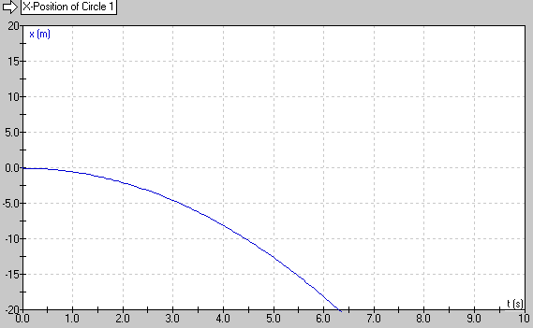 | Already moving  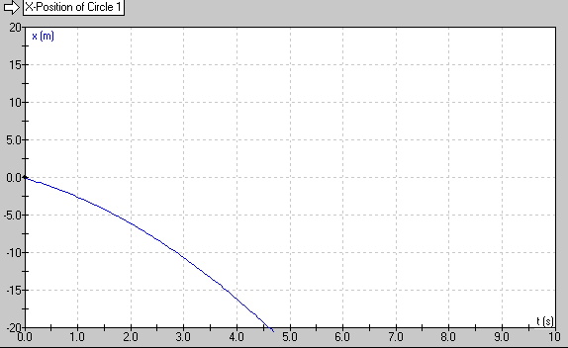 | Accelerating from rest  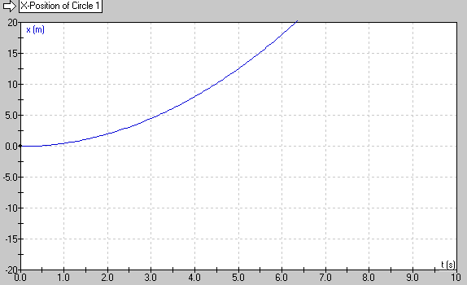 | Already moving  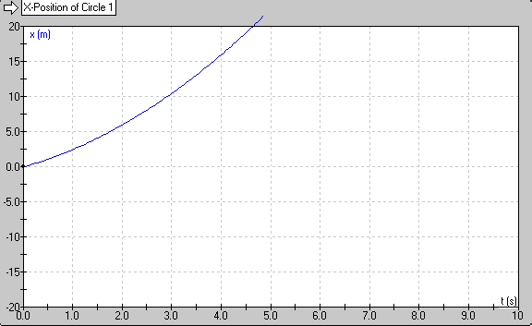
Constant Velocity | Negative velocity means negative slope. (The graph goes down as you move left to right) Constant speed means the slope doesn’t change – it’s a straight line.  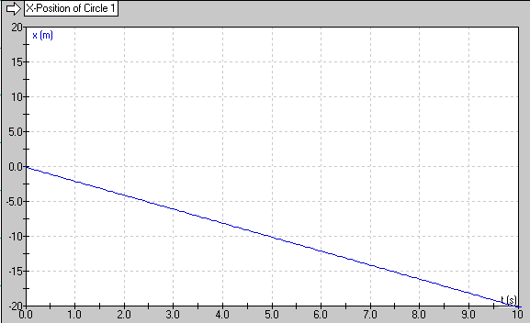 |  | Positive velocity means positive slope. (The graph goes up as you move left to right) Constant speed means the slope doesn’t change – it’s a straight line.  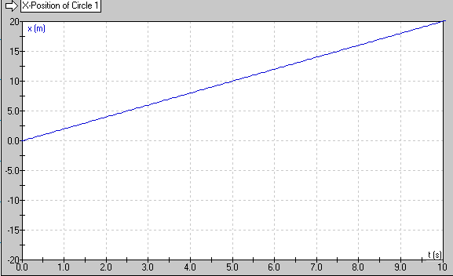
Slowing Down (Going slower and slower) | Negative velocity means negative slope. (The graph goes down as you move left to right) Slowing down means the graph gets less and less steep.  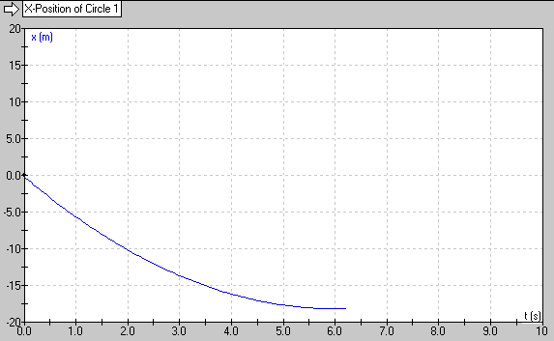 |  | Positive velocity means positive slope. (The graph goes up as you move left to right) Slowing down means the graph gets less and less steep.  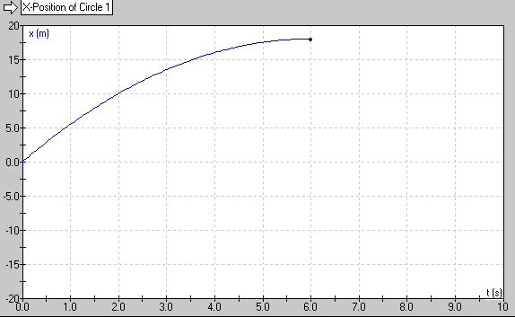

Velocity Graphs:
 | Moving to the Left (Negative Velocity) |  | Moving to the Right (Positive Velocity)
Speeding Up (Going faster and faster) | Moving to the left means the velocity is negative. Negative velocity graphs are all below zero. Speeding up means that as time goes on, the graph moves away from zero. |  | Moving to the right means the velocity is positive. Positive velocity graphs are all above zero. Speeding up means that as time goes on, the graph moves away from zero.
 | Accelerating from rest  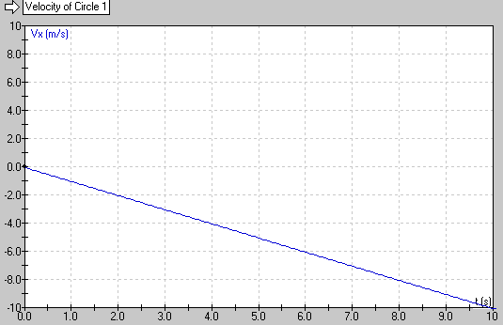 | Already moving  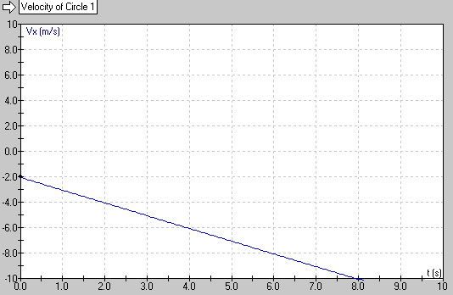 | Accelerating from rest  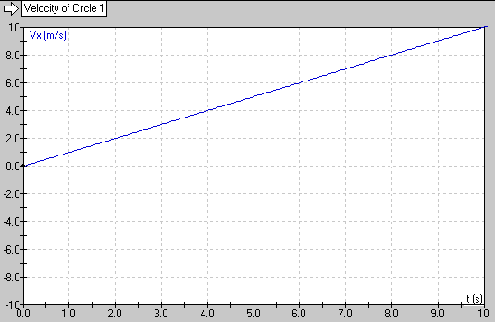 | Already moving  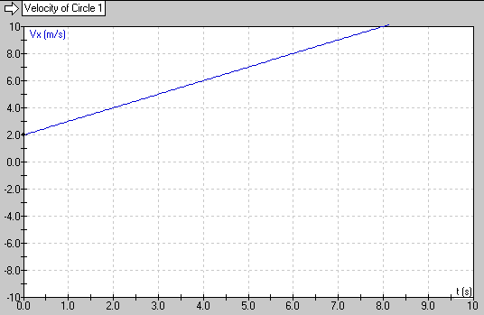
Constant Velocity | Moving to the left means the velocity is negative. Negative velocity graphs are all below zero. Constant velocity means the graph doesn’t move up or down – it’s a horizontal line.  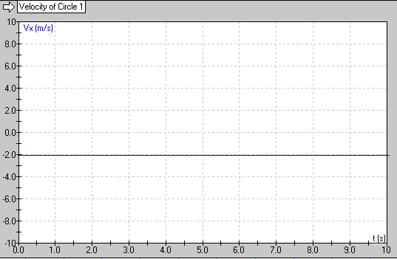 |  | Moving to the right means the velocity is positive. Positive velocity graphs are all above zero. Constant velocity means the graph doesn’t move up or down – it’s a horizontal line.  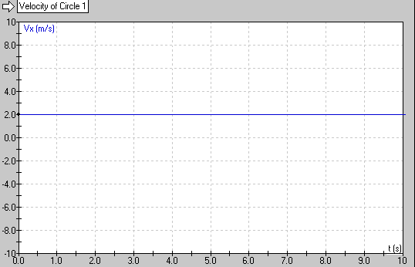
Slowing Down (Going slower and slower) | Moving to the left means the velocity is negative. Negative velocity graphs are all below zero. Slowing down means that as time goes on, the graph moves toward zero.  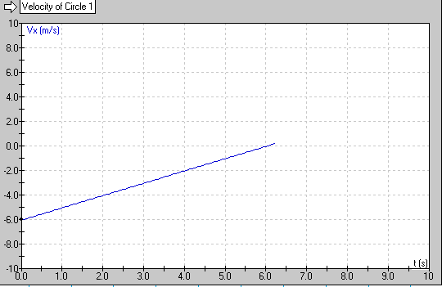 |  | Moving to the right means the velocity is positive. Positive velocity graphs are all above zero. Slowing down means that as time goes on, the graph moves toward zero.  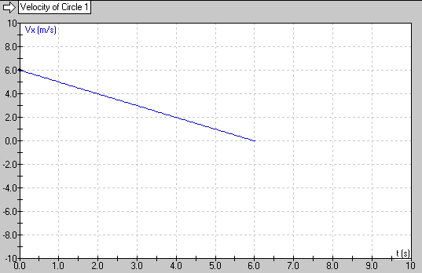

Acceleration Graphs:
 | Moving to the Left (Negative Velocity) | Moving to the Right (Positive Velocity)
Speeding Up (Going faster and faster) | In order to speed up, the acceleration and the velocity must be in the same direction. If it is moving left and going faster and faster, the acceleration must also be to the left, and therefore negative.  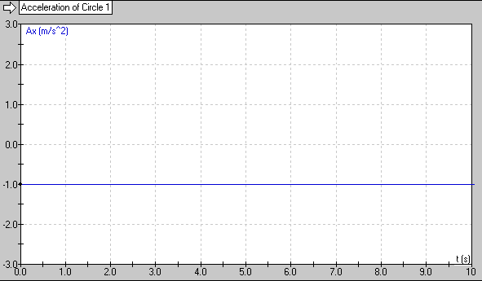 | In order to speed up, the acceleration and the velocity must be in the same direction. If it is moving right and going faster and faster, the acceleration must also be to the right, and therefore positive.  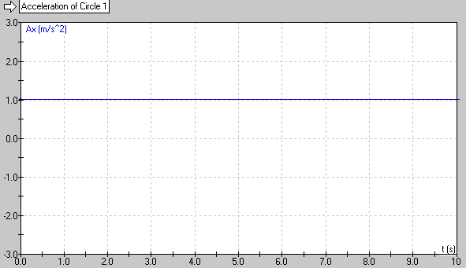
Constant Velocity | If the velocity is constant, the acceleration is zero, regardless which way it is moving.  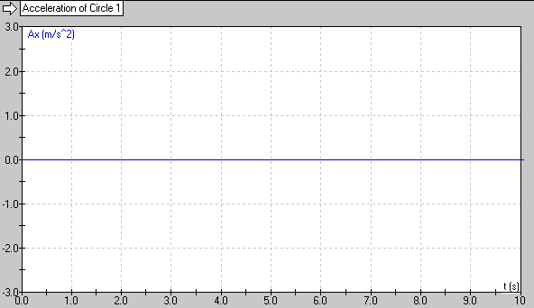 | If the velocity is constant, the acceleration is zero, regardless which way it is moving.
Slowing Down (Going slower and slower) | In order to slow down, the acceleration and the velocity must be in the opposite directions. If it is moving left and going slower and slower, the acceleration then must be to the right, and therefore positive | In order to slow down, the acceleration and the velocity must be in the opposite directions. If it is moving right and going slower and slower, the acceleration then must be to the left, and therefore negative

