More Graph Matching 2 Names ,
Using the motion encoder track and cart, create plots using Logger Pro that match the sets of motion graphs below. Then describe the motion of the cart in the spaces provided. Before doing each one, be sure the motion encoder cart is turned on, and place it right next to the sensor and hit ctl + "0" (control zero) to zero it.
Graph Set 1:
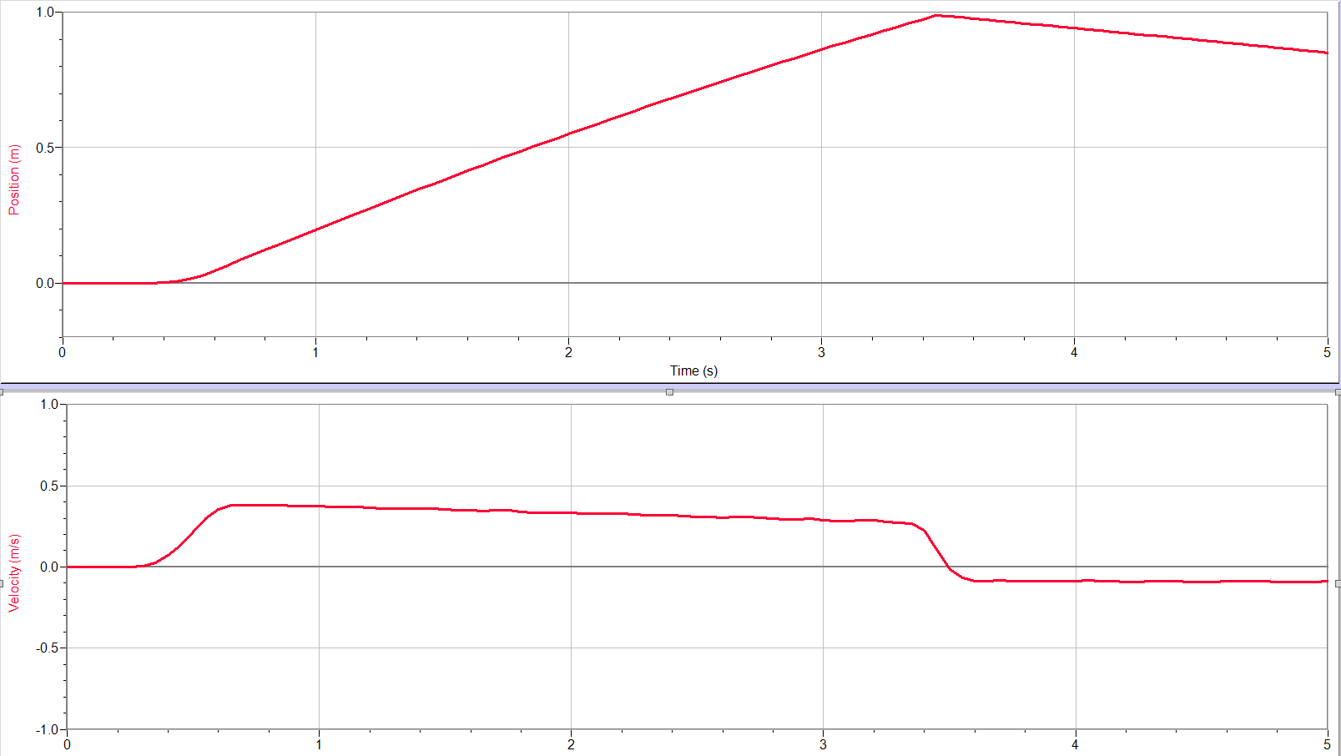
Description of motion:

Graph Set 2: (Hint - the track is tilted)
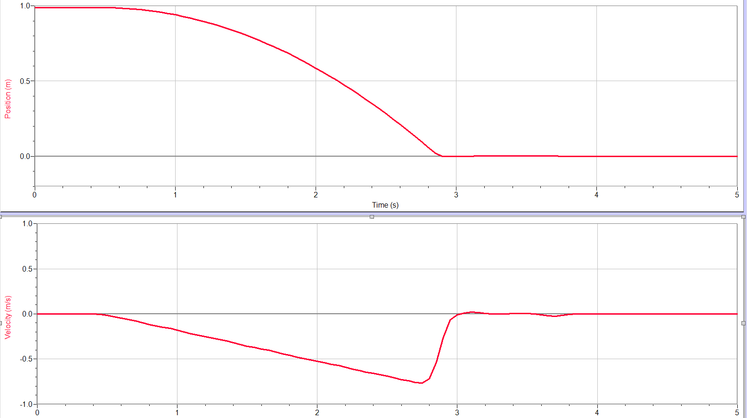
Description of motion:

Predictions: Using the blank graphs below, predict what the position and velocity graphs will look like for the given description of motion. Make your prediction using a dotted line and draw in the actual motion with a solid line.
1. Description of motion: With the ramp inclined away from the detector, push the cart up the ramp and catch it at the top.
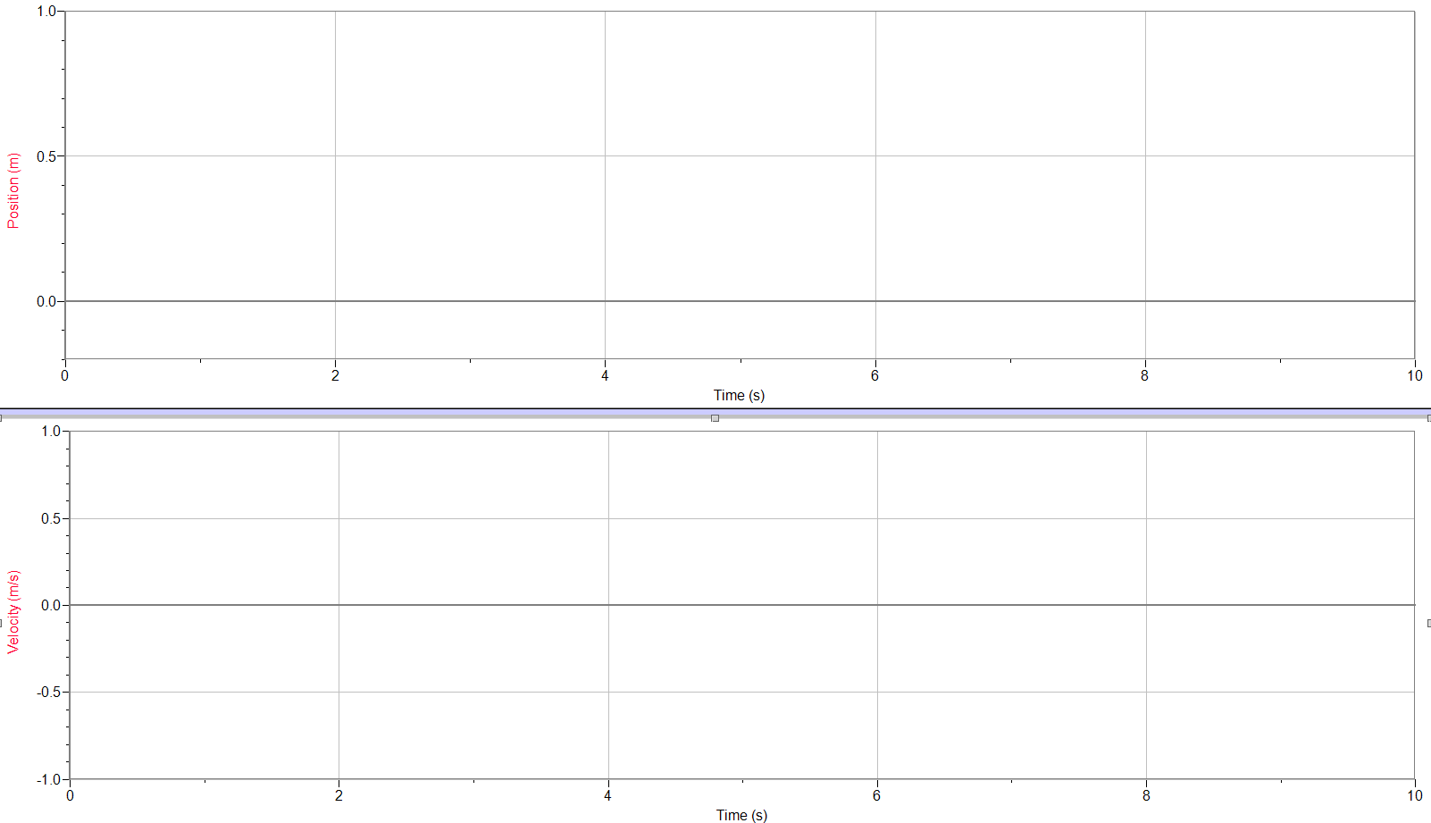

2. Description of Motion: With the ramp inclined away from the detector, push the cart up the ramp so that it comes close to hitting the wall (But doesn’t hit it!), but then changes direction and rolls down the ramp towards the detector.

