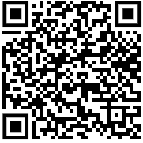
Dear IB Physics Parents and Community:
This is your cordial invitation to the 33rd annual Tualatin Physics research symposia. They will be held at 7:00-9:00 on the evenings of Tuesday, Wednesday, and Thursday January 16th, 17th, and 18th in rooms 25 and 26 in the science wing. (Enter on the North side near the flag pole; go down the first hallway to the right) Check the link in the QR code above to see which night your scientist is presenting. I will also send this to your email, and put a link there as well.
The purpose of the symposia is for my students to defend their semester research projects before the public (you). Their projects constitute one of their final examinations for the semester of IB Physics, and for the IB students, this is their Internal Assessment work.
These Symposia feature research on oscillating bars, projectile motion (of various kinds), golf kinetics, bouncing balls, magnetic fields, viscosity, fluid mechanics, generators, magnetic braking, trebuchet design, water rockets, water ripples, Jupiter’s moons, heat transfer, hot air balloons, sound production, pendulums, dynamic wind force, and buoyancy.
Hope to see you there!!!
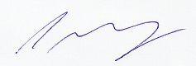
Chris Murray
Tualatin High School

