Problems from 27.1 - Photon Theory
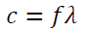
- What is the frequency of a 3.00 m long radio wave? (1.00x10⁸ Hz)
- What is the frequency of a 400. nm light wave? (7.50x10¹⁴ Hz)
- What is the frequency of a 12.0 cm microwave? (2.50x10⁹ Hz)
- What is the wavelength of a 91.1 MHz FM radio wave? (3.29 m)
- What is the wavelength of a 60.0 Hz radio wave? (5.00x10⁶ m)
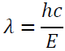
- What is the wavelength of a 2.13 eV photon? (583 nm)
- What is the energy in eV of a 400. nm light wave? (3.10 eV)
- What is the energy in eV of a 700. nm light wave? (1.77 eV)
- What is the wavelength of a 1.20 MeV photon? (1.03x10⁻¹² m)
- What is the energy of a 0.00130 nm photon in eV? (9.54x10⁵ eV)
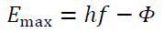
- 415 nm light ejects photo-electrons from a metal with a work function of 2.06 eV. What is the stopping potential of the photo-electrons? (0.930 V)
- 213 nm light ejects photo-electrons from a metal with a work function of 3.10 eV. What is the kinetic energy of the photo-electrons in eV? (2.73 eV)
- 117. nm light ejects photo-electrons that have a stopping potential of 3.56 V from a metal. What is the work function of the metal in electron volts? (7.05 eV)
- Light ejects photo-electrons that have a stopping potential of 1.17 V from a metal with a work function of 2.36 eV. What is the wavelength of the light? (352 nm)
- 315 nm light ejects photo-electrons from a metal that have a stopping potential of 2.65 V. What is the work function of the metal in electron volts? (1.29 eV)
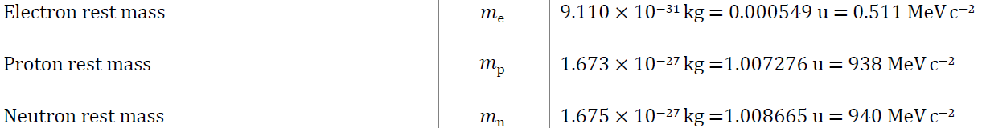
- A photon creates a proton/anti proton pair each with 180. MeV of kinetic energy. What is the maximum wavelength the photon could have? (5.55x10⁻¹⁶ m)
- A photon with a wavelength of 7.21x10⁻¹³ m creates an electron/positron pair each with what maximum kinetic energy? (0.349 MeV)
- A photon creates an electron/positron pair each with 3.20 MeV of energy. What is its wavelength? (1.67x10⁻¹³ m)
- A 5.85x10⁻¹⁶ m photon creates a neutron/anti neutron pair each with what kinetic energy? (121 MeV)
- A 3.20x10⁻¹⁵ m photon creates a charged matter/anti matter pair each having a kinetic energy of 53.9 MeV. What is the rest mass of the particles created in MeV? (140. MeV)
←This is not in the data packet
- What is the velocity of a proton with a de Broglie wavelength of 450. nm? (0.880 m/s)
- What is the mass of a particle that has a de Broglie wavelength of 926 nm, and a velocity of 0.265 m/s? (2.70x10⁻²⁷ kg)
- What is the de Broglie wavelength of an electron with a velocity of 1750 m/s? (416 nm)
- What is the velocity of proton with a de Broglie wavelength of 1.00 x 10⁻¹⁰ m? (3.96x10³ m/s)
- A particle going 1200. m/s has a de Broglie wavelength of 137 nm. What is the mass of the particle? (4.03x10⁻³⁰ kg)

