Nuclear Objectives A-S

Objective A: Isotopes and atomic notation
Questions:
- What is meant by an Isotope of an element? Give an example.
- What is meant by the letters A and Z?
- How do you calculate the number of neutrons an isotope has?

Objective B: Calculating binding energy: H-1 = 1.007825 u, n = 1.008665 u, 1 u = 931.5 MeV
Problems:
- Calculate the binding energy of Dy-164. (1340 MeV)
- Calculate the binding energy of Bk-247. (1850 MeV)
Chapter 30: 1(0.149 u), 11(2.22 MeV), 12(7.48 MeV), 14(32.0 Mev, 5.33 MeV/Nucleon), 13(7.799 MeV), 16(12.1 MeV, 15.7 MeV), 17(-0.094 MeV, unstable and +7.3 MeV, stable)
Questions:
- What does binding energy represent?
- Why do the parts of a nucleus have more mass than the whole?

Objective C: Radioactivity
Problems: (Use Appendix B)
- H-3 Decays by Beta- to what? (He-3) C-14 decays by Beta- to what? (N-14)
- O-15 decays by Beta+ to what? (N-15) Na-22 decays by Beta+ to what? (Ne-22)
- U-232 decays by Alpha to what? (Th-228) No-259 decays by Alpha to what? (Fm-255)
Questions:
- Physically what is an alpha particle, a beta- particle, a beta+ particle, and a gamma ray? What is the charge of each?

Objective D: Decay Series.
Questions
- Go to http://atom.kaeri.re.kr/ at a computer. Go way up to uranium like elements, and find your own decay series by following the links like I did in the video.

Objective E: Alpha Decay: He-4 = 4.002603 u, 1 u = 931.5 MeV
Problems:
- What is the energy of the Pa-231 alpha decay? (5.149 MeV)
- What is the energy of the Pu-239 alpha decay? (5.245 MeV)
Chapter 30: 28a(6.11 MeV), 23(Th-234, 234.04367 u), 22(All three masses increase: a by 0.00703u, b by 0.0168u, and c by 0.0133u), 20(0.0099318u increase in mass)
Questions:
- Why does the right side of the reaction have less mass than the left? Where does the mass go?

Objective F: Quantum Tunneling
Questions:
- What is the mystery that is tunneling? Why is it called tunneling? What does tunneling have to do with Heisenberg uncertainty?

Objective G: Beta Decay
Questions:
- What are the two different beta decays? What is a neutrino? Which neutrino is given off with which decay?

Objective H: Gamma Decay
Questions:
- What is a gamma ray? Why does gamma decay occur? What is meant by discrete energy levels? Which decays yield discrete energy levels of radiation?

Objective I: Activity
Questions:
- How are number of nuclei, decay probability, and activity related?

Objective J: Exponyential decay
Problems:
Chapter 30: 37(1.5E-10 /yr, 8450 s), 36(2.3 hr), 38(1.2E9 decays/s), 39(0.0625), 40(0.015625), 41(1.30E20 nuclei), 43(3.13E12 decays/s, 3.12E12 decays/s, 4.26E5 decays/s), 44(4.3E16 nuclei, 2.9E15 nuclei, 6.5E13 decays/s, 26 min), 45(0.77g), 46(1.0E11 decays/s), 47(1.68E-10 g), 48(1.38E-13 /s, 6.21E8 decays/min), 49(2.6 min), 50(71decays/s), 54(261days, 3.5E-17 kg), 52(1.1E9 yr)
Questions:
- What is meant by the half life? How is half life related to activity? Why does the decay rate decrease as time goes on? (Why is it an inverse exponential relationship?)

Objective K: Radiometric Dating
Questions:
- How do you determine the age of something using carbon 14 dating? How do you date rocks?

Objective L: Nuclear stability
Questions:
- Why is there an upper limit on the size of nuclei? Why do large nuclei tend to have many more neutrons than protons?

Objective M and N: Nuclear reactions and notation.
Problems: (t = H-3, d = H-2, p = H-1, n = neutron)
- Find the missing nucleus or particle: ⁴²₁₈Ar(?,n)⁴⁵₂₀Ca (He-4) ⁶⁵₂₈Ni ( ?,n)⁶⁸₃₀Zn (He-4) ¹⁴⁵₆₆Dy (d,n)? (Ho-146) ²⁷₁₃Al(d,p)? (Al-28) ²⁸₁₄Si(α,n)? (S-31)
- Problems from Chapter 31: 1(Al-28, Beta- to Si-28), 2(Q = +3.270 MeV, no threshold), 3(Q = +4.807 MeV, slow neutrons would do just fine), 4(Q = +17.35 MeV, released), 5(releases 5.701MeV), 6(Q = - 9.469 MeV, so 10.00 MeV can make it happen, 0.53 MeV of energy is left over), 9(4.730 MeV), 11(0.626 MeV), 12(Li-7, it strips a neutron from deuteron, Q = +5.025 MeV, so it is exothermic), 13(He picks up a neutron from carbon, C-11, Q = +1.856 MeV, exothermic), 14(P-31, Q = +8.864 MeV), 15(18.000953 u)

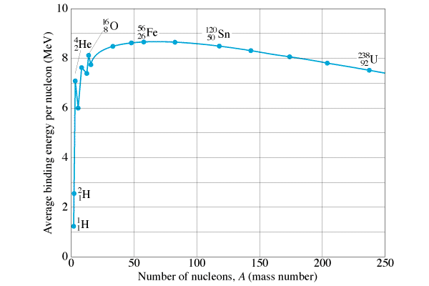

Objective O, Q, R: The Curve of Binding Energy: Fission vs Fusion
Questions:
- What is nuclear fusion? What is nuclear fission?
- On a graph of binding energy, identify those nuclei that can release energy through fusion, and those that can release energy through Fission.

Objective S: Nuclear energy
Problems:
Chapter 31: 16(126.5 MeV), 18(6E18 reactions/s), 19(9.1E-4), 20(5 neutrons, 171.1MeV), 21(3.7E-7 kg of U-238), 22(3.7E-4 kg U), 23(626 kg U), 26(17.59 MeV), 27(3.27 MeV)
Questions:
- What are the benefits and drawbacks for nuclear power?
- What percent of France’s electricity is nuclear?

