**Particle Physics Part II - Conservation Laws and Quarks**

**Conservation Laws:**

Charge Mass/Energy Nucleon #

**Conservation of Baryon number:** (All Baryons are B = +1, anti-Baryons are B = -1)



Example: Can the following reaction occur?

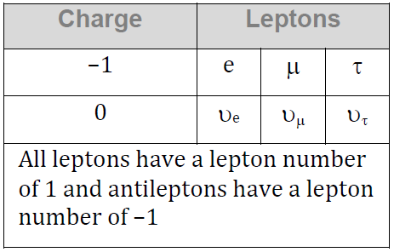 p + n → p + p + $\overline{p}$

Charge:

Mass/Energy

Baryon #

**Conservation of Lepton number:** (Conserved by type Le, Lm, Lτ)



|  |  |
| --- | --- |
| Can this decay occur?  τ- → π- + πo + υτ | Find the missing decay product:  τ- → υτ + e- + ?? |

Quark Theory:

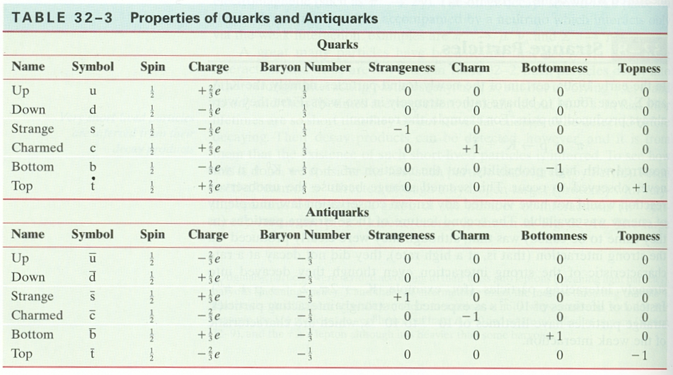

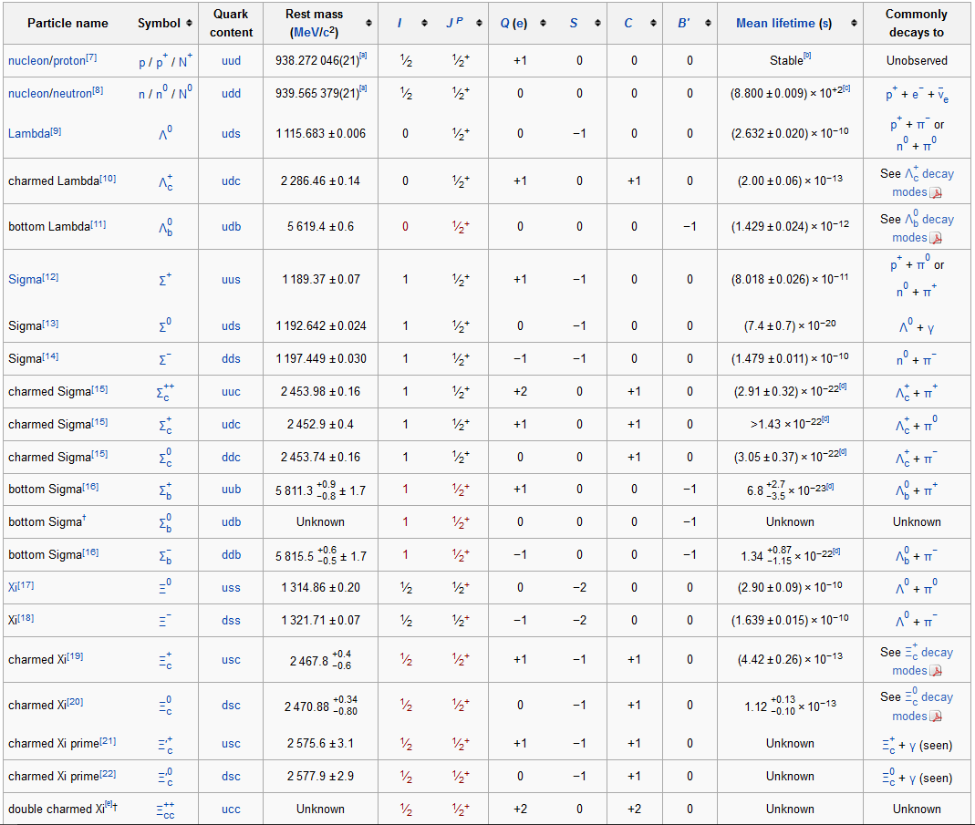

Match these quark contents with the Baryon: (Figure out the content of the rest!)

|  |  |  |  |  |
| --- | --- | --- | --- | --- |
|  | q | s | c | b |
| udd |  |  |  |  |
| uud |  |  |  |  |
| udb |  |  |  |  |
| ddc |  |  |  |  |
| udc |  |  |  |  |
| dds |  |  |  |  |
| udb |  |  |  |  |