Particle Physics Part I - Accelerators, QED and types of Particles
Particle Accelerators:
Linear Single stage Linear Multiple Stage Cyclotrons/Synchrotrons

Particle discoveries: (i.e. atoms are not fundamental particles)
1877: Electron – JJ Thomson and “Cathode Rays” (they have charge)
1930: Bothe and Becke eject a neutron by bombarding beryllium with alphas
1932: Anderson detects Positron in cosmic ray collisions. (Anti particle predicted to exist by Dirac)
1936: Anderson detect the Muon in a cosmic ray collision
1955: anti protons created in an accelerator by colliding 6 GeV protons:

p + p → p + p + p + $\overline{p}$ (How are the proton and anti proton created?)

Quantum Mechanics vs. Field Theory:
In Quantum Mechanics, Forces are mediated (transmitted) by field particles:
Feynman - QED Yukawa - mesons
π⁺ - 139.6 MeV/c²
πº - 135.0 MeV/c²
π⁻ - 139.6 MeV/c²
p + p --> p + p + πº
p + p --> p + n + π⁺
(conservation of charge)

Type Relative Strength Field Particle
Strong Nuclear 1 Gluons (mesons)
Electromagnetic 10⁻² Photon (γ)
Weak Nuclear 10⁻⁶ W⁺, W⁻ and Zº
Gravitational 10⁻³⁸ Graviton?

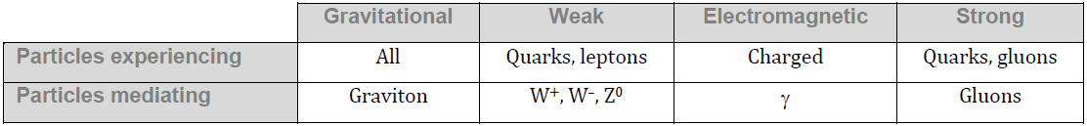
Particles and Anti Particles:
Name Particle Antiparticle
Electron e⁻ e⁺
Proton p $\overline{p}$
Pion π⁺ π⁻

What happens if particle meets anti particle:

How you know if they have an antiparticle:

What the ⁺, º, and ⁻ mean:

Types of Particles
Gauge Bosons | Leptons | Hadrons
 |  | Mesons | Baryons

