Digital Information Storage - Computers and digital electronics store data in binary form – either all “on” or all “off”

**Binary to Decimal:**

**1101** =

**Decimal to Binary:**

|  |  |  |  |  |  |  |  |
| --- | --- | --- | --- | --- | --- | --- | --- |
| 128 | 64 | 32 | 16 | 8 | 4 | 2 | 1 |
|  |  |  |  |  |  |  |  |

**Convert 237 to binary:**

**Advantages of Binary:**

**Conversion of analog to digital:**

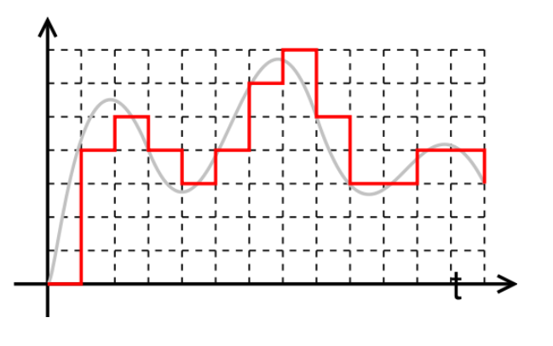

Sample rate

Sample depth

**Information storage on a CD (or DVD)**

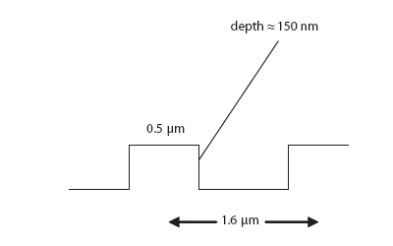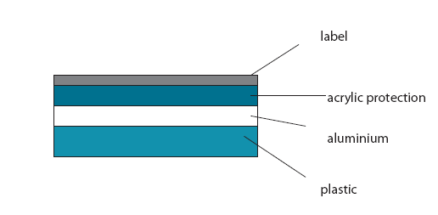

**Destructive interference:**

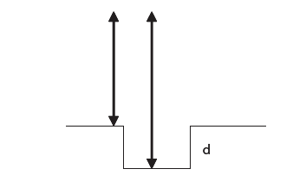

**path difference = 1/2λ = 2d**

d = depth of pit (m)

λ = laser wavelength (m)

Example – if the pits are 150 nm deep, what wavelength of laser light will create destructive interference relative to this depth?

**Rayleigh Criterion and CD Laser Optics:**

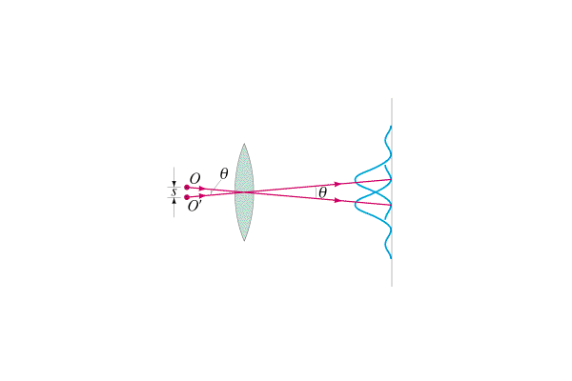



θ = Angle of resolution (Rad)

r = min distance separating pits (m)

d = distance to CD from lens (m)

λ = Wavelength of laser (m)

b = Diameter of CD Lens (m)

Example - DVDs have pits that are about 0.74μm apart. If the lens has a diameter of 4.2 mm, and the laser has a wavelength of 780 nm, what must be the maximum distance from the lens to the disc so that the reader can resolve the pits?