The Bohr Atom
Bohr develops a quantum theory for the atom to explain the spectral lines.
The spectral lines follow a pattern:

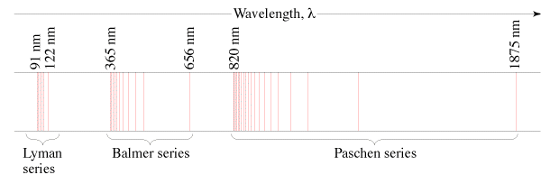

¹/_{λ} = R(¹/₂2 - ¹/_{n}2), n = 3, 4, ...(Balmer) (Visible)
¹/_{λ} = R(¹/₁2 - ¹/_{n}2), n = 2, 3, ...(Lyman) (UV)
¹/_{λ} = R(¹/₃2 - ¹/_{n}2), n = 4, 5, ...(Paschen) (IR)

Three Assumptions of the Bohr Model:
1. Electrons exist in stationary states that don't radiate energy. (More about this later - these are resonances)

2. Photons are created from the energy given off by downward electron transitions:

Example 1 – What is the wavelength of the first Lyman line?

3. Angular momentum of the electrons is quantised. (Even multiples of h-bar)
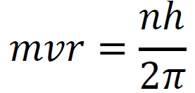
Example 2 - Show that mvr = L = Iω,

Ultimately, the energy levels can be simplified to:

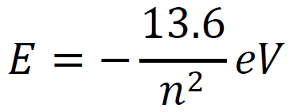
n - principal quantum number (orbital)
E - Total energy of electron (KE + PE) in eV

Example 3: What is the energy level of the 4th orbital, and the 2nd orbital?

What wavelength of light corresponds to a 4 to 2 transition for a Hydrogen atom? (The 2nd Balmer line)

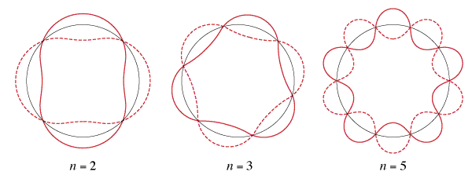
Show that the quantisation amounts to the circumference of the orbit being integer multiples of the de Broglie wavelength. (Bohr did not base his quantum hypothesis on this - it was used after the fact to explain and justify)

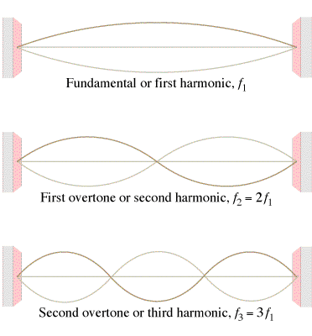

Schrodinger Wave Equation:
