de Broglie Matter Waves and Photon Interactions

**de Broglie** – If light can act as a particle, then matter can act as a wave.

|  |  |
| --- | --- |
| The wavelength/momentum of a particle:    p = momentum (kg m/s)  h = Planck’s constant = 6.626x10-34 Js  λ = wavelength (m) | The momentum of a particle:    p = momentum (kg m/s)  m = mass (kg)  v = velocity (m/s) |
|  |  |

**Davisson-Germer:**

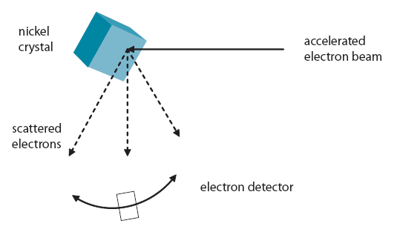

   

Example 1: What is the de Broglie wavelength of a 0.145 kg baseball going 40. m/s?

Example 2: Through what potential must you accelerate an electron so that it has a wavelength of 1.0 nm?

Example 3: A 632.8. nm photon has what momentum? A 1.0 mW laser beam has 3.2x1015 of these photons per second. What net force does this beam exert on a surface where they are absorbed?

**Photon Interactions with matter:**

**Photo-electric Effect** - photon ejects electron from a metal surface

**Compton Scattering** - Photon scatters (bounces) off an electron. Electron and photon go off in different directions, and photon's wavelength goes down. (Loses energy...)

**Absorption** - Photon energy is the same as a transition energy, so it bumps an electron up an energy level and is absorbed

**Pair Production** - A photon passing by a mass (nucleus, or electron) spontaneously creates a matter-anti matter pair.

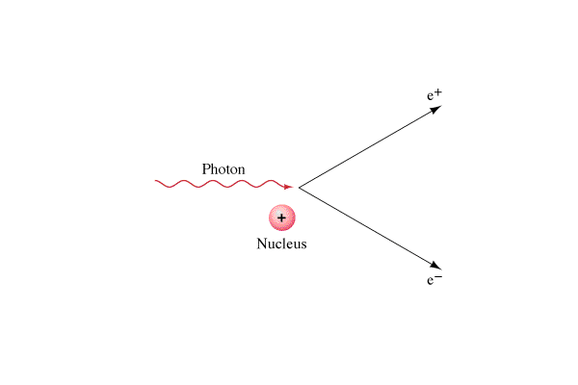 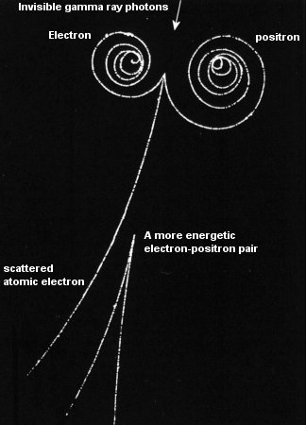

**Photon energy = Energy to create matter + Kinetic energy of pair**

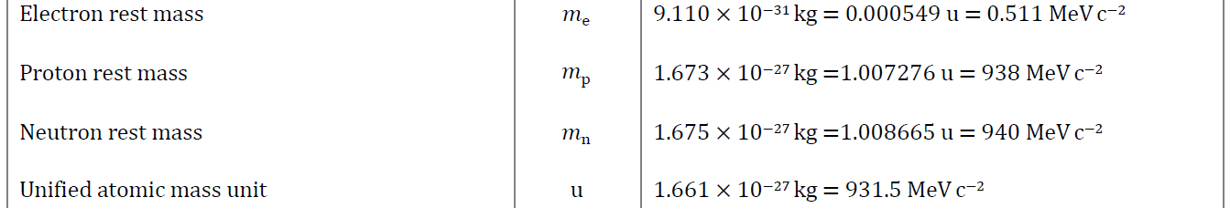

Example 1: What energy photon (in MeV) is needed to create a electron-positron pair each with a kinetic energy of 0.34 MeV? What is the wavelength of that photon?

Example 2: A 0.00025 nm photon creates a electron-positron pair. What is the kinetic energy of each particle?