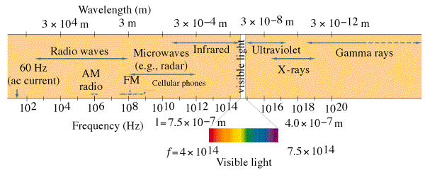
Photons and the Photo-Electric Effect

Reviewing Waves:
v = fλ
v = c = speed of light = 3.00 x 10⁸ m/s
f = frequency (Hz)
λ = wavelength (m) 1 nm = 1 x 10⁻⁹ m

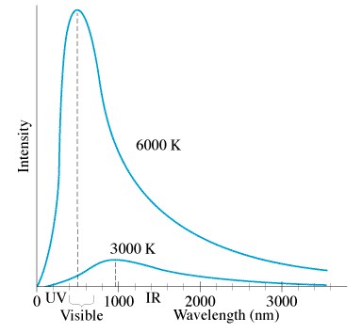

Photon Theory: Light is made of particles.
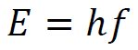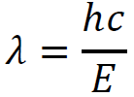
E = Photon energy (Joules)
h = Planck’s constant = 6.626 x 10⁻³⁴ Js
f = frequency of oscillations (Hz, s⁻¹)
c = speed of light = 3.00x10⁸ m/s
λ = Wavelength in m

Example 1: What is the energy (in eV) of a 460. nm photon?

Example 2: A photon has an energy of 13.6 eV. What is its wavelength?

 | Wave Model | Photon Model
Color: | Wavelength changes  Small λ = Blue  Big λ = Red | Energy per photon changes (E = hf = hc/λ)  High E = Blue/UV/X-rays  Low E = Red/Microwaves/radio
Brightness: | Amplitude Changes  Bright = big  Dim = small | # of Photons changes  Bright = many  Dim = few
Photo-Electric Effect – Electrons being ejected from a metal by light.
Photon Energy = Work + Kinetic Energy
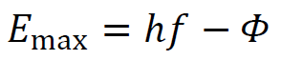
hf = φ + E_{max}

φ - Work function (Depends on material)
hf – photon energy
E_{max} – max KE of photoelectrons
(= eV_{s}) – where V_{s} is the stopping potential

Example 1: A certain metal has a work function of 3.25 eV. When light of an unknown wavelength strikes it, the electrons have a stopping potential of 7.35 V. What is the wavelength of the light?

Example 2: 70.9 nm light strikes a metal with a work function of 5.10 eV. What is the maximum kinetic energy of the ejected photons in eV? What is the stopping potential?

Differing predictions:
Model | Photoelectron energy depends on: | Photoelectron energy is independent of:
Wave

Photon

