**Noteguide for Lepton Number- Videos 32D Name**

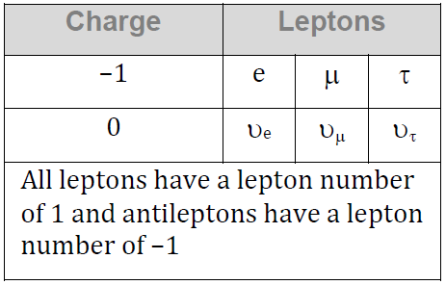**Conservation of Lepton number:** (Conserved by type Le, Lm, Lτ)



|  |  |
| --- | --- |
| Can this decay occur?  τ- → π- + πo + υτ | Find the missing decay product:  τ- → υτ + e- + ?? |

Whiteboards

|  |  |
| --- | --- |
| (no)  Why not: | (yes) |
| (yes) | (no)  Why not: |
| (no)  Why not: | In this space draw a picture of a pretty pony: |

Whiteboards:

