Noteguide for QED and Types of Particles - Video 32B Name
Quantum Electrodynamics (QED) – Richard Feynman

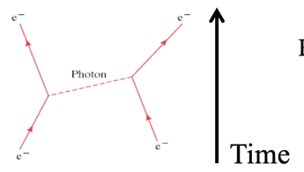
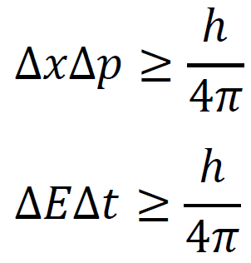
Forces are mediated by virtual particles

How QED Explains:
What charge actually is

Force dropping off over distance

How accelerating a charge causes it to radiate actual photons

The Yukawa Particle:

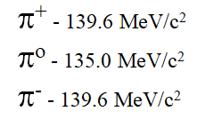

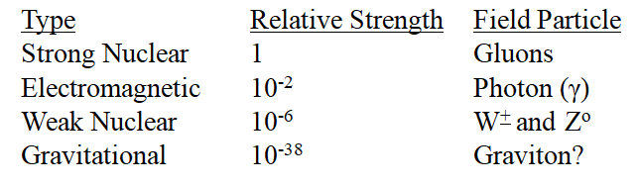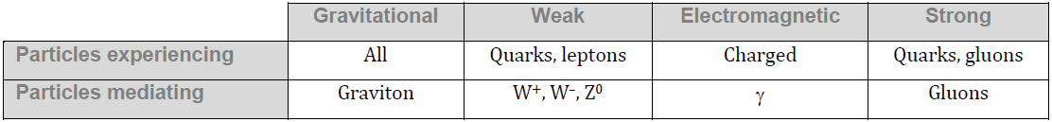

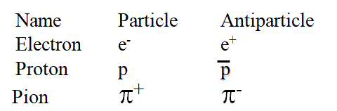

Annihilation:
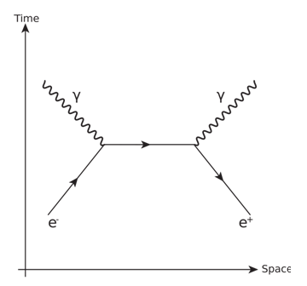
(Write down what the axes mean, and why the positron is going backwards in time)

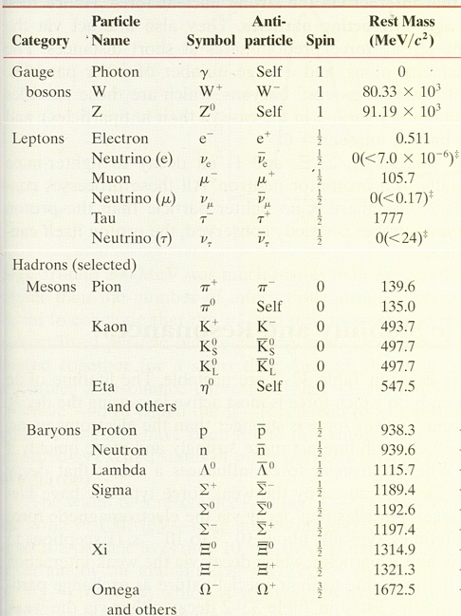
Bosons (Integer spin)

Gauge Bosons (Spin 1)

Scalar Boson (Spin 0)

Mesons (Even # of Spin ½)

Fermions (Non integer Spin or Spin 1/2)

Leptons

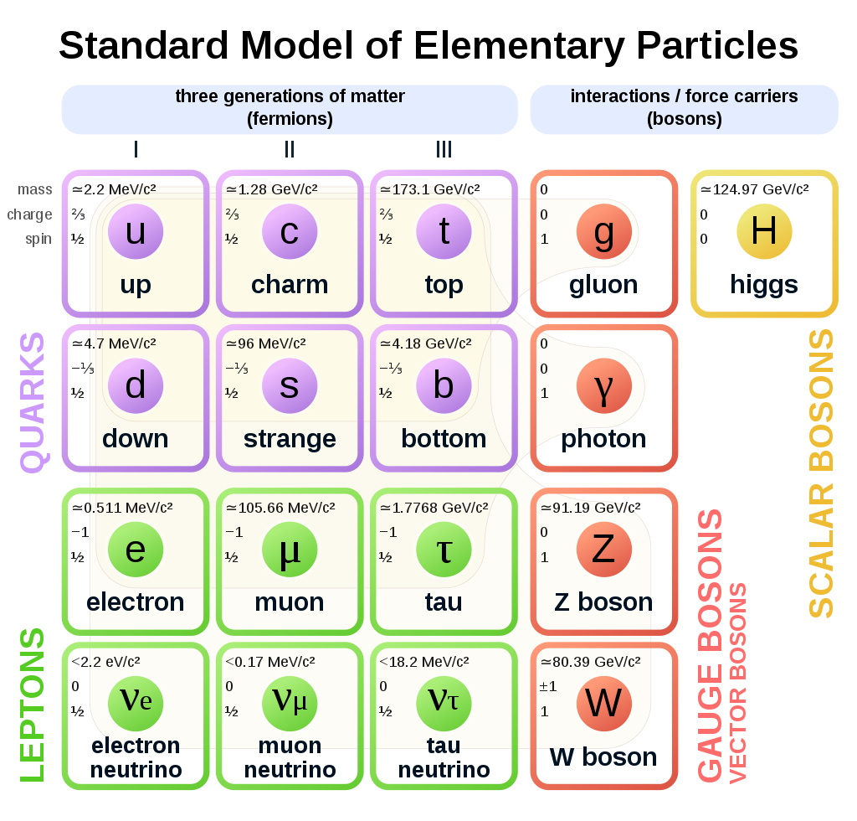

Bosons

Quarks

