Noteguide for Particle Accelerators - Video 32A Name
Basic concept - Vq = ¹/₂mv²

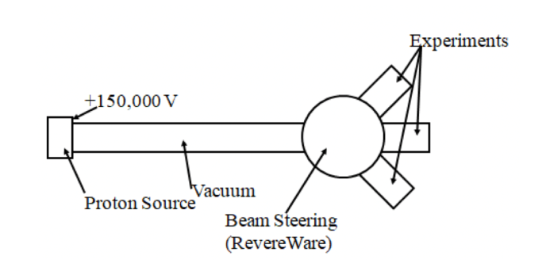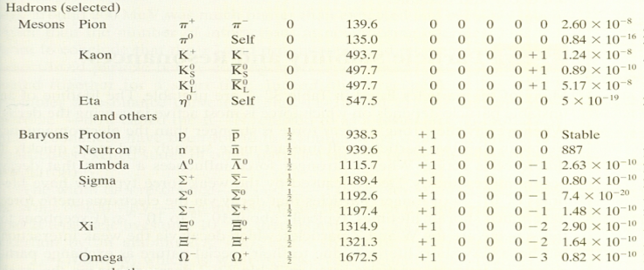

Velocity of particles?

(2 miles long, 50 GeV)

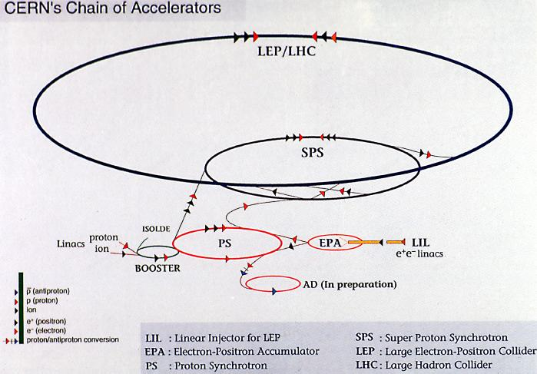 (6.5 TeV)

