Noteguide for Nuclear Power- Videos 30Q Name

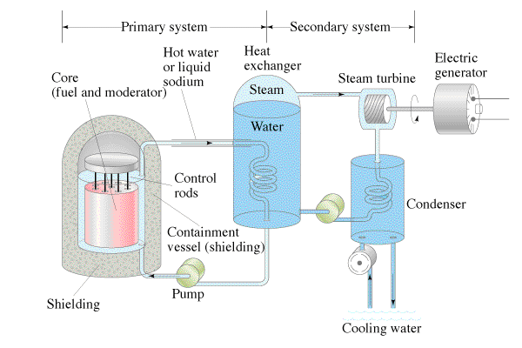
Pros: Cons:

Example Question: An 820 MW power plant is 30.% efficient. How much Uranium 235 will it use in a year? Assume that a single atom will yield 200. MeV of energy. Uranium 235 has a mass of 235.0439231u, N_{A} is 6.02 x 10²³.

Chernobyl:

