Noteguide for The Curve of Binding Energy- Videos 30O Name

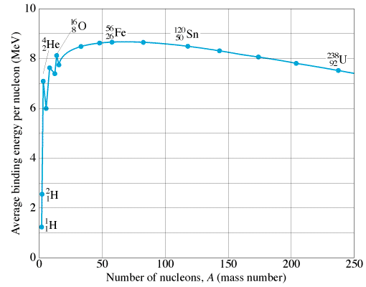
The curve of binding energy:
Define:
Binding energy per nucleon -

What’s more and less stable –

Mark where fusion (joining) and fission (splitting) can release energy. Where are the most stable nuclei?

Fusion powers the sun:  Energy comes primarily from the Proton-Proton cycle:  ¹H + ¹H = ²H + e⁺ + ν  ¹H + ²H = ³He + γ  ³He + ³He = ⁴He + ¹H + ¹H | Helium can also fuse:  ⁴He + ⁴He = ⁸Be + γ  ⁴He + ⁸Be = ¹²C + γ  Carbon can fuse as well:  ¹²C + ¹²C = ²⁴Mg + γ  ¹⁶O + ¹⁶O = ²⁸Si + ⁴He

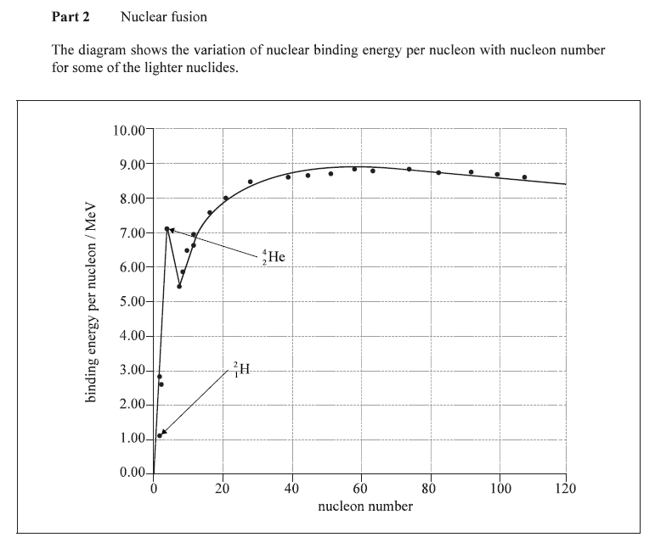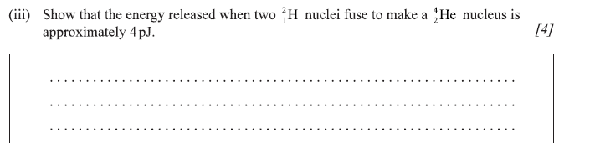

Finding Q-Value from Binding Energy per nucleon: (We did these before using mass)

K-40 has a BE of 8.538080 MeV per nucleon
Ca-40 has a BE of 8.551299 MeV per nucleon (Q = +0.529 MeV (Exo))

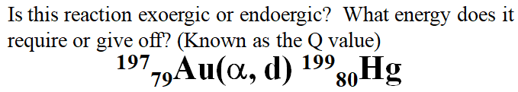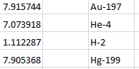 (-12.30 MeV)

