Noteguide Nuclear Fission- Video 30N1 Name
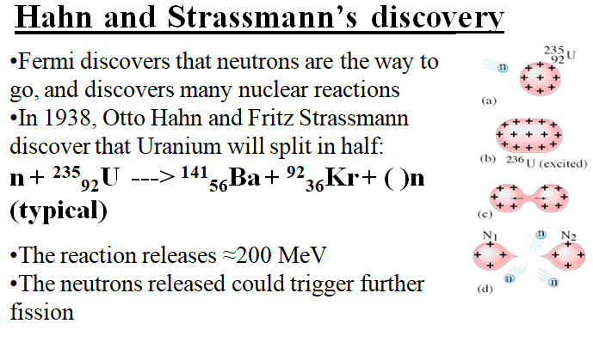

Let’s find the Q-Value:

n + ²³⁵₉₂U ---> ¹⁴¹₅₆Ba + ⁹²₃₆Kr + ( )n

How many neutrons does it release?

What is the Q-Value? (+173.3 MeV)

What is the energy density in J/kg if this is the only reaction that occurs? (7.112x10¹³ J/kg 7.112x10⁷ MJ/kg)

