Noteguide for Q Value - Videos 30N Name
Example:
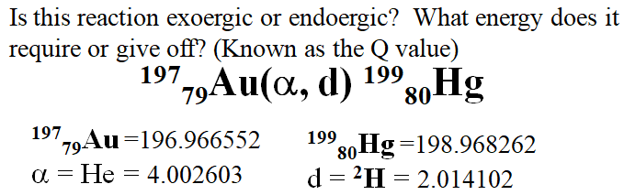

Whiteboards:
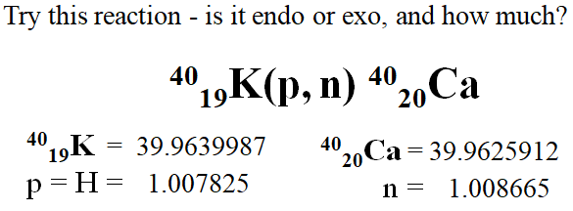 (Q = +0.529 MeV (Exo))

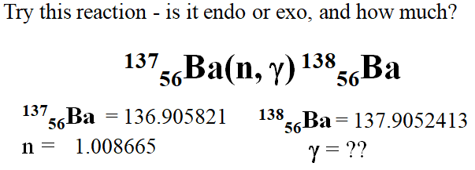(Q = +8.611MeV (Exo))

