Noteguide for Radioactivity and Decay Series- Videos 30CD Name
Videos C:
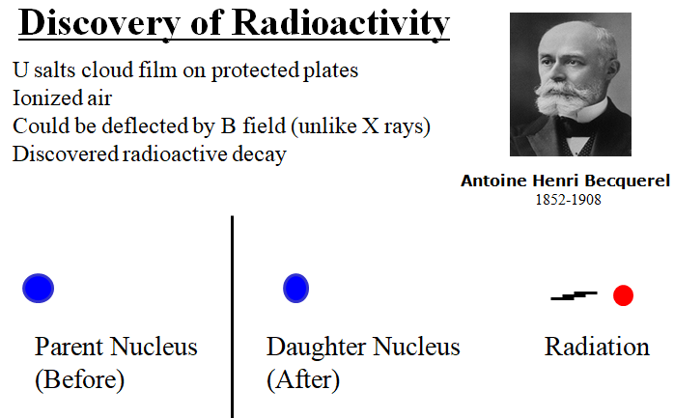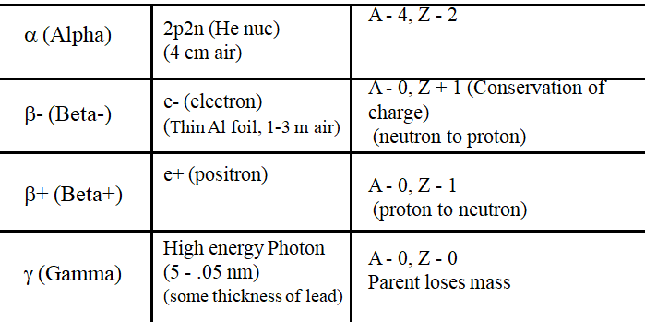

Whiteboards:
1.  () | 2.  ()
3.  (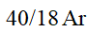) | 4.  (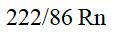)
5. 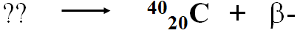  (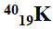) | 6.  (α)
7. 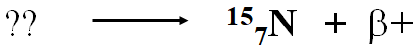  (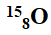) | 8. 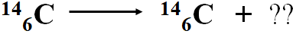  (γ)

Videos D:
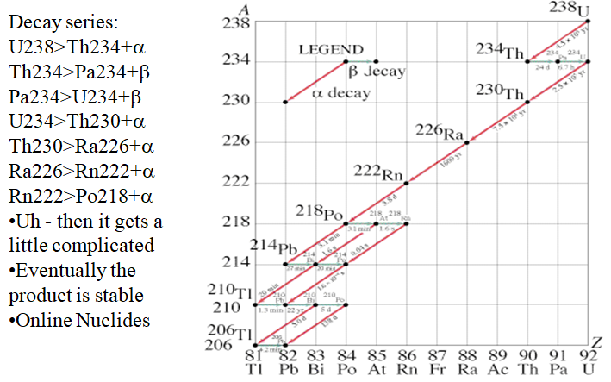

OK - So try this yourself - go to

http://atom.kaeri.re.kr:8080/ton/nuc8.html

and type U-238 into the box in the upper left corner that says

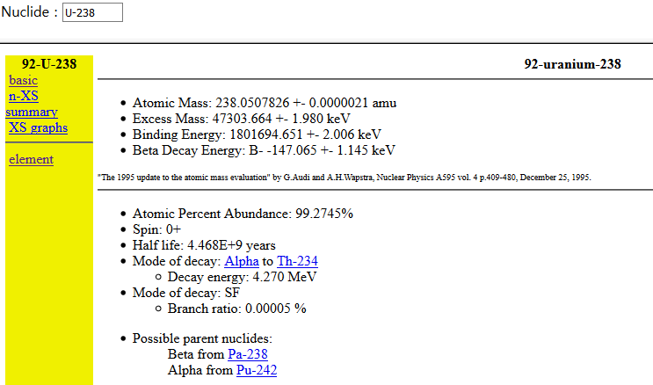 Then click on the link for Th-234.

Off you go. Keep following links after "mode of decay". Sometimes there are more than one...

Eventually, as long as you are clicking on the products of the decay, you will always end up at Pb-206
Try Bk-247
Look around up there near the top of the Chart of the Nuclides, and find other exciting decay series..

