Noteguide for Binding Energy - Videos 30B Name

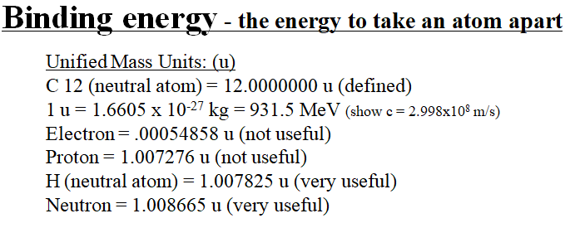

(The bigger the binding energy per nucleon, the more stable the nucleus)

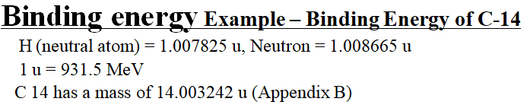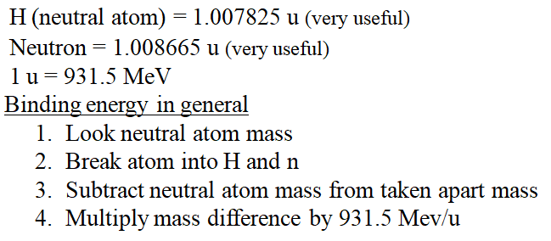

What is the binding energy for Nitrogen 13?  (Z = 7) N 13 mass = 13.005739 u  H = 1.007825 u  Neutron = 1.008665 u  1 u = 931.5 MeV  (94.11 MeV) | What is the binding energy for Carbon 12?  (Z = 6) C 12 mass = 12.000000 u (duh?)  H = 1.007825 u  Neutron = 1.008665 u  1 u = 931.5 MeV  (92.16 MeV)

