Noteguide for Atomic Notation and Isotopes - Videos 30A Name

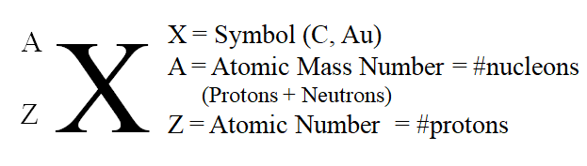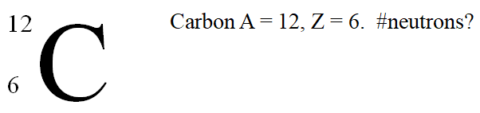

(C-12 is another notation, so the number 12 is the mass number, everyone knows Carbon is element 6)

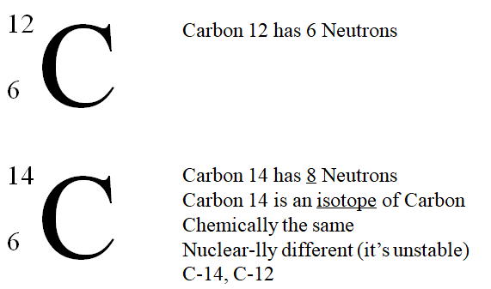

Whiteboards:
What is the Atomic notation for tritium? (tritium is an isotope of Hydrogen with 2 neutrons)  (3/1 H) | 10 protons, 12 neutrons. What is its atomic notation?  (22/10 Ne)
How many neutrons in U 235? (235 = A)  (143) | How many neutrons in Pb 208? (208 = A)  (126)
How many neutrons in Kr 78?  (42) | Draw a picture of a bunny here:

