Noteguide for Closest Approach - Videos 27J Name
Rutherford – Discovered the nucleus by scattering alpha particles (2 protons, 2 neutrons bound together) off of gold foil.
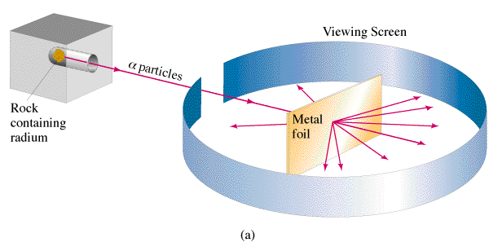

Relationship between energy voltage and charge:  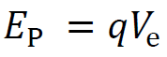  V_{e} = Voltage (V)  q = Charge (C)  E_{p} = Electrical Potential energy (J) | Voltage due to a point charge:  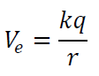  V_{e} = Potential near a point charge (V)  k = 8.99x10⁹ Nm²/C²  q = Charge (C)  r = distance to charge (m)
Kinetic Energy:
E_{k} = Kinetic Energy (J)
m = mass (kg)
v = velocity (m/s)

Example 1: What is the closest approach of an alpha (q = 2e, m = 6.644E-27 kg) particle going 2.6 x 106 m/s if it approaches a carbon nucleus head on?

Example 2: Through what potential must you accelerate an alpha particle to penetrate a Uranium (Z = 92) nucleus? (r = 7.4 fm) (1 fm = 1x10-15 m)

Whiteboards:
What is the closest approach in nm of an Alpha (2p2n) particle going 15,000 m/s to a Gold (Z = 79) nucleus? (49 nm)

An Alpha particle’s closest approach brings it to within 47 fm of a Gold nucleus.
What is its energy in eV? (4.8 MeV or 4.8x10⁶ eV)

