Noteguide for Pair Production - Videos 27G1 Name

Pair Production - A photon passing by a mass (nucleus, or electron) spontaneously creates a matter-anti matter pair.
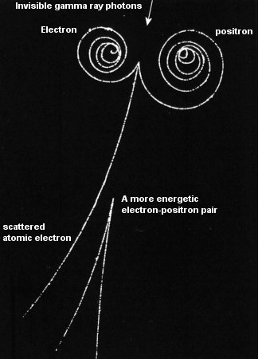

Photon energy = Energy to create matter + Kinetic energy of pair

Example 1: What energy photon (in MeV) is needed to create a electron-positron pair each with a kinetic energy of 0.34 MeV? What is the wavelength of that photon?

Example 2: A 0.00025 nm photon creates a electron-positron pair. What is the kinetic energy of each particle?

Whiteboards:
1. A photon creates a electron-positron pair each with a kinetic energy of 0.170 MeV. What is the energy of the photon? (in MeV) (1.362 MeV) | 2. A 2134 MeV photon creates a proton, antiproton pair, each with how much kinetic energy?  (129 MeV)
3. A photon with a wavelength of 5.27113x10⁻¹³ m creates a electron-positron pair with how much kinetic energy each? (answer in keV) (666 keV ) (heheheheh)

