Noteguide for Electromagnetic Spectrum - Videos 27A Name
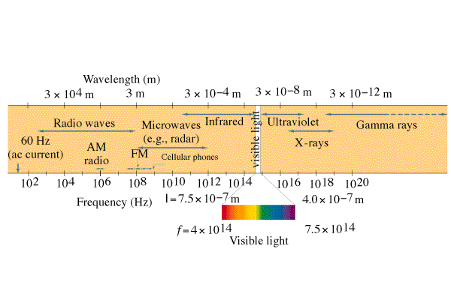

Reviewing Waves:
v = fλ
v = c = speed of light = 3.00 x 10⁸ m/s
f = frequency (Hz)
λ = wavelength (m) 1 nm = 1 x 10⁻⁹ m

Example: What is the wavelength of a 91.1 MHz radio wave?

Whiteboards:
1. What is the frequency of a 12.2 cm microwave? (ovens use this) (2.46 x 10⁹ Hz)
2. What is the frequency of a 600. nm light wave? (5.00 x 10¹⁴ Hz)

