Nuclear Stability – A nucleus is bound by the strong nuclear force. Since this force is extremely short range (1x10⁻¹⁵ m) as the nucleus gets bigger, nuclei become in general less stable because the coulombic repulsion of the protons gets stronger, and the strong nuclear gets weaker. Ultimately there is an upper limit to the size of a stable nucleus.

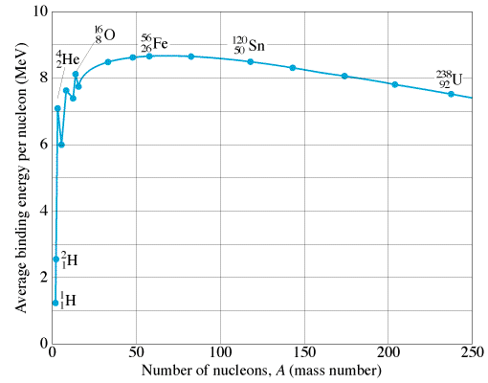
The curve of binding energy:
Define:
Binding energy per nucleon -

What’s more and less stable –

Mark where fusion (joining) and fission (splitting) can release energy. Where are the most stable nuclei?

Forces in a nucleus:
Coulombic force: Strong Nuclear Force:

A graph of neutrons vs. protons for stable nuclei:
