Binding Energy and Nuclear Notation

**Atomic Notation** – Physicists care about isotopes – the same element with different numbers of neutrons.

 -

Z = Atomic number (Number of protons and electrons in neutral atom)

A = Atomic mass number (#Neutrons + #Protons)

 and  are isotopes. (C-14 is radioactive)

**Binding Energy** – The amount of energy it would take to separate the nucleus into pieces. You split the atom into free neutrons, and hydrogen atoms, and compare the mass of the atom you look up in a table with the mass of the parts. Since the parts have more mass, they represent more energy, and the increase in energy is the work you needed to do to separate the nucleus into parts. The more work you have to do, the more stable the nucleus is.

Atomic mass in general: **Derive that 1 u = 931.5 MeV using E = mc2 here→**

|  |  |
| --- | --- |
|  |  |

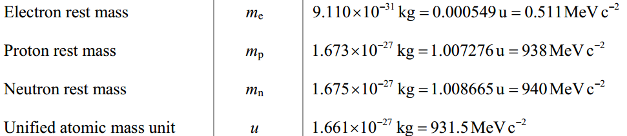

Useful things to know to calculate binding energy

|  |  |
| --- | --- |
| Mass of Neutral Hydrogen atom =  Mass of Neutron =  1 u = | 1.007825 u  1.008665 u  931.5 MeV |

Binding energy in general:

1. Look up neutral atom mass in Appendix F (p 1064) – or on the website..
2. Break atom into H and n
3. Subtract neutral atom mass from taken apart mass
4. Multiply mass defect by 931.5 Mev/u

Example 1: What is the binding energy of carbon 14?